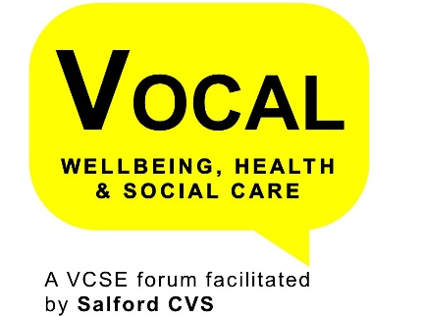
Salford Suicide Prevention Board
GM Suicide Prevention work
Salford is linked into this which will look at a wider information offer, however Salford are also sharing local information and links to an online training offer from Zero Suicide Alliance.
Bereavement support work specifically relating to suicide is being taken forward at GM level, with Salford as the lead CCG for this work on behalf on GM.
Annual audit of suicide in Salford
Mostly follow s NW pattern; eg. men 40-59, people from BME or LGBT communities, construction workers, often without family or relationships.
2016 – 17 22 suicides
2017 – 18 (to date) There have been 23, pattern has shifted a little with people in families making up a significant proportion
A 10 year audit is being explored to try and understand the trends better; this audit will also be involving data from GMP and GMFRS to include related incidents (attempts, expression of suicidal thoughts, etc.).
Prevention Pilot
Testing across two areas of Salford
- Testing approaches to prevention
- Skilling up professionals to have conversation where they are concerned for an individual
- Promote prevention to people not in contact with services i.e. through community networks, businesses, gyms, sports clubs etc.
- On-going engagement to see where best to target resources
- Production of wallet sized card with conversation tips and signposts to support which will be widely distributed
- Providing on-line training (suicide prevention)
- Producing school’s packs ( Papyrus)
- Employer resource packs (Business in the Community)

Bereavement Support
A pilot for a part-time bereavement support worker has been successfully completed in Salford via the Innovation Fund and is now recurrently funded as a full-time post. This is being delivered by 6 Degrees.
Process Mapping
Working with survivors and those bereaved by suicide to understand the touch points and opportunities for engaging in preventative work. This work was suggested by someone with personal experience and will be ongoing throughout the year.
VCSE Representatives
We are looking for 2 VOCAL representative. In order to be eligible to take up this Representative Opportunity your organisation must operate in Salford.
Commitment
The board meets virtually on a quarterly basis for 1 hours and it is anticipated that there will be around 2 hrs of reading.

As a VOCAL Representative there is also a requirement that you agree to and sign the VOCAL Representative Protocol, attend VOCAL Reps Meetings (once a quarter) and provide short summary reports for the VOCAL Wellbeing, Health & Care Forum.
This is a great opportunity to influence and shape the way in which health and social care professionals work with and for our local communities and engage in work across Greater Manchester. Additional briefing and support will be provided once engaged in this role.

