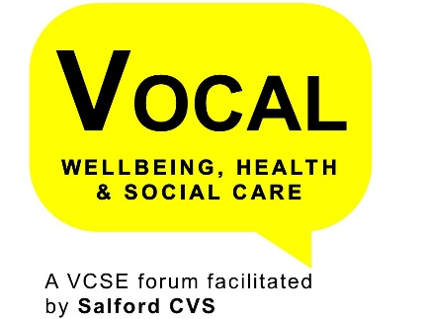
Learning Difficulties and Autism Strategy Board
Following the dissolving of the old partnership boards, Learning Disability has not had a board to provide governance to implementing the strategic priorities.
The Autism Implementation Group, was in place to oversee the National Autism Strategy, but has been poorly attended and failed to attract the correct membership to be able to progress the action plan.
Both Learning Disability & Autism have been under scrutiny as National, Regional and Local priorities. Transforming Care is a National programme of work from NHS England, with a Greater Manchester Board driving the work across all 10 localities. Adult Social Care Transformation programme has Learning Disability as a priority with 4 major areas of work, one of which was the development of the GM LD strategy and the GM Autism strategy will be ready by March 19. And NHS England has names LD & Autism as priority areas for the next 10yr long term plan.
VCSE Representatives
We are looking for a VOCAL representative. In order to be eligible to take up this Representative Opportunity your organisation must be a member of VOCAL; Wellbeing, health and Social Care and attending meetings on a regular basis
Commitment
Meetings will be held on a quarterly basis for 2 hours and it is anticipated that there will be around 2 hrs of reading.
As a VOCAL Representative there is also a requirement that you agree to and sign the VOCAL Representative Protocol, attend VOCAL Reps Meetings (once a quarter) and provide short summary reports for the VOCAL Wellbeing, Health & Care Forum.
This is a great opportunity to influence and shape the way in which health and social care professionals work with and for our local communities.

