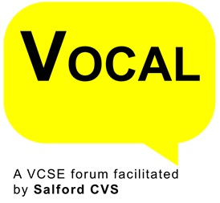
VOCAL Representatives Application Form
About VOCAL
VOCAL brings Voluntary, Community and Social Enterprise (VCSE) organisation in Salford together to ensure that their role in improving the lives of residents in the City is recognised, and that their contribution is valued and supported. It provides a model to enable the VCSE Sector to have a strong voice and influence decision makers whilst providing a process through which representatives have a mandate to speak on behalf of the sector on various strategic partnerships within the City
Aims:-
- To improve the lives of children, young people and families
- To improve health & wellbeing
- To create a cleaner and greener City
- To improve community safety
- To enable a robust, engaged and influential VCSE Sector
- To reduce poverty and inequalities
The structure is made up of the following thematic VCSE forums:-
- Community Safety
- Children, Young People & Families
- Inclusive Communities
- Environmental
- Wellbeing, Health & Care
- Leaders
Name of Applicant
Name of Organisation
Contact Tel No:
Contact E-mail
Member of which VOCAL Forum
Neighbourhoods  Please circle the neighbourhood you are based in. This is the neighbourhood you will be put forward to represent if successful. | - Swinton  - Eccles and Irlam  - Ordsall and Claremont  - Little Hulton and Walkden  - Broughton.
Summary of how you meet the skills requirement of the role, in particular:-
- Communication Skills
- Influencing & Persuading Skills
Summary of how you meet the experience requirement of the role, in particular
- Experience of working/volunteering at a senior level within a VCSE organisation
- Building relationships
- Reading, analysing and summarising complex documents

Reasons for wanting to become a VOCAL Representative
Signature of Applicant

