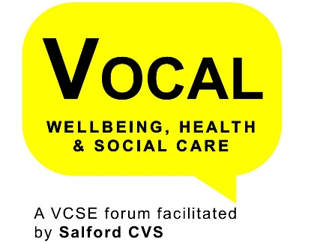**Salford Together Neighbourhood Forums**

Salford Together is developing integrated local teams as part of the transformation of health and social care in Salford. These neighbourhood teams are focussed on supporting people with long term conditions (such as mental health, diabetes and high blood pressure), identifying people who are at risk of developing ill health, addressing the wellbeing needs of individuals and offer people support and preventive care.

The neighbourhood teams consist of a range of health, care and wellbeing professionals including GPs, district nurses, social workers, hospital consultants, pharmacists, and mental health professionals. The teams will also be working closely with a range of organisations in the voluntary, community and social enterprise sector to provide a holistic approach to health and wellbeing in the wider context.

*“By working more closely together, they will aim to join up care better for the people of Salford – placing the person at the centre of everything we do”*

There will be five Neighbourhood Teams – Swinton, Eccles and Irlam, Ordsall and Claremont, Little Hulton and Walkden, and Broughton.



**Health and care neighbourhood forum**

For each of the five areas there will be a Health and care neighbourhood forum which will involve a wide range of organisations to plan, design and deliver neighbourhood services, as well as to identify local need. The vision for the forum is that they will support the Neighbourhood team to

* Deliver care closer to home
* Help people with the most complex, long term health and social care needs
* Prevent those at risk of becoming dependent on services by helping them earlier
* Making the most of skills and resources in Salford Neighbourhoods
* Improve access to GPs and community services including VCSE sector
* Provide a different offer of community and primary care services, through care navigation

**VCSE Representatives**

We are looking for a VOCAL representative. In order to be eligible to take up this Representative Opportunity your organisation must operate in one of the five neighbourhood areas to and must not be one of the Wellbeing Matters Anchor Organisations

Commitment

Initially, the Forums plan to meet on a monthly basis for 2 hours and it is anticipated that there will be around 2 hrs of reading. Meetings will take place in the Neighbourhood and it is planned to provide some development opportunities.

As a VOCAL Representative there is also a requirement that you agree to and sign the VOCAL Representative Protocol, attend VOCAL Reps Meetings (once a quarter) and provide short summary reports for the VOCAL Wellbeing, Health & Care Forum.

Salford Together have agreed to support representation and there will be some ‘backfill’ funding available.

This is a great opportunity to influence and shape the way in which health and social care professionals work with and for our local communities.