Salford CVS
Healthy Schools
Partnership Fund 2025-26
Guidance for Applicants

Summary of the Fund Criteria

- Grants to improve the health and wellbeing of primary school
children in Salford.
  - Up to £5,000 for partnerships with 1 primary school
  - Up to £10,000 for partnerships with 2-3 primary schools
- The fund is only for partnership projects involving at least one Salford primary school and at least one VCSE (voluntary, community and social enterprise) sector organisation
- VCSE Lead Partner turnover: minimum of £10,000 per year
- Closing date for applications:
12:00 noon on Friday 27th June 2025
- Decisions to be made by:
Late mid-late July 2025
- Delivery Period:
1st Sept 2025 – 31st May 2026

Section 1 – About the fund

What is the Healthy Schools Partnership Fund?
The Healthy Schools Partnership Fund is offering grants of up to £10,000 to support partnership projects involving at least one Salford primary school and at least one voluntary, community and social enterprise (VCSE) organisation.
A maximum of 4 project partners may be involved in any one bid.

The fund is looking to support projects that improve children’s health and wellbeing and build links between schools, families, and the wider community. The specific priorities are outlined in more detail under ‘Funding priorities’ (below).
We believe a partnership approach can help achieve positive outcomes and provide mutual benefit for schools and the VCSE sector. For example, schools may gain access to new ideas, approaches, skills, and capacity to support the health and wellbeing of children; while VCSE organisations may be able to utilise school resources such as equipment and additional staff support. A VCSE organisation must be the lead partner for the project.
The Healthy Schools Partnership Fund is supported by Salford ICP (Integrated Care Partnership) as part of Salford CVS’ Third Sector Fund.

Priority outcomes
Children’s health and wellbeing
The Healthy Schools Partnership Fund is looking to support new or existing partnerships between primary schools and VCSE organisations. All proposals must address one or more of the following priority outcomes:

- Improved mental health and wellbeing of children
- Improved physical health and wellbeing of children
- Increased family engagement in school life
- Increased community engagement in school life
- Increased number of children accessing local community assets*

*Examples of community assets include green spaces, historical buildings/landmarks, and community sports clubs.

Makeup of partnerships
- Each partnership must include at least one Salford primary school and at least one VCSE organisation, with a maximum of 4 partners (schools and VCSE organisations) involved in any one bid.
- The lead partner must be a VCSE organisation. If successful, they will be the accountable body for the grant monies.

Who can apply?

All VCSE organisations involved in a partnership must:
- Be a FULL MEMBER of Salford CVS at the time of application. To apply for membership, see: www.salfordcvs.co.uk/membership-0.
- Applications will only be considered from organisations based in Salford or that have a track record of working in Salford.
- Have a track record of supporting children and/or families.

Primary schools:
- Must be based in Salford and work primarily with children who are Salford residents.
- Independent schools are eligible to apply.

Please note: Schools and VCSE organisations may be a named partner in no more than two separate bids to the Healthy Schools Partnership Fund.

What policies / other documentation are required?
All VCSE organisations will be expected to have the following policies in place at the time of application:
- Health and Safety policy
- Equality/Diversity (statement/policy)
- Risk assessments
- Public Liability Insurance (cost can be included in the budget)
- Safeguarding Children policy
- Safeguarding Adults policy (if applicable)
- Volunteering policy (if applicable)

What support is available to applicants?

Support with your application
For feedback on a project idea or draft proposal, or support forming a new partnership, please contact Honor Johnstone, Grant Development Worker, by email at honor.johnstone@salfordcvs.co.uk or phone 07421 312368.

For administrative questions or concerns, please contact the Grants Team at grants@salfordcvs.co.uk or phone 0161 787 7795.

Wider development support
Salford CVS can also offer practical support to VCSE organisations with developing policies, accessing volunteers, and accessing wider funding. For further information, please visit our website at:
www.salfordcvs.co.uk/development-support

Contact the Development Team by phone 0161 787 7795 or email at: office@salfordcvs.co.uk

See our online Safeguarding in Salford resources: www.salfordcvs.co.uk/safeguarding-salford

How to apply
To apply the lead partner must submit a completed application form by 12:00 noon on Friday 27th June 2025.

Complete the application form and submit it by email to grants@salfordcvs.co.uk in WORD format.

How will applications be assessed?

On receipt of applications, Salford CVS will undertake eligibility checks – please see page 3 for the policies and other documentation we require. All applications that are eligible will then be independently scored by a panel consisting of representatives from NHS Salford ICP, a VCSE-sector organisation and Salford CVS. All successful applicants will be required to complete some additional paperwork before an offer letter is issued. Unsuccessful applicants will be provided with a summary of feedback from the assessment panel.

When will we hear the outcome?
All applicants will be informed by email by mid-late July 2025. Unsuccessful applicants will receive a short summary of feedback from the assessment panel.

If successful, when will we receive the grant?
Upon receiving an offer letter from Salford CVS, the lead partner will need to complete and return an ‘Acceptance of Grant Form’ with an invoice for the full grant amount. For organisations that have not received a grant from Salford CVS before (or changed bank account since their last award), we will also require proof of bank details. This can be a scan or photo of a bank statement or paying-in slip.

On receipt of these documents Salford CVS will issue the grant by bank transfer within 5-10 working days. The full grant amount will be paid upfront in line with the ‘Principles of Good Grant Giving.’

How long will we have to spend the grant?
All organisations receiving a grant must complete all activities and spend by 31st May 2026.

How will Salford CVS evaluate our project?
Salford CVS has a three-fold approach to evaluation:

- Assessing impact – the difference your project made in words, numbers, stories, quotes and photos
- Gathering learning – what you have learned as you have delivered the project, how you have developed and what you would do differently next time
- Providing assurance – demonstrating good management of public money

In practical terms this will mean providing feedback to Salford CVS in the shape of a simple report form when your project is completed. We may also select your project for a monitoring visit (in person or remotely) to help us understand how you are getting on and if you’re in need of any support.

As guardians of public money Salford CVS requires all funded organisations to keep receipts for all project spend. Salford CVS undertakes a number of spot-audits every year and you may be asked to provide evidence of your spending.

With your help in providing simple feedback, we can demonstrate how grants and investments can make a real difference to the health and wellbeing of young people. This is important in helping us report back to our funders / wider partners and helps secure investment in our sector over the years to come.

Any further questions?
Please contact the Grants Team by phone 0161 787 7795 or email at: grants@salfordcvs.co.uk
_______________________________________________________________________________________

Section 2 – Completing the Application Form

Section A) Who is involved?
About the lead partner

Question 1a) – Please give the details of the main and secondary grant contacts at the lead partner. The named Primary Contact will be the first point of contact for all communication relating to the application and any successful grant award. The secondary grant contact will only be contacted if we have difficulty reaching the main contact. One contact must be a senior member of staff (or both contacts must be members of the management committee if an unincorporated organisation/community group).

Question 2a) – Please state the official name of the lead partner organisation (must be a VCSE sector organisation that is a full member of Salford CVS) for this project. The lead organisation will be the first point of contact and oversee project delivery and evaluation if a grant is awarded. In terms of financial management, the lead organisation will be the accountable body.

Question 3a) – Please provide the registered address of the lead organisation.

Question 4a) – Please give the lead organisation’s turnover for the last full financial year.

Question 5a) – Please tell us how the lead organisation is constituted. Examples are provided below:
- Unincorporated Association or Community Group
- Company Limited by Guarantee
- Registered Charity
- Charitable Incorporated Organisation
- Community Interest Company
- Community Benefit Society
- Cooperative Society
- Other (give details)
Please note:
- Not-for-profit companies limited by guarantee must have an ‘asset lock’ to prevent the transfer of assets to individuals.
- Some charities might also be a company limited by guarantee.

Question 6a) – Please give the organisation number for the lead partner. Unincorporated associations will not have an organisation number.

Question 7a) – Please provide links to the lead partner’s website and social media pages.

Question 8a) – We expect all organisations to have relevant policies in place at the time of application. Please note that Public Liability Insurance costs can form an element of your bid. See the ‘What support is available to applicants?’ section above if you need advice or support on developing policies.

Please note that you will need to submit copies of the following documents along with your application:
- Safeguarding Adults Policy (only if applicable to your project)
- Safeguarding Children Policy

Question 9a) – Please confirm that staff and/or volunteers who will be involved in the project are appropriately DBS checked. As a registered DBS Umbrella Body, Salford CVS can help groups and organisations through the process of applying for DBS checks on staff and volunteers. For more information visit https://www.salfordcvs.co.uk/dbs-checks or call the office on 0161 787 7795.

About Partner Two
Please provide the details of Partner Two. If Partner 2 is a Salford primary school, complete question 3b only.

About Partner Three and About Partner Four
If applicable, provide the details of Partner Three and Partner Four. As above, some questions are not relevant to primary school partners.

Please note: all information below will be shared with the assessment panel

Section B) About the project
Project summary

Question 11) – Please give your project a memorable name. This will help us identify the project should your application be successful.

Question 12) – Please give a short description of your project that sums up what you plan to do and why (140 characters max). This will be used in our publicity and when publishing data about grant awards on our website. The character count can be accessed in the status bar in Word.

Question 13) – Please give your proposed project start and finish dates. Realistically, the earliest that funded projects can commence is 1st September 2025. Projects must be complete by 31st May 2026.
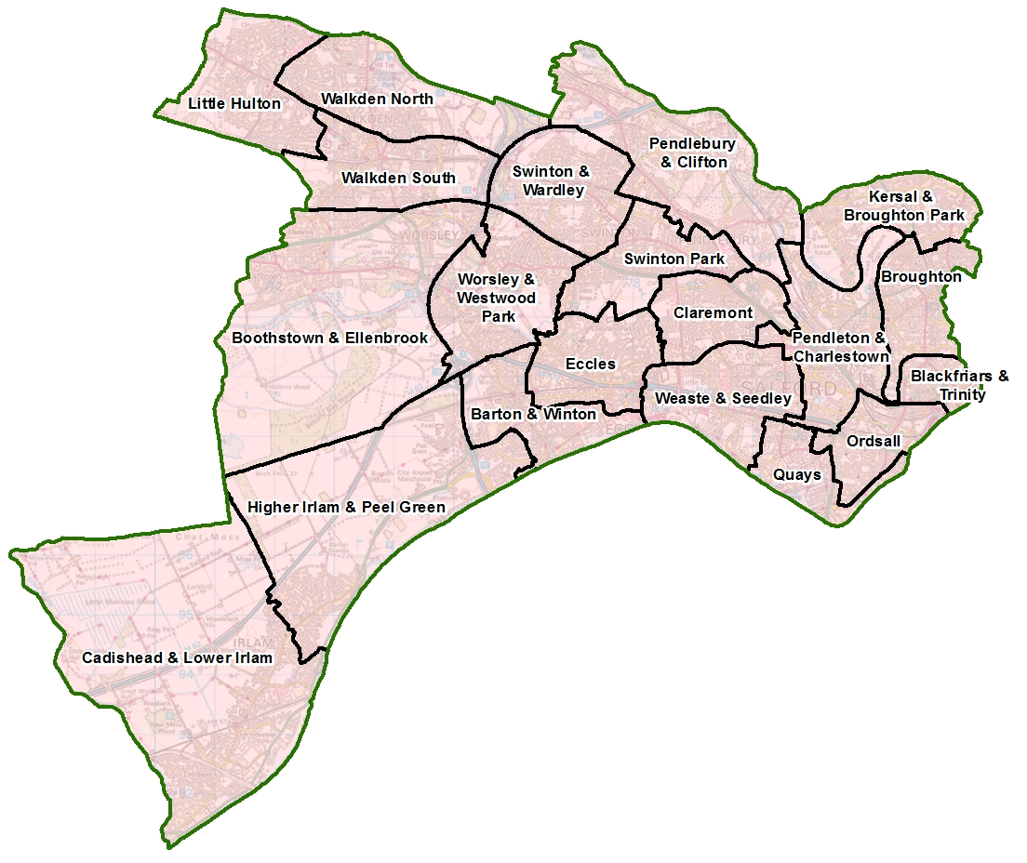
Question 14) – Please indicate the areas of Salford which will receive support from your project. See the following map showing Salford’s new ward boundaries.

Question 15) – If your project is delivered from a single location (e.g. a school or community garden) please provide a postcode for this.
If your activity will happen at more than one location, please provide all the postcodes. If this proves too difficult or isn’t applicable, please give details.

About the partnership
Question 16) – We want to understand if this is a new or existing partnership, and, if applicable, how you have worked together previously.

Question 17) – Please explain how each organisation will be involved in delivering and evaluating the project. E.g. what are the roles and responsibilities of each partner? When, where, and how often will you meet?

Project detail
Question 18) – Please describe the issues you want to address and any evidence you have of the need. Examples of evidence include demographic data, numbers/statistics, and/or insights from conversations or consultation with staff, pupils, and/or parents.

Question 19) – Please tell us know many sessions your organisation will run in total across the project.

Question 20) – Please provide all practical details of the project. This paints a picture for the panel of what will happen at the activities and how the project will be delivered. If relevant, mention how staff/volunteers are qualified.

Question 21) – In the left-hand column, please explain how the activities will achieve your chosen priority outcomes (A-E). In other words, why are the activities you have chosen the right approach to achieve this outcome?

In the right-hand column, we want you to tell us which tools or methods you will use to measure or assess whether the project has been successful. For example, pre- and post-project surveys, interviews with staff, pupils and/or parents, Outcomes Stars, pupil journals, pupil voice, etc.

NB: Your project must address at least one priority outcome. Please only complete the sections that are relevant to your project – for example, if your project addresses outcomes A and E, you would not write in the boxes underneath outcomes B, C, or D. For support completing this question contact the Grants Team at grants@salfordcvs.co.uk or call 0161 787 7795.

Questions 22-24) – Please provide information about the number of children and families at each school.

Question 25) – Please tell us the age range of the children who will take part in the project.

Question 26) – It is a good idea to discuss your project idea with the nurses at the school(s) to ensure the activities you have chosen are suitable for the children involved. If yes, please provide their names. If no, please tell us why, and how you know the activities are suitable.

Question 27) – As leading member of the Social Value Alliance, Salford CVS wants to ensure that as much of its grant monies as possible are spent in Salford, ideally through buying goods and services from local independent businesses or fellow VCSE sector organisations. This helps to support our local economy.

If possible please try and avoid large chains or corporations, and especially Amazon who have been identified as the worst company for aggressive tax avoidance which deprives our government of much-needed funds for schools, hospitals, local services etc.

Also, while your project may focus on particular health and wellbeing outcomes, how you deliver it might provide wider benefits for Salford's people, economy and environment. For example, you might be supporting the natural environment through a tree planting project; or you might provide volunteering or training opportunities that boost people’s chance of employment.

These are all great examples of added social value where you can make positive change by applying creative ideas from your project team.

Question 28) – Please explain how you will try to ensure the benefits of the project continue beyond the grant period. For example, a growing project might result in a garden on the school site that could benefit pupils for many years; it might be possible to continue supporting pupils to access local community assets; or, parents/volunteers from the local community might help to sustain the project.

Section D) About the money

Please note the maximum amount a partnership can apply for depends on the number of school partners involved in the project.
- Partnerships with 1 primary school may apply for up to £5,000
- Partnerships with 2-3 primary schools may apply for up to £10,000

Question 29) – Please give an overview of what the project will cost by describing each item and breaking down your calculation so we can see how you’ve arrived at the cost for each item. See some examples below.

Example 1
Acceptable: Project Support Worker - 5hrs/wk @ £18.75ph x 10 wks = £937.50
Not acceptable: Staffing - £937.50

Example 2
Acceptable: Venue hire – 5hrs/wk @ £30ph x 10 weeks = £1,500
Not acceptable: Venue hire – £1,500

The item cost figure may be the same as your requested amount. If you have other sources of money, it may be that you’re only looking for a contribution (see the example below).

Description of item | Breakdown of calculations | Item cost | Amount requested
Project Support Worker | 5hrs/wk @ £18.75ph x 10 wks | £937.50 | £500

Therefore, the project’s total cost may be more than the amount you are requesting from this fund. If that is the case, please include the other sources of funding which will support this project and whether the money has been secured or an application is pending. Such match funding is desirable but not essential.

Please enclose
The Safeguarding Children policies of every VCSE partner involved in the bid (and Safeguarding Adults if applicable). Schools do not need to provide policies.

Declaration
Please confirm that the project lead from each partner has read and understood the Terms and Conditions of this grant by typing their name, job title and the date.

