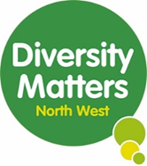

**Consultant Brief: Community Research Training Package Development.**

**DMNW Background**

DMNW started in 2007. We are a medium sized, award winning, charity based in Tameside, at the Hyde Healthy Living Centre, from where we host and co-ordinate regular services and activities for the local community, with the help of our 60 bilingual volunteers. We have a board of 8 trustees, representative of the local community and 9 staff members. Taking a ‘grow our own’ approach, we also have a small pool of casual workers, providing development opportunities and a first step into employment for many of the women we support from racialised communities.

Our services support, empower and enable women who experience a multitude of challenges and barriers to participation and engagement, including racial and gender discrimination and oppression. Our USP is our experience and knowledge of supporting racially minoritised residents to achieve positive outcomes that impact on their lives and their communities.

**We aim to:**

* Tackle issues that impact on people’s health and well-being
* Provide targeted support for disadvantaged and excluded groups.
* Promote improved community cohesion.

**Our Vision**

All women are equal in society, fulfilling their potential, and living their best life.

**Our Mission Statement**

Diversity Matters exists to challenge inequalities in health and wellbeing and to help predominantly, but not exclusively, South Asian women to develop their potential. We do this by delivering our own services, and through partnership with others. We provide a safe space in which women are supported to empower themselves, and each other.

**Our Values**

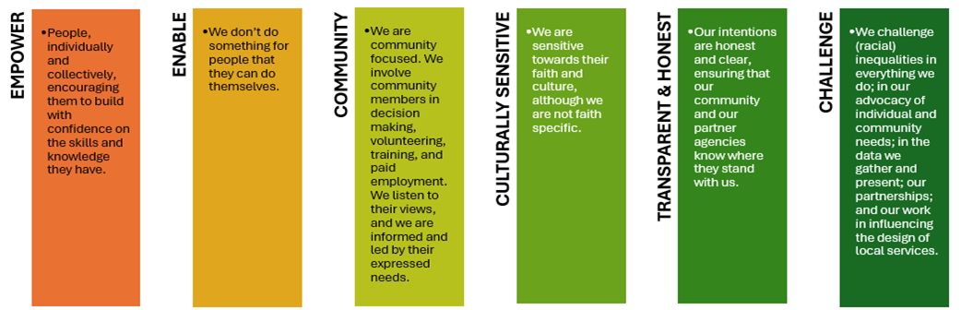

**Our Core Areas of Work**

We have 3 main areas of work which are:

1) Community Health Improvement

2) Women’s Learning and Development and

3) Support For South Asian Women In Crisis.

Many of our service users who engage with us have multiple complex support needs including mental health issues, isolation, and loneliness. This has often resulted from delayed or lack of opportunities to socialise outside the domestic space and integrate into society. By offering localised provisions, removing barriers or criteria that restrict engagement, and working with partners, we can engage with people soon after they move into the area, enabling greater integration into society, reducing the impact of isolation and poor mental well-being, so that they can take control and live their best life.

We work holistically with women, predominantly but not exclusively South Asian communities, to support and empower them to identify their needs, build their confidence and develop the skills for future employment. We work alongside the local community and service providers to reduce barriers for women experiencing racial inequalities, so that can access the services they need, and the opportunities which will allow them to progress, ultimately supporting them to fulfil their potential

**Our Strategic Objectives**

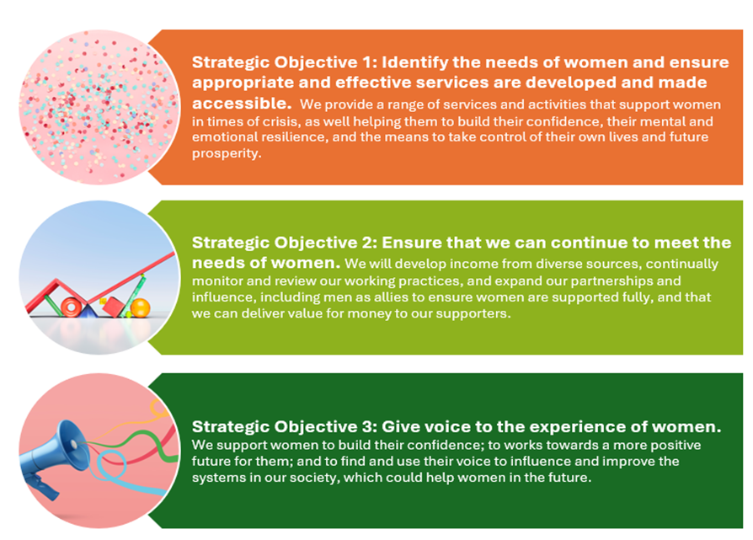

**Background to the need for this consultancy**

DMNW is the legacy project of the Asian Healthy Living Centre, a health funded initiative to empower local people and improve health and wellbeing. As such we have a track record of 18 years of engaging and involving local racially minoritised communities in research and consultation, enabling their voices to be heard and influence local policies and strategies. Examples include:

Joint project with Manchester Metropolitan University in 2016 to train and develop local researchers using participatory appraisal tools. Outcomes included building project capacity, increasing confidence and upskilling local women for future employment.

2019 Active Communities Network Girls consultation on sports activities and barriers to participation. Outcomes included the development of coproduced young girls sports club.

Consultation post Covid looking at impact of COVID on young people and barriers to accessing youth and community activity, commissioned by TMBC.

Barriers to Accessing Information Research report for TMBC Inequalities reference group (2021). Consultation with Tameside racially minoritised communities on barriers to accessing information about local services during COVID 19 pandemic. Results were presented to TMBC Inequalities Reference Group and formed the basis of ongoing actions to increase access and remove barriers.

Women Supporting Women Peer Mentoring consultation report (2021) DMNW community consultation with racially minoritised women to establish ongoing need for project supporting women in crisis, experiencing Domestic Abuse and or poor mental health. Resulted in DMNW updating the project and instrumental in securing £320,000 grant funding from the Home Office Violence Against Women and Girls Strategy. We worked with commissioners to involve women with lived experience in Survivors group. Resulting in 50% of group membership women experiencing racial inequalities.

Covid Community Consultation Report 2021: DMNW community consultation looking at impact of Covid 19 pandemic on women from local Bangladeshi and Pakistani communities, with a particular focus on Learning, training and employment aspirations. Results used to shape DMNW Training Learning and Employability work and secure £ £279,293 lottery funding. A survey of 229 women who accessed the project showed that 100% reported increased wellbeing, 100% reported increase in employment readiness 70% progressed in to further learning and training, 21% gained employment.

2023 Tameside Racial Inequalities Project. DMNW was commission to lead on community consultation with racially minoritised communities across Tameside to guide implementation of the GM Racial Inequalities Strategy in Tameside. The report highlighted recommendations for 6 areas including VSCE sector, policing, health, job centres, Tameside Council and GP practices which has now been picked up by the Tameside Health and Wellbeing board.

2023 Women Supporting Women Consultation Report. Community consultation and report was commissioned by Tameside Council’s Strategic Domestic Abuse Manager, as part of the Population Health remit as a specific piece of work to gauge the needs of women from racially minoritised community. The results were used to shape DA services in the Borough.

Smokeless / Niche Tobacco (NT):

2011 Tameside NT Project, delivered with Pennine Care NHS, Tameside and Glossop NHS and TMBC. Delivered 2 community consultations either side of a community led and co-produced training offer. Outcomes included a doubling (100% increase) in individuals registering with Hyde Smoke Free Service and a co produced bilingual NT Leaflet.

2024 TMBC Public Health commissioned DMNW to deliver community-led and co-produced consultation. Providing insight into NT use amongst racially minoritised communities to inform the development of tobacco free work. The final report highlighted recommendations around engagement, reach, barriers to access and developing inclusive communication methods. As a result the service has been rebranded ‘tobacco free instead of stop smoking service and multi-lingual resources are being produced.

We now want to build on our work and develop a formal Community Researcher training package to embed and enhance the skills we have developed delivering the above work. The package will be used to:

* deliver in-house Community Researcher training to staff and volunteers
* Train more of our staff to deliver the training
* be an addition to our current external training offer to partner organisation as part of our income generation strategy.

**Support needed**

You will consult and work alongside internal stakeholders to co-design and produce:

1. a Community Researcher training package that reflects our values
2. content that is culturally appropriate, accessible, practical and adaptable. The packages will be developed in English; however, all content should be easily translatable, and consideration should be given to a multi-lingual delivery method in developing the training. DMNW staff and volunteers have expertise in this area to share.
3. a train the trainer package which includes all facilitation materials (slides), handbooks, exercises / templates.

**Requirements for the consultant**

* Experience of working within the VCSE sector.
* Experience of working with racially minoritised groups.
* Has experience of and track record of developing community based and co-produced training and learning.
* Community research experience
* Experience of conducting, facilitating and reporting on workshops.
* Any workshops must be delivered face to face. Any prep work / follow up meetings can be done remotely over zoom or teams.

**Available Budget**

This work will be funded by the National Institute of Health Research and the available budget is: £5,000. This work is funded by the National Institute of Health Research (NIHR)

**Indicative Timescale**

|  |  |
| --- | --- |
| August 2025 to October 2025 |  |
| Call for Proposals | 29th July 2025 |
| Deadline for responses | 17th August 2025 |
| Interviews with shortlisted consultants | Week commencing 25th August 2025 |
| Contract start date | 1st September 2025 |
| Contract end date | By December 2025 (latest) |

Your response should cover the following areas:

* Your experience and track record
* An outline of how you plan to deliver the brief
* Your costings
* Details of 2 referees you have previously worked for as a consultant

Please send responses to the brief to [lesley@diversitymattersnw.org.uk](mailto:lesley@diversitymattersnw.org.uk)