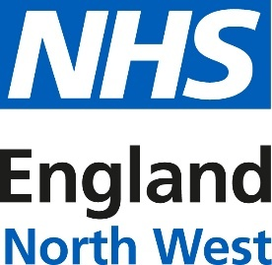
Version 1: August 2025

NHS England – North West
Communications toolkit: Winter resource pack

Introduction:
This winter communications resource pack has been produced by NHS England - North West, with thanks to colleagues at North West Ambulance Service, NHS Lancashire and South Cumbria, NHS Greater Manchester and NHS Cheshire and Merseyside, Lancashire and South Cumbria NHS Foundation Trust and Blackpool Teaching Hospitals NHS Foundation Trust for their work helping to bring this together.
Our aim is to support communications teams across the North West region to deliver regular and consistent communications that will help manage demand for urgent and emergency care services by bringing local, regional and national resources in one place for use from September 2025 to March/April 2026.
Evaluation metrics could include impacts on service or vaccine uptake, 111 contacts and A&E non-urgent attendance, as well as content reach and engagement.
All resources in this pack have been generically NHS branded for all organisations to use and can be used at any time to complement your own organisation’s assets and planned activity. To ensure content meets accessibility requirements, resources include alternative (ALT) text and subtitles, where applicable.
The table below sets out the monthly themes that NHS England - North West will be working to this winter, alongside our wider UEC comms work. You can choose whether to align with our timings or work to your own timetable:
Sept | Oct | Nov | Dec | Jan | Feb | March
Falls  CVD | Mental Health - crisis | Self care / managing long-term conditions  Pharmacy | Repeat prescriptions/ NHS App  111/ festive signposting | Mental health - wellbeing | Discharge  Keeping well in hospital | Prevention
Key Dates:
NHSE NW, NWAS and ICB communications teams will also use the content to support the following awareness days/weeks:
Event | Date
Know Your Numbers Week (blood pressure/ CVD) | 8-14 September
Falls Awareness Week | 15-19 September
World Pharmacists Day | 25 September
World Mental Health Day | 10 October
Ask Your Pharmacist Week | 3-9 November
Self-care Week | 17-23 November
Time to Talk Day (mental health) | 6 February

How you can get involved:

You can help by sharing information on your website, social media channels and in your newsletter (if you have one) as well as issuing any press releases that are relevant to your work to local media. You could consider localising with your own spokespeople, data and images.

We’d love it if you could look out for posts on our social media channels and share them to your followers.

If you don’t already follow us, you'll find us here:
- Facebook: facebook.com/NHSENGLANDNW/
- X (previously Twitter): x.com/NHSNW
- Instagram: instagram.com/nhsenglandnw/

This toolkit contains assets for the following themes:
1. Prevention
2. NHS Health Checks
3. Vaccinations
4. Self care
5. NHS 111
6. Repeat Prescriptions
7. Pharmacy
8. NHS App
9. Mental health
10. Long term health conditions
11. Pressures
12. Falls
13. Keeping well in hospital
14. Discharges

Click on the theme link above to take you to the relevant section in this pack.

To return to the top of this document - click ‘Ctrl + Home’

1. Prevention

NHS Community Pharmacy Blood pressure check service:

The NHS Community Pharmacy Blood Pressure Check service helps to identify people over the age of 40 who have previously not been diagnosed with hypertension (high blood pressure) and if found or suspected, refers them for appropriate management.

It also helps promote healthy behaviours to service users and where required allows for ad hoc clinic and ambulatory blood pressure measurements at the request of general practice.

Since October 2021, pharmacies in the North West have provided over 950,000 blood pressure checks, identifying over 102,000 people with high or very high blood pressure. Those patients have been supported to receive appropriate onward care, testing and diagnosis, helping to prevent potential strokes and heart attacks.

Our aim is to increase awareness: improve public awareness about the importance of knowing blood pressure (BP) numbers, encourage BP checks and increase BP checks at local pharmacies.

National campaign materials, including a communications toolkit and assets can be found here: Hypertension (High Blood Pressure) | Help Us Help You - Heart Attack, Stroke and Hypertension | Campaign Resource Centre

We will also link this to Know Your Numbers week which runs from 8 – 14 September.
Key messages:
- Regular blood pressure checks can save your life – early detection prevents serious complications.
- Do you know your blood pressure numbers? If do not have an existing diagnosis of high blood pressure. Get checked today at your local pharmacy.
- Get your blood pressure checked at a pharmacy if you think you might be at risk of having high blood pressure and/or you’re aged 40 or over and have not had your blood pressure checked for more than 5 years.
- If you are 40 or over, take up the invite of the free NHS Health Check to understand your risk for heart disease, diabetes, kidney disease, and stroke. Early detection and lifestyle changes can significantly reduce your risk.
- Managing your blood pressure at home? Share your readings with your GP for better control and health outcomes.
- Over 90% of pharmacies in the region are providing this service.

Newsletter/Website copy:

Get your blood pressure checked

High blood pressure is the largest known single modifiable risk factor for cardiovascular disease (CVD) which can lead to heart attacks, strokes and dementia.

CVD causes 1 in 4 deaths in England - around one death every four minutes and is a leading cause of disability. As the condition usually has no symptoms, it is estimated that 4.2 million people in England have undiagnosed high blood pressure. The only way to know if you have high blood pressure is to get a blood pressure test, which is a free, simple, non-invasive procedure. If you're aged 40 and over, you can get a free blood pressure check at your local participating pharmacy, without needing to book in advance.

Find a pharmacy that offers free blood pressure checks near you by searching “pharmacy blood pressure check” or visit the NHS website directly here.

Press release template:
Do you know your numbers? Get a blood pressure check this Know Your Numbers! Week and help prevent a heart attack or stroke
<clinician> is urging people to get their blood pressure checked to help prevent killer conditions such as heart attacks and strokes – and save lives.
<spokesperson> has spoken out for national Know Your Numbers! Week (8-14 September) to encourage people of all ages to regularly monitor their blood pressure and get high blood pressure under control.
The North West has the highest number of people with GP recorded hypertension in England, but it’s thought many more could have high blood pressure without realising it.
Know Your Numbers! Week, an annual initiative by Blood Pressure UK, aims to raise awareness of the importance of managing blood pressure and encourage those at risk to get their blood pressure checked regularly.
High blood pressure (hypertension) is a major risk factor for cardiovascular disease (CVD) increasing the risk of heart attacks, stroke and diabetes, and is a leading cause of death and disability in the North West. It’s estimated that improving detection and treatment of hypertension in the North West could prevent 910 heart attacks and 1,358 strokes over a three-year period.
<spokesperson> said: “The early detection of high blood pressure gives people a better chance of preventing them from have a stroke or heart attack and potentially developing long term health problems. Knowing your numbers could help you manage potential risks and save your life.
“The only way to find out if your blood pressure is high is to have your blood pressure tested. High blood pressure rarely has noticeable symptoms, but if untreated, it increases your risk of heart attack and stroke.
“Checking your blood pressure is easy to do. If you have a blood pressure machine at home you can do it yourself. Just take readings morning and evening for a week, work out the average, and send it to your GP practice Alternatively, you get a free blood pressure check, at your pharmacy, GP surgery, at many workplaces, or as part of your NHS Health Check.”
It’s recommended that healthy adults 40 to 74 years of age have their blood pressure tested at least every five years. People who are near the threshold for high blood pressure may be asked to monitor it more often.
GPs and community pharmacists across the North West are leading the fight against common conditions that cause cardiovascular disease (CVD) and stroke, by encouraging self-awareness and lifestyle changes. This includes encouraging communities to exercise, eat well, drink within safe limits and stop smoking.
Community pharmacists are trained to carry out blood pressure checks, analyse the results and refer patients with high blood pressure to their GP for further checks and advice on lifestyle changes.
6 top tips to reduce your blood pressure:
- Regular physical activity – Try to do some moderate-intensity activity every day and build up to at least 150 minutes per week, in bouts of 10 minutes or more.
- Keep to a healthy weight – For some people, losing weight is all they need to do to get their blood pressure down to a normal level.
- Eat a healthy balanced diet – Use the Eatwell plate to guide the proportions you include from each food group. In particular, include a variety of fruit and vegetables.
- Cut down on salt – Don’t cook with salt or add any to your food at the table, and cut down on processed foods, which contain a lot of salt.
- Don’t drink too much – If you drink alcohol, stick within the recommended limits. No more than 3–4 units a day for men and no more than 2–3 for women.
- Take medications as prescribed – Most people will need to take more than one type of medicine to control their blood pressure. Don’t stop taking your medication without consulting with your GP first.

Social media and other materials:

National Assets
Blood Pressure Check:  This all partner toolkit can be used by all partners who are supporting and encouraging people 40+ to get their blood pressure checked in pharmacy and includes social media, posters and digital screens (inc. editable versions) email signatures, and a communications toolkit to help share the campaign with colleagues, customers and patients | All Partner Toolkit | Hypertension - Blood Pressure Check
Regional Assets
 | To follow

2. NHS Health Checks
Key messages:
- The NHS Health Check is a free check-up of overall health and is offered to everyone aged 40 to 74, who don’t have a pre-existing health condition, every five years.
- Your general practice or local council should proactively invite you to attend for a health check.
- If you think you are eligible but have not been invited, contact your GP surgery to find out if they offer NHS Health Checks or contact your local council to find out where you can get an NHS Health Check in your area.
- The health check will look at and check risk factors of heart disease, diabetes, kidney disease and stroke.
- During the check-up you'll discuss how to reduce your risk of these conditions.
- Your NHS Health Check will be done by a healthcare professional. This will usually be a nurse, but it could also be a doctor, pharmacist or healthcare assistant.
- The check takes about 20-30 minutes and usually includes:
  - measuring your height and weight
  - measuring your waist
  - a blood pressure test
  - a cholesterol test, and possibly a blood sugar level test, which is usually a finger-prick blood test. You may be asked to have a blood test at or before the NHS Health Check
- You’ll also be asked some questions about your health including:
  - whether any of your close relatives have had any medical conditions
  - if you smoke, and how much
  - if you drink alcohol, and how much
  - how much physical activity you do
  - Age, gender and ethnicity will also be recorded.

Newsletter/Website copy:
What is an NHS Health Check?
The NHS Health Check is a free check-up of your overall health. If you’re aged 40 to 74 and do not have a pre-existing health condition, you should be invited to an NHS Health Check by your GP or local council every five years. It can tell you whether you're at higher risk of getting certain health problems, such as:
- heart disease
- diabetes
- kidney disease
- stroke
During the check-up you'll discuss how to reduce your risk of these conditions.

If you’re aged over 65, you’ll also be told about symptoms of dementia to look out for. If you think you are eligible but have not been invited, contact your GP surgery to find out if they offer NHS Health Checks or contact your local council to find out where you can get an NHS Health Check in your area.
How do I get an NHS Health Check?
If you’re aged 40 to 74 and do not have a pre-existing health condition, you should be invited to an NHS Health Check by your GP or local council every 5 years.
If you think you are eligible but have not been invited, contact your GP surgery to find out if they offer NHS Health Checks or contact your local council to find out where you can get an NHS Health Check in your area.
What happens at an NHS Health Check?
Your NHS Health Check will be done by a healthcare professional. This will usually be a nurse, but it could also be a doctor, pharmacist or healthcare assistant.
The check takes about 20-30 minutes and usually includes:
- measuring your height and weight
- measuring your waist
- a blood pressure test
- a cholesterol test, and possibly a blood sugar level test, which is usually a finger-prick blood test. You may be asked to have a blood test at or before the NHS Health Check
You’ll also be asked some questions about your health including:
- whether any of your close relatives have had any medical conditions
- if you smoke, and how much
- if you drink alcohol, and how much
- how much physical activity you do
Your age, gender and ethnicity will also be recorded.
Your NHS Health Check results
You'll usually be told your NHS Health Check results during the appointment.
You'll be given your cardiovascular risk score of developing a heart or circulation problem, such as heart disease, stroke, type 2 diabetes or kidney disease, over the next 10 years.
The healthcare professional may describe this risk score as low, moderate or high.
Everybody's cardiovascular risk rises with age, so the next time you have an NHS Health Check your risk score may be higher, even if your test results are the same.

There are some things about your risk which you cannot change, such as your age, ethnicity and family history. But the most important factors in your risk score (such as smoking, your cholesterol level and blood pressure) can be changed.
Your NHS Health Check results should also be broken down into:
- your body mass index (BMI) score
- your blood pressure
- your cholesterol levels
- your alcohol use score
- your physical activity assessment result
- your diabetes risk assessment
At the end of your NHS Health Check, you'll have the chance to discuss your results and how to improve your scores, including where you can get support.
This could include talking about how to:
- improve your diet
- increase the amount of exercise you do
- lose weight
- stop smoking
- reduce the amount of salt in your diet
- reduce your alcohol intake
- reduce your cholesterol
You may also be referred to local services, such as stop smoking and physical activity services, to help you make any changes.
Benefits of the NHS Health Check
The NHS Health Check aims to lower your risk of getting conditions that affect the heart and blood vessels, such as heart disease, stroke and kidney disease. Many of the warning signs for these conditions, such as high blood pressure and high cholesterol, do not have symptoms.
The NHS Health Check helps you find out if you are at risk of getting these conditions so you can take action to improve your health. This could include making lifestyle changes or taking medicines.

3. Vaccinations
Increasing uptake of routine vaccinations is an important part of the Urgent and Emergency Care plan. This includes increasing uptake of routine childhood immunisations through to winter vaccines like flu and maternal vaccines like pertussis (whooping cough). There are specific eligibility groups for each vaccine.
Childhood vaccines
There are national assets available for childhood immunisations, linked below.
Winter vaccines

During the winter period, NHS England - North West will be delivering a paid for marketing campaign that aims to increase uptake of winter vaccinations in key groups.

- Flu
  - Pregnant women
  - All children aged 2 or 3 years on 31 August 2025
  - Those aged 18 years to under 65 years in clinical risk groups
  - Health and social care workers

- COVID-19
  - Adults aged 75 years and over
  - Residents in care homes for older adults
  - Individuals who are immunosuppressed aged 6 months and over
There will be national assets available for each cohort, as well as regionally produced materials, which will be shared separately and added to this toolkit throughout the winter period.

Maternal vaccines
The NHS offers pregnant women vaccinations that help protect them and their babies during and after pregnancy. RSV and whooping cough are offered year-round. The flu vaccine is offered to women pregnant during the flu season and they are one of the key cohorts for vaccination.

Vaccine | When is it offered
Whooping cough (pertussis) vaccine | Offered in every pregnancy, around the time of the mid-pregnancy scan (usually 20 weeks) and ideally before 32 weeks.  It may be given from week 16 up to the time a woman gives birth. It may be less effective if given close to when the baby is born.  Women can also receive the vaccine after delivery, for up to 8 weeks until their baby is old enough to get their first dose. This can help protect the mother from pertussis, reducing the chance that their baby will be exposed to the infection.
RSV vaccine | Offered in every pregnancy, from 28 weeks and ideally around the time of the 28-week antenatal appointment.  This was a new vaccine programme introduced on 1 September 2024.
Flu vaccine | During flu season at any point in pregnancy.
The links below will take you to the campaign resource centre where national communications toolkits and assets are available for download.
National Assets
Maternal vaccines – CRC assets | Maternal vaccinations (RSV, pertussis and flu) | Vaccinations | Campaign Resource Centre
Children’s Imms – CRC assets | Childhood Vaccination 2022 | Vaccinations | Campaign Resource Centre
Winter vaccines – CRC assets | ‘Get vaccinated, stay strong’ coming soon
Community Pharmacy vaccinations: RSV & Pertussis. Assets include posters and digital screens | campaignresources.dhsc.gov.uk/campaigns/vaccinations/rsv-vaccinations/community-pharmacy-vaccinations-rsv-pertussis/  RSV Vaccinations | Vaccinations | Campaign Resource Centre
HPV vaccinations | HPV Vaccination | Vaccinations | Campaign Resource Centre
Regional Assets
Body text/ALT text | Thumbnail/link
Pharmacist Grace reminds us to protect ourselves and others this winter 💉  Community pharmacies offer seasonal flu and Covid vaccinations:  ✅ Easy to book  ✅ No need to visit your GP  ✅ Local and convenient  Ask at your local pharmacy today ➡️nhs.uk/service-search/pharmacy/find-a-pharmacy/ | Video: Pharmacist Grace talking about getting vaccinated at a pharmacy:  Grace – vaccination services.mp4 - Google Drive
North West Deputy Chief Midwife tells us how important it is for pregnant women to get vaccinated against whooping cough, to protect themselves and their baby.  If you’re pregnant, speak to your midwife or GP about the whooping cough vaccine.  nhs.uk/pregnancy/keeping-well/vaccinations/  Or  Whooping cough can be very serious for young babies.  If you’re pregnant, you can help protect your baby by getting vaccinated ideally from 16 weeks up to 32 weeks pregnant.  Speak to your midwife or GP practice.  nhs.uk/pregnancy/keeping-well/vaccinations/ | Video of Michelle Waterfall, Deputy Chief Midwife at NHS England North West
RSV vaccine in pregnancy  The RSV vaccine in pregnancy is the best way to protect your baby and reduce the risk of them becoming seriously unwell during the first few months of their life.  Speak to your midwife about the vaccine today.  nhs.uk/pregnancy/keeping-well/vaccinations/ | Video of Dr Teresa Kelly, Consultant Obstetrician at St Mary’s Hospital in Manchester
Are you or someone you love at higher risk of flu? 🦠  This winter, protect yourself and your loved ones—get your flu vaccine! 💉  Join Becky, who suffers from asthma, as she gets her flu vaccine to help protect her health this winter.  #Vaccines #Vaccinations #GetWinterStrong | Video: Day in the life flu vaccine: https://future.nhs.uk/NorthWest_UECComms/view?objectId=256582629
Are you eligible for the flu vaccine? 💉  If so, now’s the perfect time to prioritise your health and get vaccinated!  Stay protected against #flu this winter – 📅 book your vaccine or find out more here nhs.uk/nhs-services/vaccination-and-booking-services/book-flu-vaccination/  #StayWellThisWinter #Vaccinations #flu | Video: A&E doc – flu vaccine: https://future.nhs.uk/NorthWest_UECComms/view?objectId=256583845
Protect your baby today from RSV🤰 🤔  Respiratory syncytial virus is a highly contagious virus that can be caught by most children under RSV can lead to serious illnesses like pneumonia and bronchiolitis and causes 20 –30 infant deaths every year in England. 💉  If you are pregnant, the best way you can protect your baby is by having a vaccination from 28 weeks of pregnancy.  The RSV vaccine passes on protection to your baby to protect them in the first few months of life.  📞Reach out to your maternity service or general practice team today to get your FREE RSV vaccine.  #RSV #Vaccines | Video: Day in the life – RSV vaccine: https://future.nhs.uk/NorthWest_UECComms/view?objectId=256584613
Stay protected this winter 🛡️ if you're eligible, protect yourself and your loved ones by getting vaccinated against these key illnesses:  🌡️ #Flu  💉 #COVID19  🤧 #RSV  🤱 #WhoopingCough  🎄 Don’t wait, book your COVID-19 and flu vaccination appointments on the NHS online booking system, NHS App, or by calling 119!  Act now to protect yourself and those around you this winter!  Book your vaccination today or find a walk-in clinic near you at: nhs.uk/nhs-services/vaccination-and-booking-services/ | Podcast – importance of vaccines: https://future.nhs.uk/NorthWest_UECComms/view?objectId=256583173

Proposed media release schedule - vaccinations:
Please note, the dates below are iterative and will be subject to change. Template releases will be shared in the weekly regional communications bulletin for ICB and Trust comms teams closer to the time of publishing.
Date | Title | Vaccine programme
August | Back to school – childhood imms | Childhood imms
August | Going to a festival? Make sure immunisations are up to date. | Childhood imms – specifically MMR / HPV
Mid-August | Launch of flu season | Winter vaccinations – flu for all eligible cohorts
Mid / end August | Flu nasal spray for children | Winter vaccinations – child flu
Early September | Prep for flu vaccination programme and opening of NBS. | Winter vaccinations – flu for all eligible cohorts
Mid-September | Healthcare workers flu programme – keeping patients safe this winter | Winter vaccinations – healthcare worker flu.
October | Launch of adult flu programme | Winter vaccinations – flu for all eligible cohorts
November | Key milestone – flu data | Winter vaccinations – flu for all eligible cohorts
Early December | Make sure you are vaccinated for party season | Winter vaccinations – flu for all eligible cohorts
Early January | Its not too late to be vaccinated | Winter vaccinations – flu for all eligible cohorts

4. Self care

Introduction:
These resources can be used to support national Self Care Week (17-23 November) which has a theme of ‘mind and body’.
They can also be used through the winter, including during times of increased pressures, to encourage people to self-manage minor illness, injury and health conditions such as asthma and other respiratory conditions.

Newsletter/website/press release copy:
Health chiefs share tips to help people with their physical and mental wellbeing this Self Care Week
People across <location> are being urged to support and help raise awareness of the importance of self care as we begin a full week dedicated to looking after your mind and body.
Self Care Week is a national event that happens every year in November. This year the theme focusses on improving physical and mental wellbeing and runs from 17-23 November.
<spokeperson>: “This year’s theme is ‘Mind and Body’ and it’s the perfect time to think about how we live our lives and how we can make some small changes that will improve our health and wellbeing, and our family’s too.”
Staying active, keeping check of regular medication and knowing how to treat common illnesses yourself can help to prevent health and wellbeing issues getting to the point of needing medical assistance, which hugely helps the NHS when it is under pressure during the winter months.
Knowing what to do and where to go for help is an important part of practising self care for life. It isn’t just the GP practice that can help, pharmacies are also health experts, and they are on every high street. Pharmacists can help with all sorts of ailments, and they will also signpost you to the right place for additional health advice or treatment if you need it.
<spokesperson> added: “If you want advice on how you can self care, your local pharmacist has a range of knowledge and skills to help with common ailments and offer the best clinical advice.

“They can offer advice on a whole host of symptoms from coughs and colds, skin rashes, tummy upsets and even temporary solutions for dental pain. And if parents have any questions about common childhood ailments, high-street pharmacies can be accessed as a good source of expert advice.”
When a child is unwell it can be worrying, and you may need advice on what to do if you can’t get to a pharmacy. The Alder Hey Children’s Hospital Symptom Checker can provide information when you need it.
Dr Matt Rotheram, an expert in children’s conditions and Consultant in Paediatric Emergency Medicine at Alder Hey Children’s Hospital, said:
“Parents can use our online Symptom Checker tool to find information on several of the most common symptoms in children requiring urgent care or advice. The tool helps parents understand where is best to get the right care for their child’s needs and can get them to the right help or advice, faster.
“The Symptom Checker tool is fast, easy to use and reliable, and offers advice you can trust.”
People with long-term health conditions are at greater risk of becoming unwell at this time of year as the colder weather makes conditions worse. One way to take good care of yourself is to ensure you don’t run out of your regular medication. You can order repeat prescriptions through the NHS App, online service or your GP practice.
Social media:

National Assets
Self Care Forum | National Self-Care Week Resources - Self Care Forum
Regional assets
Body text/ALT text | Thumbnail/ link
When a child is unwell, it can be worrying.  Use Alder Hey Hospital’s online symptom checker tool to find information on the most common symptoms in children ➡️alderhey.nhs.uk/conditions/symptoms-checker/  ALT text:  “Use our online symptom checker tool to find information and advice about the most common symptoms in children."  Dr Matt Rotheram. Consultant in Paediatric Emergency Medicine. Alder Hey Children's NHS Foundation Trust | Matt Rotheram.jpg - Google Drive
Kieran Potts, Community Specialist Paramedic at North West Ambulance Service, shares some top tips and advice for managing respiratory conditions this winter.  If you have a respiratory condition, such as COPD or asthma, you should ensure you take your medication regularly and have an action plan should you need it. | Video: Kieran Potts NWAS
Dr Aashish Vyas, a Respiratory Consultant and Head of Severe Asthma Services in the North West, shares some top tips and advice for managing respiratory conditions this winter.  If you have a respiratory condition, such as asthma or COPD, taking your medication regularly will help to keep you well during winter. | Video: Dr Vyas planning respiratory video
Feeling under the weather?  Treat coughs, colds, flu and COVID-19 symptoms at home this winter with medicines from a pharmacy or supermarket.  ALT text:  You don't need a prescription to stock your medicine cabinet. Shopping list: painkillers. Antacids. Cough medicine. Antihistamines. Lozenges. Diarrhoea and constipation relief. Plasters and bandages. Head lice treatment. | Medicine cabinet asset  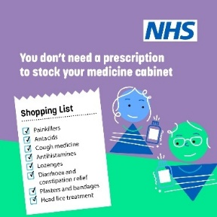
If you have a strain or sprain, in most cases, you can treat it yourself at home by following PRICE - Protect, Rest, Ice, Compression, Elevate.  Contact NHS 111 for further advice if you need it▶️ 111.nhs.uk  ALT text:  What to do: Sprains and strains. Treat it yourself by remembering PRICE. Protect the limb. Rest it. Use ice on the area. Compression bandages will help. Elevate the limb. Seek medical advice if: You can't move an affected joint. Your skin feels numb over the area. It doesn’t improve after 3-4 days. You can’t walk properly because of the injury. The area is deformed or shows lumps or bumps. You notice more than only mild bruising. | Regional Self care sprain and strains - UEC Comms North West - Futures  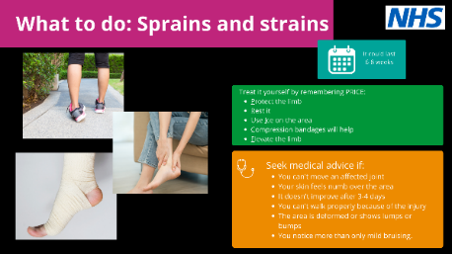
Lower back pain can be quite common and in most cases isn’t anything serious - but there are things you can do to treat it at home, with the help of your local pharmacy.  Use 111.nhs.uk if you have more serious symptoms  ALT text:  What to do: Lower back pain  Treat it yourself with:  - A hot bath or hot water bottle to ease the pain.  - 'Rub on' treatments and pain killers such as paracetamol and ibuprofen should also help.  See your pharmacist for advice on stronger painkillers.  Make an appointment with your GP if:  - Pain doesn't ease after 3 days  - The pain moves to your chest  - It was caused by a major fall  - You also have a fever.  Seek urgent advice through NHS 111 or an Urgent Treatment Centre if:  - You feel numb or get pins and needles in the area or down your legs.  - You lose control of your bowels | Regional Self care back pain - UEC Comms North West - Futures  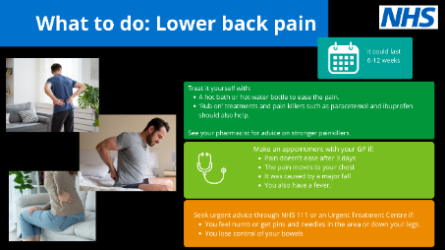
If you’ve got a sore throat, symptoms usually last between 3-7 days.  You can self care by drinking plenty of fluids and taking regular painkillers.  nhs.uk/conditions/sore-throat/  ALT text:  What to do: Sore throat  Treat it yourself by:  - Eating cool, soft food and drinking cool or warm drinks  - Sucking lozenges, ice cubes or hard sweets  - Gargling with warm, salty water  - Painkillers will help to relieve symptoms. Speak to your pharmacist.  Seek medical advice from your GP if:  - Your symptoms are no better after two weeks  - You get sore throats frequently that don't respond to painkillers  - You have a persistent high temperature over 38C  - You find it difficult to breathe in  - Your voice becomes muffled  - You find it difficult to drink enough to stay hydrated.  Seek urgent care through NHS 111 if you're drooling and find it difficult to swallow. | Self care - sore throat - Google Drive  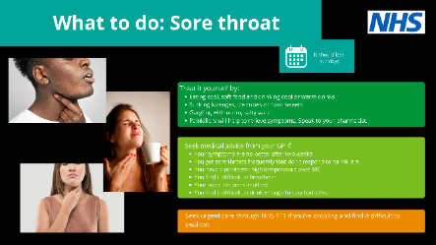
Tips for Keeping Yourself and Your Home Warm This Winter ❄️ 🌨️  Keeping warm over winter can help prevent colds, flu, and serious health problems like heart attacks, strokes, and pneumonia.  ✅ Make sure any heating and cooking appliances are working safely—contact a Gas Safe registered engineer. For more details, visit gassaferegister.co.uk and nationalfirechiefs.org.uk.  Stay warm, stay safe! 💙  #WinterSafety #HomeHealth #GasSafety #StayWarm #WinterCare #HealthTips  ALT text:  Keep warm at… HOME | future.nhs.uk/NorthWest_UECComms/view?objectId=59782256  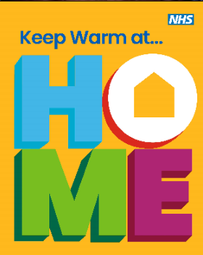
Winter can be tough on our health – it can worsen existing conditions, increase the risk of falls, and make us more vulnerable to respiratory illnesses.  Here are our tips on how to #StayWellThisWinter  ✅ Stay up to date with vaccinations  ✅ Keep yourself and your home warm  ✅ Stay hydrated  ✅ Check your home for safety hazards (e.g. fire risks)  ✅ Prioritise your mental wellbeing  ✅ Keep active and stay on top of prescriptions  Winter can be particularly hard for older neighbours, friends, and family members as they may need extra help. Keep in touch with them, especially if they live alone.  Let’s support each other and #StayWellThisWinter! 💙  ALT text:  Healthy start to the new year. Letters spelling HOME – revealing images of people at home within the shape of the letters. | future.nhs.uk/NorthWest_UECComms/view?objectId=239523365  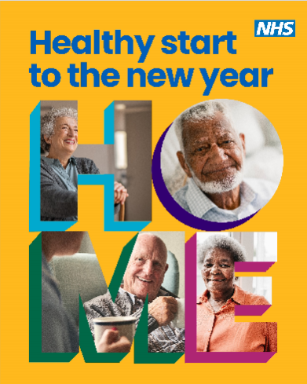

5. NHS 111

Introduction:

NHS 111 helps people get the right advice and treatment when they urgently need it. Clinicians, such as nurses, doctors, pharmacists and paramedics now play an important role in NHS 111. In fact, over 50% of people who call 111 speak to someone in one of these roles.

If needed, NHS 111 can book patients in to be seen at their local A&E / emergency department or an urgent treatment centre, emergency dental services, pharmacy or another more appropriate local service – as well as send an ambulance should the patient’s condition be serious or life-threatening.

NHS 111 is here to make it easier and quicker for patients to get the right advice or treatment they need, be that for their physical or mental health.
It is available 24 hours a day, 7 days a week.

It is important to raise awareness of the use of NHS 111 online to help free up phone lines for those who are unable to use the online service. Using 111 online is the quickest and easiest way to get urgent medical help. It will use information of the user’s symptoms to direct patients to the best place to get help.

Find NWAS data on numbers of 111 calls last winter and reasons for calls broken down by ICB area here.

Key messages:

Winter is a particularly busy period for NHS 111, especially during the festive period between Christmas and New Year.

If a patient needs urgent medical help but is unsure where to go, they can use NHS 111 to get assessed and be directed to the right place for them.​ They can call, go online or use the NHS App.

The online service will provide patients with the same advice as they would get over the phone and is simple to use. They can answer questions about their symptoms on the website or in the NHS App and it will tell them what to do next.

Depending on what they need, they might be advised to:

call 999 or go to A&E in an emergency

go to an urgent treatment centre

see an evening and weekend GP (out-of-hours GP)

book a callback from a nurse

get urgent specialist support, for dental or mental health problems

contact their own GP surgery

see a pharmacist for help with a minor illness

look after themselves safely at home

NHS 111 online is for people aged five and over. Patients should call NHS 111 if they need help for a child under five.

The 111 service also offers a mental health option, enabling callers experiencing a mental health crisis to select option 2 for 24/7 access to crisis mental health support.

Newsletter/website/press release copy:

NHS 111 here to support you and your family this winter

THIS winter <organisation> is encouraging people to become familiar with NHS 111 – a quick, easy and reliable service for urgent health advice and support.

For life threatening emergencies and serious injuries people should use 999 or A&E services and for urgent but non-emergency help and advice people can use NHS 111 online at 111.nhs.uk or via the NHS App or call 111.
NHS 111 can assess and direct people to the most appropriate local service, including urgent treatment centres, GP practices, and consultations with a pharmacist. If needed it can arrange a call back from a nurse, doctor or paramedic or provide self-treatment advice over the phone. It is available 24 hours a day, seven days a week.
<spokesperson> said: “When you or a loved one needs medical help, NHS 111 is your first point of contact for guidance and support, covering everything from physical health symptoms to mental wellbeing. The service is available 24 hours a day, seven days a week. Advisors are at hand to help you get the right care, quickly and effectively.

“We know that up to two-fifths of A&E attendances could be better treated elsewhere, as well as one in six calls to 999 just needing advice over the phone. It is because of this that we’re encouraging everyone to use our free, around the clock 111 service that can give millions of people this winter fast, safe and easy access to the advice or treatment they need.
“111 can direct you to a pharmacist, GP team or community provider, or arrange a call with a nurse or paramedic. By using it you can help us ensure everyone is getting the care they need.”
NHS 111 is available to everyone, offering support in over 200 languages through interpreters, ensuring that no matter your community, culture or language, help is always just a phone call away.
The 111 service also offers a mental health option, enabling callers experiencing a mental health crisis to select option 2 for 24/7 access to crisis mental health support.
The NHS 111 service also offers assistance in British Sign Language (BSL), which is available online via video link, offering a convenient and vital service.
When to use NHS 111:
- If you’re unsure where to go for treatment
- For non-emergency medical advice
- If you have a mental health concern
- If your GP or pharmacy is closed
- When you need urgent care but it’s not life-threatening
How to access NHS 111
- Call 111 for free from any phone
- Visit 111.nhs.uk for online support or access it via the NHS App. The online service is suitable for people aged 5+. For children under 5, use the phone service.
- Use the BSL NHS 111 service at signvideo.co.uk/nhs111

Social media:

National Assets
NHS 111 campaign – including posters, digital screens, e-signatures – CRC | Help Us Help You - NHS111 | Campaigns | Campaign Resource Centre
NHS 111 mental health | NHS 111 mental health assets | NHS 111 | Campaign Resource Centre
Regional Assets
Body text and ALT text | Thumbnail/link
Feeling unwell?  111.nhs.uk could be the more appropriate solution rather than ringing 999.  Clinicians like Donna support patients, if needed, to provide advice or direct you to the right care. | Reel – Meet Donna  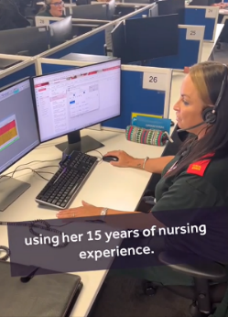
111.nhs.uk is the place to go if you need medical advice and it's not an emergency. | Reel – NHS 111 call handlers are often extremely busy.  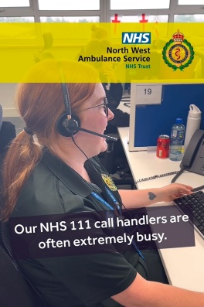
Winter is always a busy time for NHS 111. In the North West, almost 140,000 calls were received last December alone. Help keep lines free by using 111.nhs.uk – it’s quick, easy to use and you’ll get the same advice as you would over the phone.  ALT text:  Picture of NHS 111 call handler sat at desk. Their hands are typing on a keyboard. They are wearing a headset. | 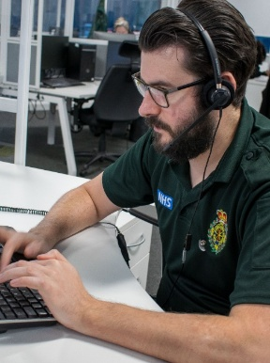  Male 111 health advisor social
We use our smartphones for pretty much everything these days but do you use NHS 111 online when you need urgent healthcare advice? It’s quick and easy to get you to the right place depending on your symptoms.  ALT text:  Picture of hand holding a mobile phone. The mobile screen shows accessing NHS 111 online. | 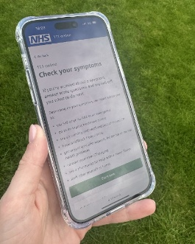  111 online social
When you call 111, you’ll be connected to a trained health advisor who will ask you a series of questions so that they can direct you to the right place for the care you need.  You could save time by using 111 online, where you’ll receive the same advice as you would do over the phone.  ALT text:  Picture of female NHS 111 call handler. | 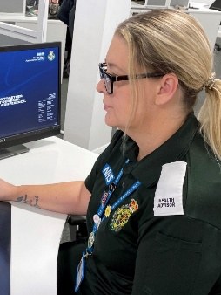  Female 111 health advisor social
NHS 111 online provides quick medical advice, is easy to use and will direct you to the right service.  When you need urgent medical help, go to ▶️ 111.nhs.uk | Video: Dr Paula Cowan  Dr Paula Cowan NHS 111 online subtitled.mp4
NHS 111 online can give you the same urgent medical advice as the telephone service and you will be called back by a clinician if you need one  Go to 111.nhs.uk | Using 111 online video walkthrough:  using 111 online.mov
Translated and accessible resources
Text options (x 4):  Feeling unwell? 111.nhs.uk could be the more appropriate solution rather than ringing 999. There are clinicians at hand to support patients, if needed, to provide advice or direct you to the right care.  111.nhs.uk is the place to go if need medical advice and it's not an emergency.  Not sure how to use NHS 111? Here’s a handy A-Z guide about what the service can help you with. #Inside111 nwas.nhs.uk/services/non-emergency-111/nhs-111-a-z-guide/  NHS 111 service also offers assistance in British Sign Language (BSL), making it more accessible for the deaf community. The BSL 111 service is available online via video link, offering a convenient and vital service to those who need it most. | - Dr Abdul Zubairu (four videos): Link to resource here  - Dr Yazdan Zargham: Link to resource here  - Dr Santosh Davis: Link to resource here  - British Sign Language version: Link to resource on YouTube here  - Translated social media messages in Arabic, Bengali, Chinese Mandarin, English, French, Polish, Punjabi, Romanian, Somalian, Spanish, Urdu:Link to resources here

  - Repeat Prescriptions

Introduction:

Each bank holiday, NHS 111 sees a huge increase in calls from people who need urgent repeat prescriptions.

Pharmacies have limited opening hours over bank holidays, making it more challenging for patients to access medicines at short notice. Waiting and using emergency or urgent services over the break puts added pressure on already busy NHS services.

Statistics from last winter (Oct 2024 – Feb 2025) show North West Ambulance Service (NWAS) received over 52,000 calls to the NHS 111 service for repeat prescriptions, the highest reason for calling.

This indicates why there needs to be a particular focus on repeat prescriptions this winter to ensure that they’re ordered in advance to avoid running out. Running out of medication for people who rely on it can have serious consequences, and it’s avoidable by planning ahead.
Key messages:
- Winter is a particularly busy period for NHS 111, especially during the festive period between Christmas and New Year.
- Running out of your usual medication can have serious consequences, especially if you use them to control a heart condition, breathing problems or have a health condition such as diabetes.
- Calls for emergency medication can be avoided by planning in advance to make sure any repeat prescriptions are ordered before running out.
- Repeat prescriptions are available to order via the NHS app, online or via patient GP surgeries. nhs.uk/nhs-services/online-services/how-to-order-a-repeat-prescription/
- If a patient does run out of medication, NHS 111 can request a limited emergency supply, but it’s always best to plan ahead. NHS 111 online can provide an emergency supply of regularly prescribed medicine for someone of any age.

Newsletter/website/press release copy:

People urged to order repeat prescriptions ahead of the bank holiday

<insert local clinician> is advising people to order any repeat prescriptions that are due ahead of the <insert> bank holiday.

It is recommended that any repeat prescriptions due in the days over the bank holiday weekend are ordered by <insert date>.

Each bank holiday the NHS 111 phone service sees huge increases in calls from people who need urgent repeat prescriptions.

Pharmacies may have limited opening hours over the bank holiday, and many will be closed on Monday <insert date>, making it more challenging for patients to access medicines at short notice. Waiting and using emergency or urgent services over the break puts added pressure on already busy NHS services.

<spokesperson> said: “Keeping your medicine cabinets stocked, knowing when your GP practice is open, and planning for repeat prescriptions that are due will ensure you can make the most of the bank holiday weekend.

“Running out of your usual medication can have serious consequences, especially if you use them to control a heart condition, breathing problems or have a health condition such as diabetes.

“The easiest way to order repeat prescriptions is by using GP online services, via the NHS App or through your GP practice website. If you do not have access to GP online services, you can phone your GP practice to order prescriptions.”

As well as ordering repeat medications, the NHS App allows people to book and cancel appointments at their GP practice, view their health record and get health advice, searching trusted NHS information and advice on hundreds of conditions and treatments. Download the NHS App on the app store or on google play.

Over the bank holiday, urgent and emergency care services will be open as normal. The public should call 999 or attend accident and emergency services in the event of a life or limb threatening emergency. For non-emergency health advice, people can contact NHS 111 online at 111.nhs.uk, which offers the same help and advice as the telephone service. If you cannot access 111 online, please call 111.

Social media and other materials:

National Assets
Ordering repeat prescriptions in the NHS App | Ordering repeat prescriptions in the NHS App (promotional pack) - NHS Digital
Regional Assets
Body text/ALT text | Thumbnail/link
Remember to order your repeat prescriptions in time so that you don’t run out of medication. If that means putting post-it notes in places to make you remember, we’re down for that!  #RepeatPrescriptionReady  X version  Remember to order your repeat prescriptions in time so that you don’t run out of medication. If that means putting post-it notes in places to make you remember, we’re down for that!  nhs.uk/nhs-services/online-services/how-to-order-a-repeat-prescription/  #RepeatPrescriptionReady  ALT text:  A small child with a reminder note on their back that reads "It's that time again" walking outdoors, with a caption suggesting the importance of remembering prescriptions, including the number 111. | drive.google.com/drive/folders/1g_ctpRMHbhQRvTc2xkhTpLLeoELx3cBs?usp=sharing  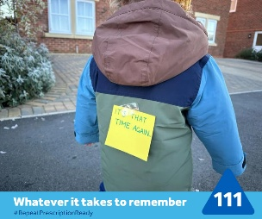
You wouldn’t forget the dog treats, as little Daisy is pointing out, so please don’t forget to order your prescriptions ahead of the forthcoming bank holidays.  #RepeatPrescriptionReady  ALT text:  A Springer Spaniel dog on a pavement, a red lead is visible and they are wearing a harness with a sign that reads "Don't forget my treats and…." There's a blue NHS 111 logo in the bottom left and text that says "Whatever it takes to remember.  #RepeatPrescriptionReady." | drive.google.com/drive/folders/1g_ctpRMHbhQRvTc2xkhTpLLeoELx3cBs?usp=sharing  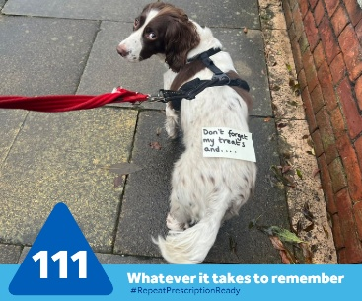
Don’t let it become an emergency. Order your repeat prescriptions before you run out, even if it means putting notes in random places!  You can order a repeat prescription by logging into your account using the NHS app/NHS website.  #RepeatPrescriptionReady  ALT text:  Open toilet seat with a sticky note saying "Have you done it?" affixed to the lid. Text under the image reads "Whatever it takes to remember #RepeatPrescriptionReady" next to the number 111 logo in blue. | drive.google.com/drive/folders/1g_ctpRMHbhQRvTc2xkhTpLLeoELx3cBs?usp=sharing  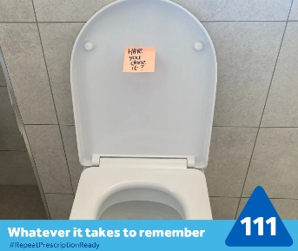
Last winter NHS 111 received over 52,000 calls for requests for repeat prescriptions. Please remember to order your repeat prescriptions in advance to avoid unnecessary stress and potential health risks.  You can order a repeat prescription by logging into your account using the NHS app/NHS website.  #RepeatPrescriptionReady  X version  Last winter NHS 111 received over 52,0000 calls for requests for repeat prescriptions. Please remember to order repeat prescriptions in advance to avoid unnecessary stress and potential health risks. nhs.uk/nhs-services/online-services/how-to-order-a-repeat-prescription/  #RepeatPrescriptionReady  ALT text:  Person using a tablet displaying NHS website about how to order a repeat prescription, with a focus on the screen content. | drive.google.com/drive/folders/1g_ctpRMHbhQRvTc2xkhTpLLeoELx3cBs?usp=sharing  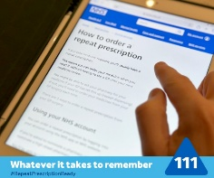
December is a busy time, and it’s easy to overlook the essentials. Let this festive video from [insert NWAS handle/tag depending on platform] be a friendly reminder to order your repeat prescriptions before the upcoming bank holidays.  Plan ahead and get #RepeatPrescriptionReady today!  X version  December is a busy time, and it’s easy to overlook the essentials. Let this festive video from @NWAmbulance be a friendly reminder to order your repeat prescriptions before the upcoming bank holidays.  Plan ahead and get #RepeatPrescriptionReady today! | Christmas reel (version available without music on request from press.office@nwas.nhs.uk  drive.google.com/drive/folders/1g_ctpRMHbhQRvTc2xkhTpLLeoELx3cBs?usp=sharing  
Take inspiration from [insert NWAS handle/tag depending on platform] and add repeat prescriptions to your shopping list as a reminder to order your repeat prescriptions ahead of the bank holidays.  #RepeatPrescriptionReady | Reel:  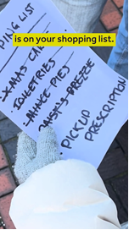  drive.google.com/drive/folders/1g_ctpRMHbhQRvTc2xkhTpLLeoELx3cBs?usp=sharing
Last winter, NHS 111 received over 52,000 calls for requests for repeat prescriptions in the NW. Please remember to order your repeat prescriptions before the Christmas bank holidays to avoid unnecessary stress and potential health risks.  You can order a repeat prescription by logging into your account using the NHS app/NHS website or through your GP practice.  #RepeatPrescriptionReady  X version  Last winter, NHS 111 service received over 52,000 calls for requests for repeat prescriptions. Please order repeat prescriptions before the Christmas bank holidays to avoid unnecessary stress and potential health risks. nhs.uk/nhs-services/online-services/how-to-order-a-repeat-prescription/  #RepeatPrescriptionReady  ALT text:  Close-up of a hand holding a smartphone displaying the NHS app homepage with options such as urgent help, prescriptions, and health record visible. The background is blurred, and there is an NHS logo with text encouraging users to order repeat prescriptions through their website or app. | drive.google.com/drive/folders/1g_ctpRMHbhQRvTc2xkhTpLLeoELx3cBs?usp=sharing  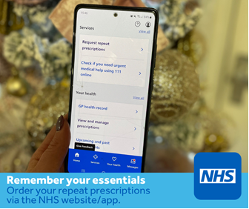
While you're getting ready for Christmas and picking out presents, remember to order your prescriptions early to stay prepared during the upcoming bank holidays. The simplest way to do this is through your NHS account via the NHS app or website.  #RepeatPrescriptionReady  X version  While you're getting ready for Christmas and picking out presents, remember to order your prescriptions early to stay prepared during the upcoming bank holidays. The simplest way to do this is through your NHS account via the NHS app or website.  #RepeatPrescriptionReady  ALT text:  A promotional image featuring a festive setting with wrapped Christmas gifts, a winter-themed decoration, and a pharmacy bag. A caption asks if you've got your gifts and reminds you to order repeat prescriptions via the NHS website or app. | drive.google.com/drive/folders/1g_ctpRMHbhQRvTc2xkhTpLLeoELx3cBs?usp=sharing  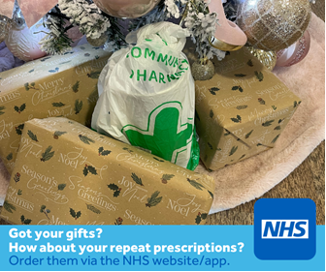
GP Dr Paula Cowan reminds people it’s free and easy to order repeat prescriptions on the NHS App.  Don’t let it become an emergency. Order your repeat prescriptions before you run out. | Dr Paula Cowan video:  https://drive.google.com/file/d/1dmq9JFHOCjsiINzblQWpJAannIJDlbP8/view?usp=drive_link
To avoid delays in getting your medicines over the bank holiday, order any repeat prescriptions that are due in good time.  You can order repeat prescriptions through the NHS App or via your GP surgery.  ALT text:  Remember to order prescriptions early  To avoid delays in getting your medicines over the bank holiday, order you prescriptions in good time.  You can order repeat prescriptions through the NHS App or an your GP surgery. | 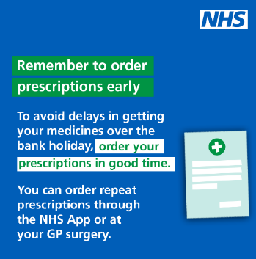
✨ Have a prescription check in on your loved ones and neighbours.  💊 Make sure they have their prescription medicines available, or if they need help picking them up.  If your loved one needs help while GP practices or pharmacies are closed, NHS 111 is here for them.  🌐 Visit 111.nhs.uk for advice on what to do and where to go. A little care can go a long way! ❤️  #StayWellThisWinter #CommunitySupport #RepeatPrescriptionReady  ALT text:  HOME: Prescription check in | future.nhs.uk/NorthWest_UECComms/view?objectId=233111141  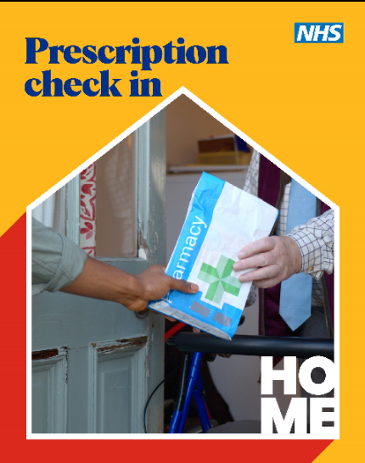

7. Pharmacy
Introduction:

The NHS Pharmacy First scheme launched in January 2024 following publication of the delivery plan for recovering access to primary care. The service incorporates the previous Community Pharmacist Consultation Service and builds on it to enable community pharmacy to complete episodes of care for the seven common conditions below following specific clinical pathways.
- sinusitis
- sore throat
- earache for ages over 1yr – 17yrs
- infected insect bite
- impetigo
- shingles

Over 95% of community pharmacies in the region are participating in the service which means there is a wide range of coverage to all populations in the region.

Content in this pack can be used to help raise awareness of pharmacy services and the Pharmacy First scheme and encourage uptake, helping to reduce the burden on other NHS services.

Key messages:

- Pharmacy First gives patients quick, easy access to support for common conditions through their high street pharmacy.
- It includes the supply of appropriate medicines for seven common conditions including earache, sore throat, shingles, and urinary tract infections, aiming to address health issues before they get worse.
- If someone goes to a pharmacy with one of the seven conditions, the pharmacist will offer advice, treatment or refer them to a GP or other healthcare professional if needed.
- People aged 40 and over can also get their blood pressure checked for free at local pharmacies. This can lower their risk of a fatal heart attack, stroke, kidney disease or vascular dementia.
- If someone lives with a long-term condition, they may also be able to save money on prescriptions.
- A Prescription Prepayment Certificate will save people money if they pay for more than three items in three months, or 11 items in 12 months.
- People on a low income could be entitled to help with NHS costs or free prescriptions depending on their circumstances. People can check if they’re eligible for help using the online eligibility checker. It only takes a few minutes.

Newsletter/website/press release content:

Content available in national toolkits.

Social media and other materials:

National Assets
Think Pharmacy First – Campaign Toolkit on CRC | Campaign toolkit | Think Pharmacy First | Campaign Resource Centre
Think Pharmacy First – social media assets and post copy on CRC | Social media assets and post copy | Think Pharmacy First | Campaign Resource Centre
Oral contraception toolkit | Oral contraception | Think Pharmacy First | Campaign Resource Centre
Regional Assets
Body text/ALT text | Thumbnail/links
Local pharmacist Sarah encourages you to keep your medicine cabinet winter-ready!  Check with your pharmacist first to ensure what’s right for you.  Find your nearest pharmacy ➡️  nhs.uk/service-search/pharmacy/find-a-pharmacy/ | Video – Pharmacist Sarah talking about the winter medicine cabinet:  Sarah winter – winter medicine cabinet.mp4 - Google Drive
Winter months can bring coughs, colds, sore throats & more.  Community pharmacists like Sarah can provide quick health advice and even supply over the counter medication if needed.  Find your nearest pharmacy ➡️  nhs.uk/service-search/pharmacy/find-a-pharmacy/ | Video – Pharmacist Sarah gives winter health advice:  Sarah winter – winter advice.mp4 - Google Drive
Coughs, colds, earache, and sore throats can be more common during winter.  Many can be treated at your local pharmacy—often without an appointment.  Pop in for advice and care from friendly staff ready to help. | Video – Pharmacist Sarah talking about common winter ailments:  Sarah winter 2 – common winter ailments.mp4 - Google Drive
The Pharmacy First scheme can help you get better quicker.  The 7 conditions covered are:  - earache in children  - UTIs in women  - shingles  - sinusitis  - sore throats  - impetigo  - infected bites  Walk in for a consultation — no appointment needed.  They’ll assess your symptoms and can offer advice or antibiotics if needed. | Video – Pharmacist Grace talking about the Pharmacy First scheme:  Grace - pharmacy first .mp4 - Google Drive
Pharmacists can offer advice on a range of illnesses, such as coughs, colds, sore throats, ear infections and aches and pains.  They can also give advice about medicines. This includes how to use your medicine, worries about side effects or any other questions you have. | Longer video: Dr Paula Cowan  Link to video asset on GoogleDrive
Pharmacists can suggest over-the-counter treatments for a range of conditions, without the need for a prescription. | Shorter video: Dr Paula Cowan  Link to video asset on GoogleDrive
Community pharmacists are clinically trained professionals who can advise and treat a range of minor illnesses and injuries, such as aches and pains, skin rashes, cystitis and earache.  Find your local community pharmacy ➡️nhs.uk/service-search/pharmacy/find-a-pharmacy/ | Link to video asset on GoogleDrive

  - NHS App

Introduction:
The NHS App provides a digital route to access a wide, and increasing, range of NHS health and care services, and enhancing it and increasing uptake is a significant focus of the 10 Year Health Plan.
Almost four million patients (3,980,160) aged 13+ in the North West have already registered for the NHS App (as of 23 June, 2025), with around six and a half million patient log-ins each month and over 48,000 appointments being managed on the app monthly.
By 2028, the app is expected to provide functionalities such as appointment booking, access to health records, and personalised health advice based on data from wearables and other health metrics.
The goal is to make the NHS "digital by default," improving efficiency and patient engagement.
Communications activity aims to increase awareness of the services and functions that are available via the NHS App and encourage greater uptake.
Key messages:
- The NHS App is a simple and secure way to access a range of NHS services on your smartphone or tablet. Your NHS is at your fingertips. Find out more at nhs.uk/nhsapp
- Millions of people are using the NHS App to manage their health the easy way, from ordering a repeat prescription to checking their records. Start using the app today. Find out more at nhs.uk/nhsapp
- Join the millions using the NHS App by downloading it on your smartphone or tablet via the Google play or Apple App store. Your NHS is at your fingertips.
- Millions of people are already accessing their GP health record on the NHS App. If you are over the age of 16 you can see your consultation notes, letters and test results. Start using the app today. Find out more at nhs.uk/nhsapp
- Accessing your GP health record on the NHS App can help you better understand and manage your condition, without having to phone your GP surgery. Check if you already have access by clicking ‘View your GP health record’ in the NHS App. Start using the app today. Find out more at nhs.uk/nhsapp
- The NHS App enables you to view your GP health record, order repeat prescriptions, and nominate your preferred pharmacy from the comfort of your home. Start using the app today. Find out more at nhs.uk/nhsapp

- The NHS App enables you to manage repeat prescriptions and easily change your nominated pharmacy, so you can send orders when it’s convenient for you. Start using the app today. Find out more at nhs.uk/nhsapp
- The NHS App enables you to access your appointment information in one place, get the support you need, and manage your hospital appointments. Start using the app today. Find out more at nhs.uk/nhsapp.

Newsletter/website/press release content:
NHS App can help you manage repeat prescriptions… and more
Senior clinical leads across <insert area/organisation> are encouraging local people to sign-up to the NHS App.
The NHS App can help people order repeat medications, meaning they do not need to ring or contact their GP practices, and if their pharmacy offers it, they can receive notifications once their medication is ready to be collected.
But that isn’t all the app can do. Once an NHS account is linked you can:
- View your health record – securely access your GP health record, to see information like your allergies and your current and past medicines. If your GP has given you access to your detailed medical record, you can also see information like test results and details of your consultations
- Register your organ donation decision – choose to donate some or all of your organs and check your registered decision
- Find out how the NHS uses your data – choose if data from your health records is shared for research and planning
- View your NHS number
- Book appointments – some GP practices allow you to search for, book and cancel appointments at your GP surgery, and see details of your upcoming and past appointments
- Access NHS 111 online for trusted medical help and advice on hundreds of conditions and treatments.
<spokesperson> said: “Using the NHS App can save you time, help you manage your health needs, and enable you to manage your personal health at a time that suits you.
“These days when a large number of us are used to using apps for everything from ordering our shopping to checking sports updates, the NHS App offers a convenient option – and new features are in development, including making it possible to manage hospital appointments.

“There’s also the added bonus that the more people use the NHS App, the more this frees up time of staff to help those who aren’t as tech-savvy.”
You can download the NHS App on the app store or on google play.
Once you have downloaded the app, you can get help and support from the NHS website.
ENDS
Social media and other materials:
National assets
Campaign toolkit includes campaign overview, key messages, long and short copy, and links to suggested social media posts. | Campaign toolkit | NHS App | Campaign Resource Centre
Social media assets and post copy grid - includes social media statics and social media post copy matrix. | Social media assets and post copy grid | NHS App | Campaign Resource Centre
NHS App – assets, inc digital screens, posters, bus panels, e-signatures, on CRC | NHS App | Campaigns | Campaign Resource Centre
REGIONAL ASSETS
Body text/ALT text | Thumbnails/links
Campaign hashtag: #MakeMoreTimeNHSapp  Body text included in the ‘Make more time’ social media toolkit: | ‘Make more time’ reels:  NHS App winter 2025 - reels - UEC Comms North West - Futures
Campaign hashtag: #MakeMoreTimeNHSapp  Body text included in the ‘Make more time’ social media toolkit:  Social media toolkit - Make More Time winter 2025 - NHS App - UEC Comms North West - Futures | ‘Make more time’ social graphics: NHS App autumn-winter 2025-6 - UEC Comms North West - Futures  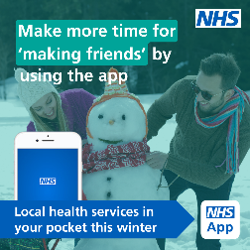
Suggested body text in NHS App Christmas countdown toolkit | NHS App Christmas countdown toolkit:  XMAS 2025 - NHS App social media toolkit - UEC Comms North West - Futures  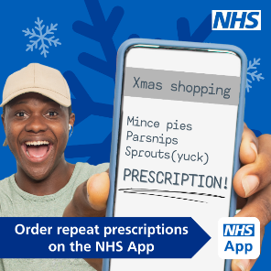

  - Mental health

Introduction:
Communications activity aims to raise awareness of activities and services to support mental wellbeing and how to access crisis mental health services. The content in this pack can be used at any time, including to mark World Mental Health Day on 10 October, Time to Talk Day on 6 February, in the run up to Christmas and in the New Year when people may experience greater mental health difficulties.
Key messages:
- We all feel down from time to time, no matter our age. You can find information and tips on keeping mentally healthy at nhs.uk/every-mind-matters
- Speak to your GP practice about NHS Talking Therapies if you are anxious, depressed or struggling to cope. They can help you – physically and mentally – and can refer you to the right service. You can also self-refer by visiting: nhs.uk/talk
- If you live with serious mental illness, you are entitled to a free NHS annual health check – talk to your GP, key worker or mental health service to book it.
- If you or a loved one are experiencing a mental health crisis, you can call NHS 111 and press Option 2 for 24-hour mental health advice and support. Information and contact details are available on:
- nhs.uk/urgentmentalhealth

Newsletter/Website/press release copy:
Reach out for mental health help this January
The NHS in the North West is urging people to reach out if they are struggling with their mental health this January.
The period following Christmas and the New Year is recognised as a challenging time that can leave people feeling overwhelmed and anxious – but there are a number of things you can do to help.
<spokesperson> said: “We recognise that Christmas and the festive period can amplify feelings of low mood, loneliness and anxiety and this can continue into January when factors such as reduced daylight hours and financial worries can cause a decline in mood.
“We are urging everyone to be aware of their own mental health and to actively take steps to protect themselves and ask for help if needed.”

Talking Therapies is a psychological therapy service offering a range of free talking therapies. The service can be assessed across the North West in person, online or telephone and specialises in psychological interventions to support people’s differing emotional needs including generalised anxiety, panic, depression, obsessive-compulsive disorder and post-traumatic stress disorder.
<spokesperson> said “Try to make a conscious effort to maintain healthy habits. Spending time outdoors with friends and family is a great way to boost your mood and going for a walk will increase your exposure to vitamin D.
“If you feel like you need any mental health support, reach out and ask for help. People who are struggling often say what a huge relief it is to talk about what they are experiencing.”
Talking Therapies is made up of psychological wellbeing practitioners (PWP), cognitive behavioural therapists (CBT), counsellors, team leaders and administrative staff and offers support to people experiencing feelings of depression or anxiety. A practitioner will always discuss the best options available during an initial telephone assessment. Access to Talking Therapies can be made via a GP or self-referral online.
Further details and find a local service can be found by visiting NHS talking therapies for anxiety and depression – NHS
Call NHS 111 and select the mental health option 2 if you, or someone you know, is in a mental health crisis. Available 24/7, you’ll speak to a mental health professional who can help you find the right support. If there’s an immediate risk to life ring 999 or go to A&E.

Social media:
National Assets
NHS 111 option 2 – campaign assets on CRC | NHS 111 mental health assets | NHS 111 | Campaign Resource Centre
Every Mind Matters – assets on CRC | Better Health Every Mind Matters | Campaigns | Campaign Resource Centre
NHS Talking Therapies – assets on CRC | Help Us Help You - NHS Talking Therapies | Campaigns | Campaign Resource Centre
Regional Assets
Body text/ALT text | Thumbnail/link
There are many things you can do to take care of your own mental health. Find what works best for you.  For tips and advice about mental health, including stress, anxiety and sleep, go to➡️nhs.uk/every-mind-matters/ | Video – Paul from NWAS:  https://drive.google.com/drive/folders/179H-hwEEtSCVsyp8-Zk8Ak1ta1VmfQU2
Video – Sarah from NWAS:
https://drive.google.com/drive/folders/179H-hwEEtSCVsyp8-Zk8Ak1ta1VmfQU2
Video – Josh from NWAS:
https://drive.google.com/drive/folders/179H-hwEEtSCVsyp8-Zk8Ak1ta1VmfQU2
Suggested body text included in toolkit | Regional mental health communications toolkit, includes a mix of national, charity and regionally developed, generically-branded assets and body text:  Mental health communications toolkit winter 2025-6 - UEC Comms North West - Futures

  - Long term health conditions

Introduction:
Providing information to support people to manage long-term conditions during winter can help to keep people well and prevent them becoming more seriously ill.
Key messages:
- Long-term conditions, or chronic diseases, are conditions that require ongoing care and often are managed by medications and other treatments. Examples include diabetes, arthritis, high blood pressure, epilepsy, asthma and heart or kidney disease.
- Winter illnesses can aggravate any existing health problems, make people more vulnerable to respiratory problems and raise the risk of increased blood pressure, heart attacks and strokes.
- It is better for patients and the NHS to help keep people well rather than treating them when their health worsens.

Newsletter/Website copy:
Long-term conditions, or chronic diseases, are conditions that require ongoing care and often are managed by medications and other treatments. Examples include diabetes, arthritis, high blood pressure, epilepsy, asthma and heart or kidney disease.
Despite early signs of spring, winter illnesses continue to circulate at this time of year and can aggravate any existing health problems, make us more vulnerable to respiratory problems and raise the risk of increased blood pressure, heart attacks and strokes.
Everyone’s experience of living with a long-term condition is different but there are few things people can do to help their manage their condition, including:
- Get the flu vaccine – it’s available until 31 March 2025. Find out more at: www.nhs.uk/flujab
- Make sure that you have had any planned reviews of your condition
- Take your medication as prescribed and see your pharmacist for any medication concerns
- Keep warm
- If you smoke, consider steps to quitting
- Eat a healthy and balanced diet
- Exercise daily: even short walks and housework count as physical activity.
There are a few other things you can do:
- If you feel unwell don’t wait – get advice from your nearest pharmacist
- Think ahead - make sure that you have enough medication to last when your GP surgery may be closed. It’s important that
- Book any routine appointments with your practice in plenty of time and ensure that you have enough to last you over these times. Don’t use A&E as a back-up pharmacy, plan ahead.
- Eat well and wrap up warm - keep active and have regular hot drinks and nutritious meals. If you have breathing problems even a small change in temperature can affect you.
- For help with living with asthma see nhs.uk/conditions/asthma/living-with/
- For help living with COPD see nhs.uk/conditions/chronic-obstructive-pulmonary-disease-copd/living-with/
- For help living with type one
- For help living with type two diabetes see nhs.uk/conditions/type-2-diabetes/food-a
Social media:
National Assets
If you have or are at risk of having type 2 diabetes, lifestyle changes like a healthy diet, exercise, trying to lose weight and stopping smoking can help lower your blood glucose (sugar) levels.  nhs.uk/conditions/type-2-diabetes/food-and-keeping-active/ | 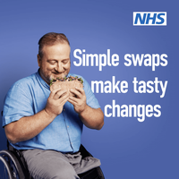  Social media animations | Better Health Adult Obesity | Campaign Resource Centre  Social media statics | Better Health Adult Obesity | Campaign Resource Centre
The National Diabetes Prevention Programme #NDPP is a great way to prevent type 2 diabetes and helps with weight loss and lifestyle changes. | 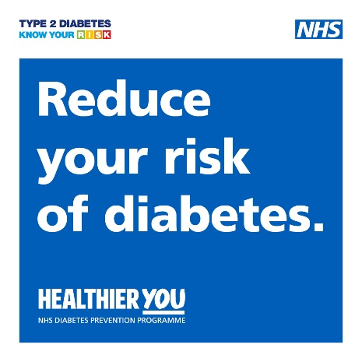  Social media graphics | Healthier You NHS Diabetes Prevention Programme | Campaign Resource Centre
Lifestyle changes including eating a healthy diet, exercising regularly and stopping smoking can all help you manage heart failure. nhs.uk/conditions/heart-failure/living-with/ | 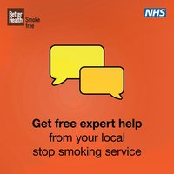  assets.nhs.uk/campaign-resource-centre-v3-production/documents/Quit_smoking_support_Social_1x1.mp4
If you live with a long-term condition, you may be able to save money on your prescriptions.  Find out more: nhs.uk/nhs-services/prescriptions/ | 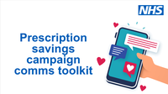Comms toolkit | Prescription savings campaign | Campaign Resource Centre
Regional Assets
Body text/ALT text | Thumbnail/link
Living with asthma?  Get help and advice here: nhs.uk/conditions/asthma/living-with/  ALT text:  Image of someone using an inhaler. Living with asthma? Want advice on managing your condition?#Search ‘NHS asthma’ to take you to the NHS.uk website. | 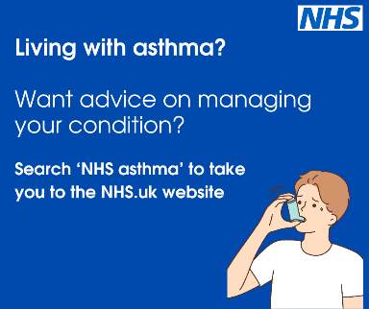  This and further assets available at: Long Term Conditions - UEC Comms North West - FutureNHS Collaboration Platform
Living with COPD?  Get help and advice here: nhs.uk/conditions/chronic-obstructive-pulmonary-disease-copd/living-with/  ALT text:  Image of a person’s lungs. Living with COPD? Want advice on managing your condition? Search ‘NHS COPD’ to take you to the NHS.uk website. | 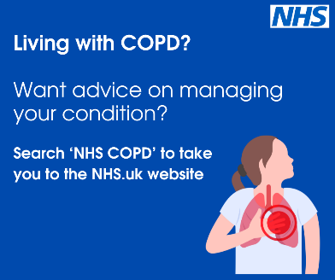  This and further assets available at: Long Term Conditions - UEC Comms North West - FutureNHS Collaboration Platform

  - Pressures

Introduction:
Winter is a time of increased pressures due to rising demand and higher prevalence of respiratory illness and other infections.
The regional winter pressures communications pack includes core narrative and template resources to help support trust communications teams when they are managing increased pressures and incidents.
It is intended to be used alongside organisations’ own established resources and approach to managing pressures.

  - Falls

Introduction:
Falls are not a normal part of ageing, and many falls can be prevented by following a few simple steps.
Falls, particularly for older people, can cause injury, pain, loss of confidence, and reduced quality of life. They are also a major reason for hospital admission and can lead to further complications and health problems.
Reducing the number of falls is important for maintaining the health, wellbeing and independence of older people.
During winter the cold weather can increase the risk of falls because of wet leaves, snow, rain and ice all making the ground slippery.
We’ve developed this toolkit with tips and advice on how to prevent falls both in and outside the home.
The messages in this toolkit are aimed at those most likely to experience a fall as well as their carers and family members who support them.

Key messages:

- Falls are not a normal part of growing older and many falls can be prevented. If you, or somebody you care for, is more at risk of a fall, there are simple steps you can take to make a fall less likely.
- It’s true that as we age our chances of having a fall increase but making changes to prevent falls can help you avoid injuries and keep your confidence and independence.
- There are a number of reasons why someone might be more likely to fall. These include things like weak muscles or poor balance, health conditions like dementia or the side effects of medication. Trip hazards in the home or cold weather can also increase someone’s chances of falling.
- Falls can lead to serious injury and hospital treatment. Even if a fall does not lead to serious injury, it can cause the person to lose confidence, become withdrawn, and feel as if they have lost their independence.
- It’s important to discuss any falls you have had with a health care professional and let them know if it's had an impact on your health and wellbeing. They can carry out simple tests to check your balance and signpost you to further support.
- If you’re not online ask for help with setting up a tablet or phone. You can then access trusted health sites.
- Falls are more likely during the winter months because of factors such as icy conditions, snow and less daylight.
- Take the time to check in on older friends, neighbours and loved ones, particularly during winter, and help them make simple changes to reduce their risk of a fall.
- The NHS top five tips for preventing falls include:
  - Keep yourself as active as you can. Try to add strength and balance exercises into your regular routine. You could try the KOKU app
  - Stay up to date with your eye tests.
  - Stay up to date with your medication reviews.
  - Keep your home free from clutter.
  - Be prepared for cold weather.
- What to do if you have a fall:
  - If you have a fall, it's important to keep calm.
  - If you're not hurt and you feel strong enough to get up, do not get up quickly. Roll onto your hands and knees and look for a stable piece of furniture, such as a chair or bed.
  - Hold on to the furniture with both hands to support yourself and, when you feel ready, slowly get up. Sit down and rest for a while before carrying on with your daily activities.
  - If you're hurt or unable to get up, try to get someone's attention by calling out for help, banging on the wall or floor, or using your personal alarm or security system (if you have one). If possible, crawl to a telephone and dial 999 to ask for an ambulance.
  - Try to reach something warm, such as a blanket or dressing gown, to put over you, particularly your legs and feet.
  - Stay as comfortable as possible and try to change your position at least once every half an hour or so.
- Visit the NHS falls prevention page for more information.

Newsletter/Website copy:
Falling doesn’t have to happen as you get older – tips for staying on your feet this winter
Many people think falling is just something that happens as we age — but it’s not.
Older people can be more likely to fall because of things such as weaker muscles, health conditions such as dementia and the side effects of medication but, most falls can be prevented.
Falls can lead to serious injury, but it can also impact a person’s wellbeing and confidence. So, it’s important, particularly during winter when the ground is more slippery and there’s less daylight, that we follow simple steps to help prevent falls.

Top tips to help you stay on your feet:
- Keep active – Add strength and balance exercises into your regular routine. You could try the KOKU app
- Check your eyesight – get regular eye tests, which are free if you’re over 60, to catch changes that could affect your balance.
- Have regular medication checks – some medications can make you more at risk of a fall. Make sure to ask your GP for a yearly review.
- Make your home safe – clear away clutter, particularly from floors and stairs. Make sure rooms and hallways are well lit and remove loose rugs. You can use this checklist to help you make your home safe.
- Be careful outside – during winter, watch out for ice, wet leaves, and snow. Wear good-grip shoes and use handrails where possible.
If you are a friend, relative or carer of someone who is at more at risk of falling, talk them through the importance of following these tips and ensure their home is as safe as it can be. Also share with them what to do if they do have a fall at home alone and how to get help.
Remember: Getting older doesn’t mean you have to fall. Stay safe and independent this winter.
Visit the NHS falls prevention page for more information.
Social media:
Regional Assets
Body text/ALT text | Thumbnail/links
Your eyesight helps you keep your balance and stop falls.  When did you last have your eyes checked? Maybe it’s time to book an appointment.  Go to the NHS website and search ‘eye tests’ to learn more.  #PreventingFallsThisWinter  ALT text:  Two people, both wearing woolly hats are stood outside, both are looking at the camera. One has a pink hat on and has her arms around the other. One in a blue hat is also wearing sunglasses.  Text reads: Keep safe from slips, trips and falls.  Top tip 1 – stay up to date with your eye tests. | 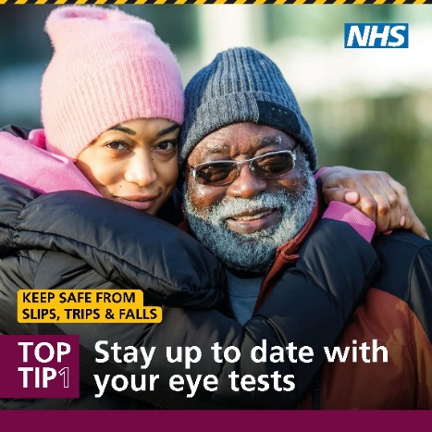  assets - UEC Comms North West - Futures
Falls aren’t just a normal part of getting older — they can be prevented! Staying active lowers your risk of falling.  Add strength and balance exercises into your routine to prevent falls. Search ‘koku app’ for more information.  There are other simple activities to keep active— even a quick 10-minute walk can make a difference.  #PreventingFallsThisWinter  ALT text:  Two people wearing coats and holding hands are walking on a street with leaves on the ground. Their backs are to the camera.  Text reads: Keep safe from slips, trips and falls.  Top tip 2 – keep yourself as active as you can. | 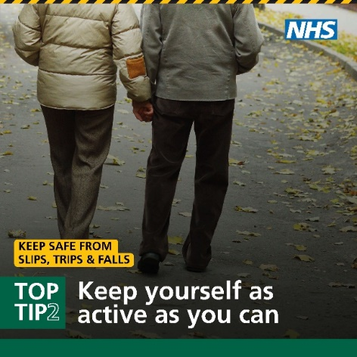  assets - UEC Comms North West - Futures
Falls aren’t a normal part of aging — but taking lots of medications at the same time can increase your risk. Side effects from medicines may affect your balance  Make sure you go to your health checks and medication reviews when invited, and if you have any questions, ask your GP.  #PreventingFallsThisWinter  ALT text: A pair of hands. In one hand is a glass of water, in the other are two tables.  Text reads: Keep safe from slips, trips and falls.  Top tip 3 – stay up to date with your medication reviews | 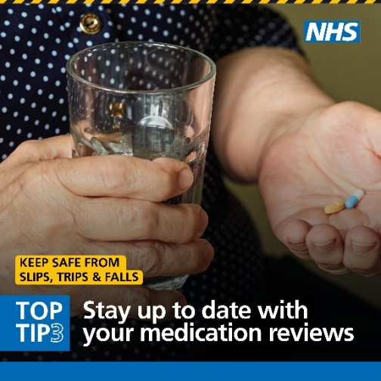  assets - UEC Comms North West - Futures
Remember, falls aren’t a normal part of getting older —make your home safer to help prevent them.  Here are our top tips to keep safe:  - Clean up spills straight away.  - Remove clutter, loose wires, and worn carpets.  - Use non-slip mats and rugs.  - Keep all rooms, hallways, and stairs well lit.  - Arrange your furniture so you don’t have to climb, stretch, or bend often.  - Ask for help with tasks that aren’t safe to do alone.  #PreventingFallsThisWinter  ALT text:  Living room with a navy sofa and coffee table. Clutter around the room such as tissues and rubbish on the floor.  Text reads: Keep safe from slips, trips and falls.  Top tip 4 – keep your home free from clutter. | 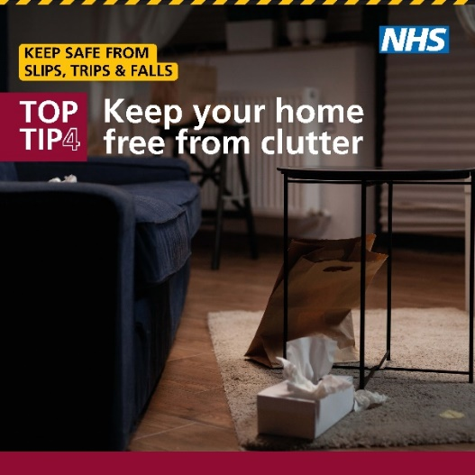  assets - UEC Comms North West - Futures
Remember, icy, snowy, or paths covered in leaves during winter can make slips trips and falls more likely.  With colder temperatures, it’s important to dress warmly and wear shoes with good grip. Gloves can help protect your hands if you do slip.  Also, remember to keep your driveway and paths clear of ice and snow.  For more tips, visit the NHS website and search ‘falls’.  #PreventingFallsThisWinter  ALT text:  A wet and icy pavement.  Text reads: Keep safe from slips, trips and falls.  Top tip 5 – be prepared for the colder weather. | 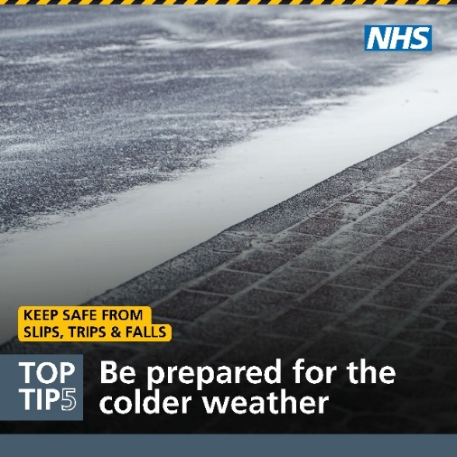  assets - UEC Comms North West - Futures assets - UEC Comms North West - Futures
Leah Hindley, a Community Physiotherapist in Bury, shares some simple winter tips to help keep yourself or a loved one safe.  Remember, falls aren’t a normal part of aging — taking these simple steps can help keep you steady and on your feet.  #PreventingFallsThisWinter | Video: assets - UEC Comms North West - Futures  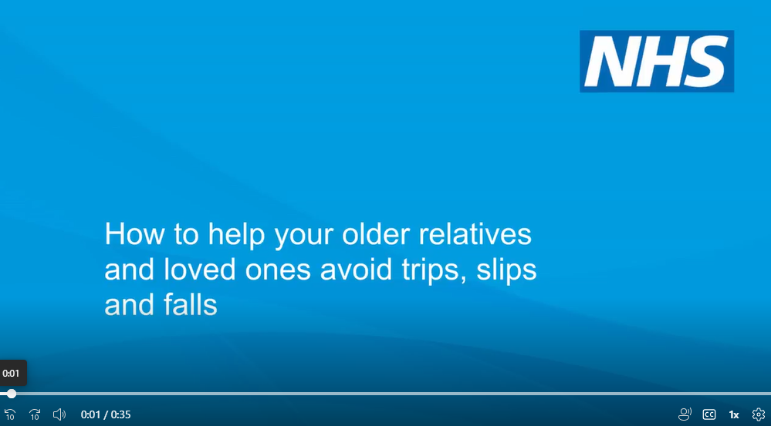
Did you know that staying hydrated can help prevent a fall?  Professor Rowan Pritchard Jones, Medical Director, NHS Cheshire and Merseyside, explains the risks of dehydration and the importance of staying hydrated for older people.  This is a reminder to help your loved ones to stay hydrated no matter what time of year. ❤️  #StayWellThisWinter #HomeCareTips #Hydration | Video: future.nhs.uk/NorthWest_UECComms/view?objectId=234906853  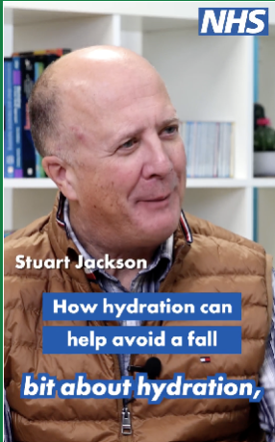
Simple changes around the home can potentially avoid life-changing falls, particularly amongst those more susceptible to falling. This could be clearing away clutter or removing loose mats and rugs that could cause a trip hazard.  Watch to find out how you can help a loved one avoid a fall.  #PreventFallsThisWinter  ALT text:  Falls risks are all over our homes. | future.nhs.uk/NorthWest_UECComms/view?objectId=239529125  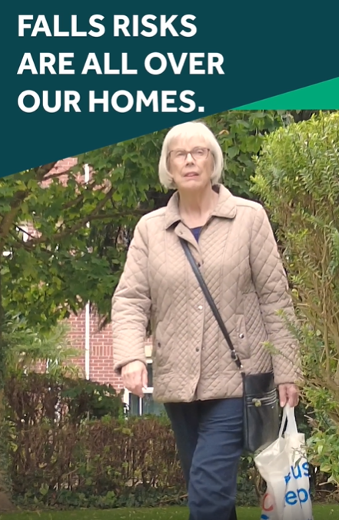
The drop in temperature in winter means more chance of ice, snow and falling leaves. These can all increase the risk of a fall, so it’s important to be extra careful.  But, it is also really important to stay active, as this can help keep your bones and muscles strong and reduce your risk of falls.  👉Here are our top tips on how you can stay safe, whilst being active this winter.  #PreventingFallsThisWinter #Winter #StayWellThisWinter  ALT text:  HOME  Top Tips to stay safe outside | future.nhs.uk/NorthWest_UECComms/view?objectId=59281424  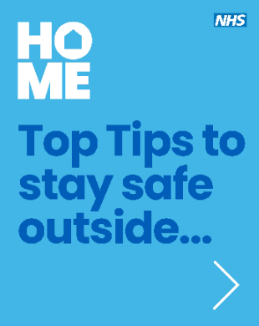

  - Keeping well in hospital

Introduction:
Sharing information to encourage patients to keep well in hospitals – and their families and friends to support them - will help efforts to ensure timely discharge, which in turn supports hospital flow and helps to manage pressures.
Key messages:
Advice for patients:
While you’re in hospital
- When you are lying in bed for a long period of time your muscles will begin to lose strength, making recovery more difficult.
- You can prepare yourself for going home by staying as active as possible while you are in hospital.
- Being active in hospital will help you get better faster and also means that you will have less chance of problems when you go home.
- Ask your clinical team what simple exercises you can do either in or out of bed.
- If possible sit out of bed in your own clothes and keep your mind active by doing puzzles or reading.
- It is very important to eat well to aid recovery. Eating little and often small and nutritious meals will help to fight infection, give you more strength to move around and breathe better, and stay in hospital for less time.
For family and friends:
- If you are visiting a loved one ask them if they'd like any snacks bringing in to help with their appetite. Always choose full fat and full sugar food and drinks.
- Help older people in hospital to stay well and reduce the risk of pressure sores by helping them walk around the ward if their medical team say it’s ok and encouraging them to change position if they are in bed when you visit.
- Help your loved ones maintain a routine that is similar to what they do at home can help to aid their recovery, such as sitting up for meals, getting dressed and walking to the bathroom.

Social media:
Regional Assets
Body text/ALT text | Thumbnail/links
Why is it important to stay active when in hospital?  When you are lying in bed for a long period of time your muscles will begin to lose strength, making recovery more difficult.  That is why it is essential that you or your loved one stay active in hospital, to help make the transition to home easier.  We’re here to support you on your journey to getting better. ❤️  #StayWellThisWinter #Supportinhospital #Activeinhospital | Video: future.nhs.uk/NorthWest_UECComms/view?objectId=234903717  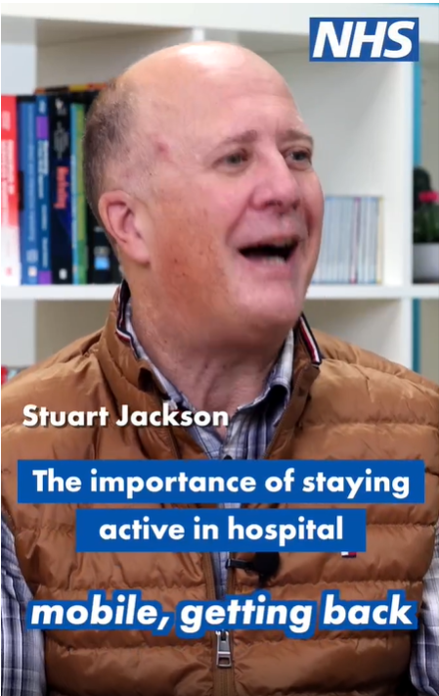
You can prepare yourself for going home by staying as active as possible while you are in hospital.  Being active in hospital will help you get better faster and also means that you will have less chance of problems when you go home.  👉Follow for tips on how you or a loved one can stay active whilst in hospital.  #StayActive #ActiveInHospital  ALT text:  Letters spelling out HOME. Getting ready to go home. | future.nhs.uk/NorthWest_UECComms/view?objectId=60937904  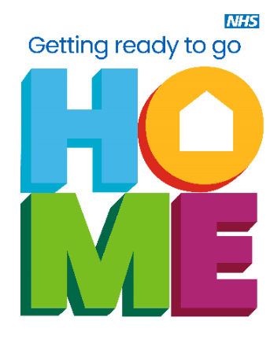
🏥 Nobody wants to be in hospital longer than needed. Being home or back in the community is best for recovery! 🏡💙  For those age 80+, 10 days in hospital = 10 years of muscle loss.  Let’s support safe, timely discharges.  #StayWellThisWinter #RecoveryMatters | Video: Samantha Westwell, Chief Nurse - the importance of staying active in hospital: Keeping well in hospital/Getting home quicker - Chief Nurse - Sam Westwell - UEC Comms North West - Futures
Help stop the spread of illness in hospitals.  Join Sam, a chief nurse, as she shares essential tips on keeping patients, staff, and visitors safe. Learn how small actions can make a big difference when visiting loved ones in hospital. 💙  #StayWellThisWinter #StaySafe #StopTheSpread | Video: Samantha Westwell, Chief Nurse – preventing the spread of infection in hospital: https://future.nhs.uk/NorthWest_UECComms/view?objectId=256579877
A4 posters for patients, staff and visitors: B0155_A4_Posters_Patients_NHS_Blue - UEC Comms North West - Futures
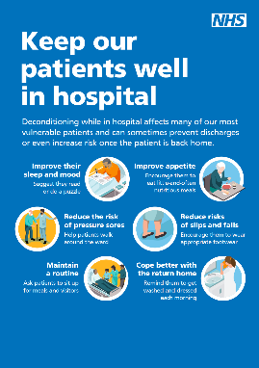
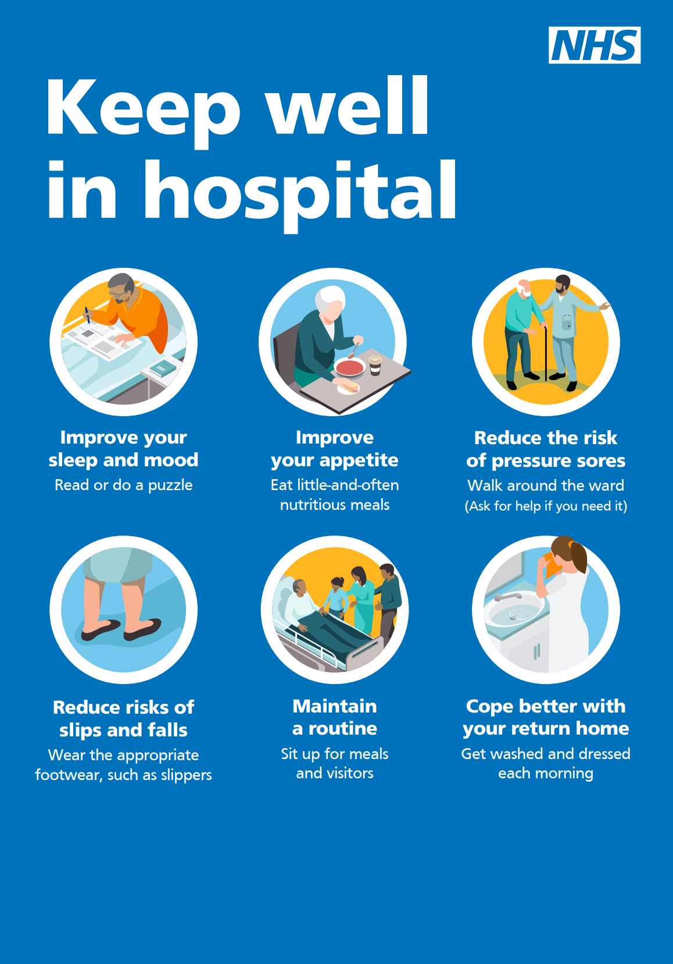
Option 1:  Do you have a loved one in hospital? Did you know you could help improve their sleep or mood on your next visit.  Sleep is as important to our patients health as eating, drinking and breathing. It allows our bodies to repair themselves and our brains to consolidate our memories and process information.  Next time you visit consider taking them in ear plugs, a sleep mask, Book or puzzle to keep them well in hospital  Option 2:  Help your loved ones maintain as much as a normal routine as possible while they are in hospital.  When you visit encourage, if appropriate your loved one to sit up for meals like they would at home.  Being in hospital can make it easier to just stay in bed, but lying down all day makes our muscles weaker. The longer they stay in a hospital bed, the harder they may find it to get up and about as they get better.  ALT text:  Help keep your loved one well in hospital. Improve their sleep and mood. Suggest they read or do a puzzle. | Social media assets for family/carers: B0155_SM_Sq_Public_NHS_Blue.pdf  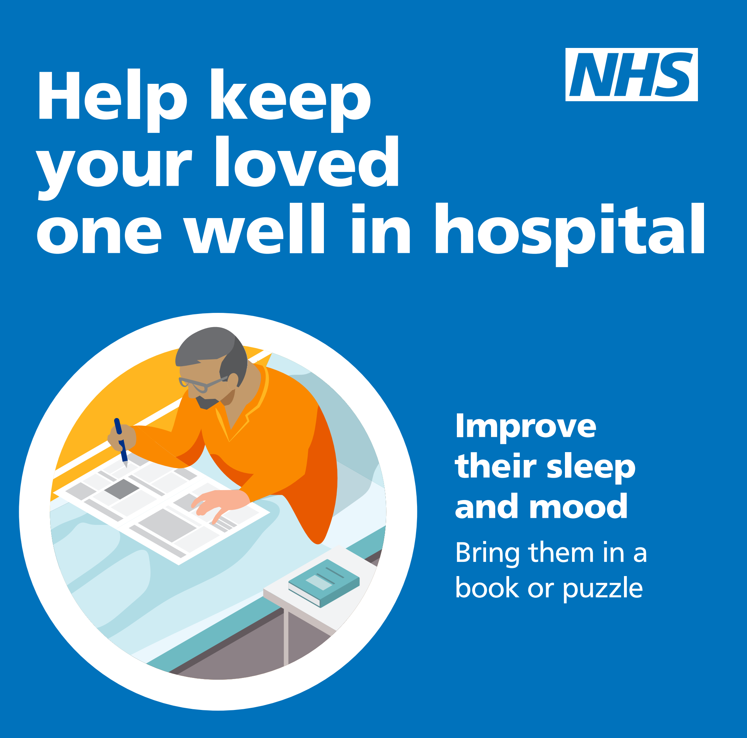
Together we can help keep our patients well in hospital by:  Reminding them to get washed and dressed each morning.  Helping patients walk around the ward.  Encouraging them to wear appropriate footwear.  ALT text:  Help keep our patients well in hospital. Improve their sleep and mood. Suggest they read or do a puzzle. | Social media assets for staff: B0155_SM_Sq_Staff_NHS_Blue - UEC Comms North West - Futures  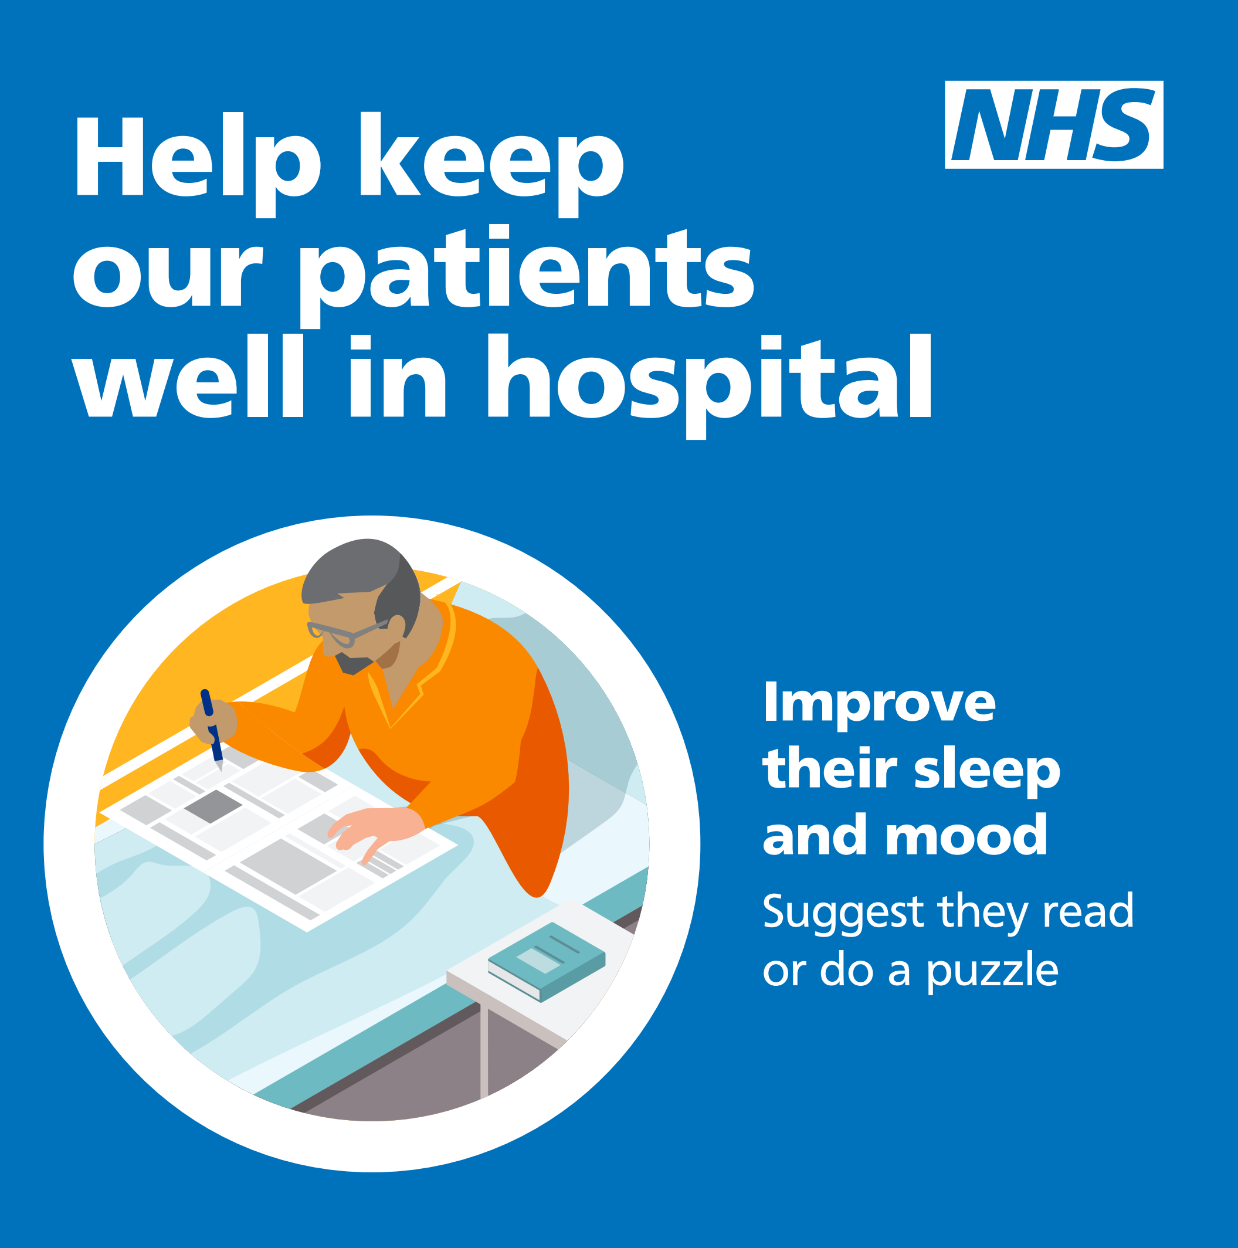
Background for Microsoft Teams: B0155_TeamsBack_NHS_Blue - UEC Comms North West - Futures
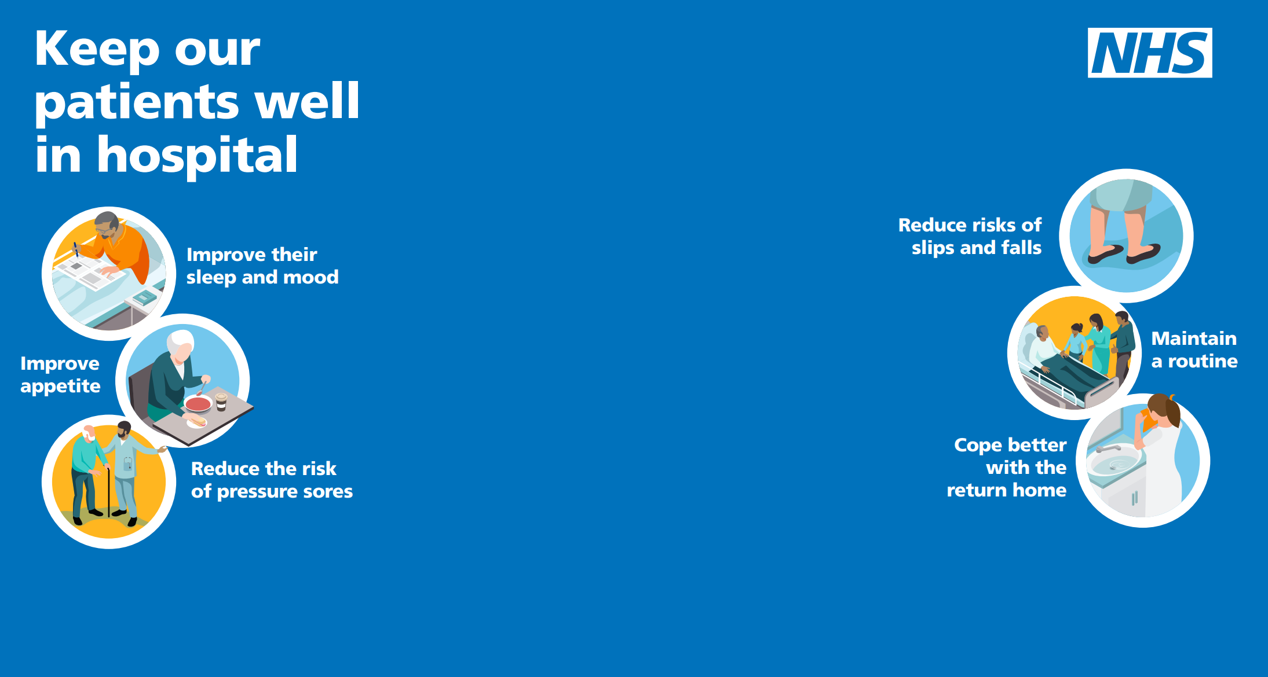

  - Discharges

Introduction:
This content aims to highlight the importance of effective discharge and ensure that discharge awareness amongst staff across the health and care sector is raised.
It provides messaging for use in staff communications as well as messaging for patients, families and carers.
Messaging for staff seeks to raise the awareness of harm caused by avoidable delays in discharge and prolonged length of stay in hospital. Messaging for patients, families and carers focusses on patients in hospital in relation to how they can prepare for discharge and for families and carers on what they can do to prepare for someone coming home
Key messages:
Staff facing:
It is important that staff working across health and care understand the impact that avoidable delays in discharge can have on patients. For some people delays and prolonged lengths of stay in hospital can have a detrimental and long-term impact on them as an individual and for their families. The following messages have been summarised to provide context and can be used to include in staff and partner communications.
- A delayed discharge is a potential harm event - each day we fail to return people home to recover, the risk of their physical or mental health deteriorating increases. 35% of 70-year-old patients experience functional decline while in hospital.
- A delayed discharge not only increases risk to the patients but also prevents patients who need a bed being admitted in a timely way – it creates bottlenecks and pressure in the system.
- There is a small window of opportunity to return older, frail people home, or they may never return to their usual home. If we delay them being discharged, they can become dependent very quickly, resulting in a lengthy hospital stay and possibly needing to move into a care facility afterwards.
- Safe, timely discharges should happen every day of the week. Planning to discharge patients at weekends and during holidays is critical to maintaining patient flow and minimising delays to discharge.
- Plan their return home as early as possible. Speak to the patient about what they would like in place before they go home and discuss with family and carers. Make sure GPs and care providers are aware at an early stage about medication and care arrangements. Could local voluntary or faith organisations help with support at home?

- Resources are available to support you with discharge planning. Reach out to your local discharge coordinators, social care teams, or community partners for guidance.
- Keep patients as active as is safely possible while in hospital. Encourage all patients to be dressed before breakfast and walk around the ward. Ask family and friends to bring in clothes, shoes, glasses and walking sticks to help them.
Patient/family facing:
In addition to any national or locally developed assets, Trusts and partners may want to focus on the concept of ‘home’ to create a sense of positive imagery and messaging to encourage patients to get back to the things, people and activities they enjoy. The following messages have been developed to support this concept and can be used to supplement established information or assets.
Going home is the best place to be to help you recover
- Once you have had the care that you need in hospital, research shows that going home will help you get better much faster.
- The longer you stay in a hospital bed, the harder you may find it to get up and about as you get better. So, it’s really important that we work together to get you home when it is safe to do so.
- By asking questions, sharing information and following the advice of the doctors and nurses looking after you, we can help you get ready to go home quicker.
- Find out the questions you can be asking your doctors and nurses to help you get home quicker.

Bringing a loved one home from the hospital?
Follow these points on how you can help support your loved one once they return home from the hospital.
- If you’re not able to care for them, and/or need help to do so, then you have a right to a carer’s assessment to have your needs considered too.
- Check what your council or local authority can offer. Find their websites using the online postcode tool at www.gov.uk/find-local-council
Once your loved one is home
- Have a prescription check in on your loved ones and neighbours
- Make sure they have their prescription medicines available, or if they need help picking them up, before the festive period—or before bad weather hits.
- If your loved one needs help while GP practices or pharmacies are closed, NHS 111 is here for them.
- Visit 111.nhs.uk for advice on what to do and where to go. A little care can go a long way.
- Ensure they have sufficient amounts to eat and drink
- Make sure there are no trip hazards to prevent falls
- If your loved one needs to go out then ensure they have sturdy shoes with a good grip. A scarf around the mouth will help to protect them from the cold air, and to reduce their risk of chest infections.

Social media:
National Assets
National patient-facing resources | When Am I Going Home?
National staff-facing resources | Where Best Next?
Regional Assets
Body text/ALT text | Thumbnail/links
👩‍⚕️ Join Sam, a Chief Nurse, as she talks about the key organisations and people who help patients transition safely from hospital to home. 🏡💙 | Video: NHS Chief Nurse – the transition from hospital to home is a team effort: https://future.nhs.uk/NorthWest_UECComms/view?objectId=256579301
Are you preparing for a loved one to come home from hospital?  Here are some top tips from Sam, a Chief Nurse, to help you prepare:  ✅ Keep their home warm and cosy  ✅ Stock up on food and essentials  ✅ Bring warm, comfortable clothing  ✅ Arrange early-morning transport  A little preparation can make a big difference! 💙  #StayWellThisWinter #returninghomefromhospital | Video: NHS Chief Nurse – loved ones returning home: https://future.nhs.uk/NorthWest_UECComms/view?objectId=256579269
Once you have had the care that you need in hospital, research shows that going home will help you get better much faster.  The longer you stay in a hospital bed, the harder you may find it to get up and about as you get better. So, it’s really important that we work together to get you home when it is safe to do so.  By asking questions, sharing information and following the advice of the doctors and nurses looking after you, we can help you get ready to go home quicker.  Find out the questions you can be asking your doctors and nurses to help you get home quicker.  ALT text:  Hospital to home time to ask…  What’s the matter with me?  What happens next?  What can I do to get better?  When might I go home? | future.nhs.uk/NorthWest_UECComms/view?objectId=233110949  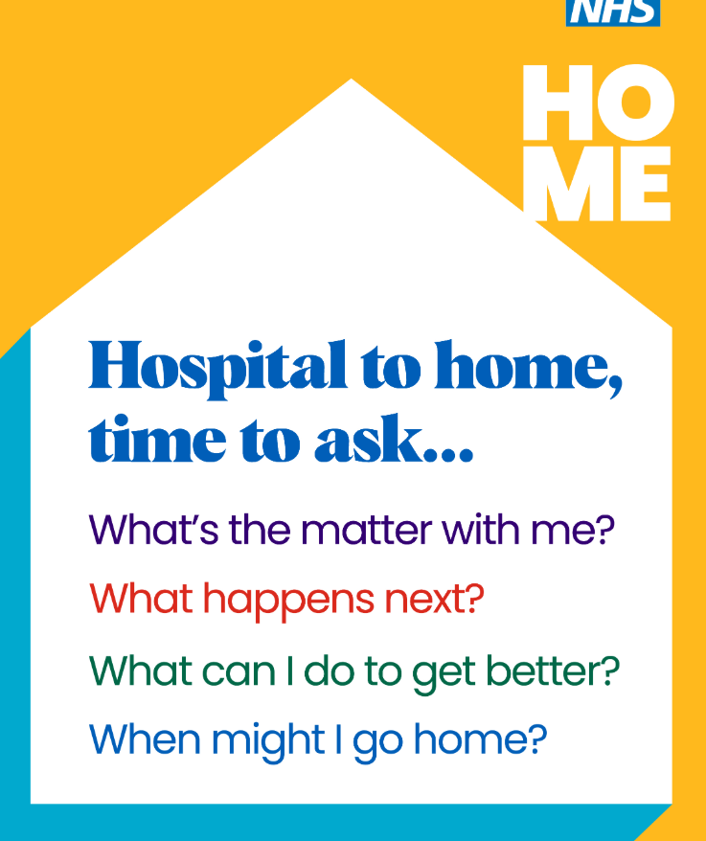
Bringing a loved one home from the hospital?  Follow these points on how you can help support them on their return home.  If you’re not able to care for them, and/or need help to do so, then you have a right to a carer’s assessment to have your needs considered too.  Check what your local council can offer. Find their websites using the online postcode tool at gov.uk/find-local-council  #StayWellThisWinter #CommunitySupport  ALT text:  Bringing a loved one HOME.  Emotional Support. Housework help. Personal support. Medicines or food. Paid services. | future.nhs.uk/NorthWest_UECComms/view?objectId=239522245  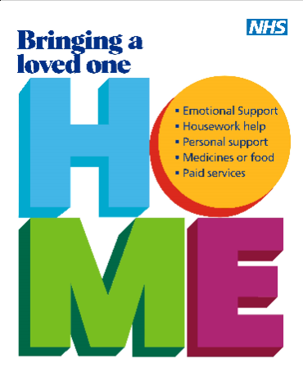
Getting ready for a loved one’s return from hospital? 🏠  Catch Professor Rowan Pritchard Jones and Stuart Jackson as they share tips on how you can prepare their / your home after returning from hospital. 👇  We can work together to help your loved one have a safe and comfortable transition home ❤️  #StayWellThisWinter #HomeHealth | Video: future.nhs.uk/NorthWest_UECComms/view?objectId=233112037  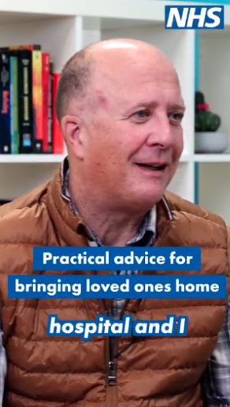
Steps on how you can prepare for the return of a loved one from hospital 👇  Join Professor Rowan Pritchard Jones as he chats with Julie about how her family can ensure their home is a safe and welcoming place for her dad’s return from hospital.  Together, we can ensure a safe and comfortable transition back home for your loved one 🏠❤️  #StayWellThisWinter #HomeCareTip | Video: future.nhs.uk/NorthWest_UECComms/view?objectId=239382629  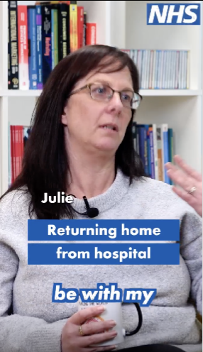
Do you have an older loved one who often forgets to take their medication? 💊  Here Professor Rowan Pritchard discusses the importance of medication being taken correctly, and how you can best support your loved one to do this.  We are here to help support you, to support them 💙  #StayWellThisWinter #HomeHealth #Medication #MedicationTips #WinterCare #HealthTips | Video: future.nhs.uk/NorthWest_UECComms/view?objectId=59782960  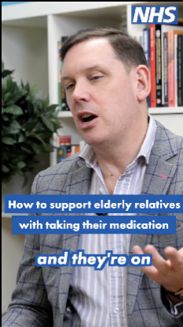
Supporting a loved one on their return home from hospital can make a positive difference in their recovery. From emotional support to everyday tasks, there are many ways you can help. 💙  👉 Swipe to find out our top tips on how you can support a loved one returning from hospital.  Let’s work together to help them feel safe, supported, and cared for. 🤝  #StayWellThisWinter #SupportAfterHospital #HomeCare  ALT text:  HOME.  Top Tips for supporting someone returning home from hospital. | future.nhs.uk/NorthWest_UECComms/view?objectId=60935696  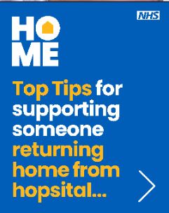
Home for Christmas assets

Winter can be a challenging time, especially for older neighbours, friends, or family members.  Here’s how you can help:  🎁 Check Supplies: Make sure they have enough food for a few days in case bad weather keeps them indoors.  🎁 Stay Warm & Safe: If they need to go out, encourage sturdy shoes with a good grip, and a scarf around the mouth to protect them from the cold air, and to reduce their risk of chest infections.  🎁 Prescriptions Check In: Help them get any medicines they need before the holidays or bad weather hits.  If they need help when GP practices or pharmacies are closed, NHS 111 is available online at 111.nhs.uk for advice on what to do and where to go.  Your kindness could make all the difference this festive season. 🌟  #StayWellThisWinter #ChristmasKindness #LookingOutForOthers | future.nhs.uk/NorthWest_UECComms/view?objectId=233110885  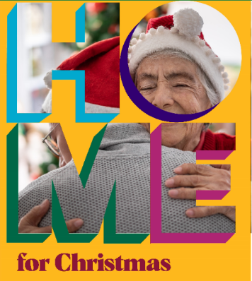
Do you have older loved ones visiting this festive period? 🏠  Take some time to check your home is safe and comfortable for their stay, whether they are stopping for a few hours or a few days.  These steps can help to prepare your home this festive period 🎄 ❤️  #StayWellThisWinter #ChristmasKindness #LookingOutForOthers | future.nhs.uk/NorthWest_UECComms/view?objectId=233110085  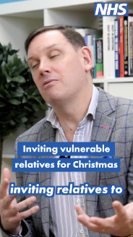

Additional discharge assets:
The resources below can be found at: UEC Comms North West - FutureNHS Collaboration Platform
You will need to register on NHS Futures to access.
- NHS England North West discharge communications toolkit – including staff facing posters
- NHS-branded patient and staff facing assets for social media and digital screens, including Christmas messaging
- NHS branded patient leaflet (produced and shared by the Northern Care Alliance, Greater Manchester)
- NHS branded social media resources (produced and shared by the Countess of Chester Hospital, Cheshire and Merseyside)
https://future.nhs.uk/NorthWest_UECComms/view?objectId=54275408
Recordings of Lunch and Learn webinar sessions hosted by NHS Cheshire and Merseyside can be found below and are suitable for sharing with staff more widely in the North West. The sessions feature presentations from subject matter experts on key improvement topics in relation to managing patient flow.
- Session 1 - Engaging the Voluntary Sector in Hospital Discharge
- Session 2 – Ambulance handovers
- Session 3 – Super charge your Super MaDE
- Session 4 – Capacity and Flow – Challenges for Mental Health
- Session 5 – Thinking like a farmer - Developing sustainable improvement approach
- Session 6 – Redline Toolkit
- Session 7 – RCP Modern ward round self assessment
- Session 8 - Role of SDEC within Acute Medicine

