Completing the Application Form - Part 1
Contact Information

Question a) – Please give the name of the lead contact for this application / project. They will be the primary point of contact for all matters relating to this application and any successful project award.

Question b) – Please give a secondary contact. They will only be contacted if we have difficulty reaching the lead contact.

Unincorporated Associations (community/voluntary groups): both contacts should be members of your management committee.

Organisations: at least one contact must be a board member or senior member of staff.

About your organisation

Question 1) – Please give the full name of your organisation.

Question 2) – Please give the registered address of your organisation. If you don’t have a registered address as such, please provide the address of your Chair.

Question 3) – Please give your organisation’s turnover for the last full financial year.

Question 4) – Please tell us how your organisation is constituted, for example:

- Unincorporated Association (community/voluntary group)
- Company Limited by Guarantee
- Registered Charity
- Charitable Incorporated Organisation
- Community Interest Company
- Community Benefit Society
- Cooperative Society
- Other (give details)

Please note:
- All organisations must be not-for-private-profit
- Companies Limited by Guarantee must have an ‘asset lock’ to prevent the transfer of assets to individuals
- Some charities might also be a company limited by guarantee

Question 5) – Please give your organisation number (i.e. registered with the Charity Commission or Companies House). If you have more than one organisation number, please provide both. Please note, Unincorporated Organisations (community groups) will not have an organisation number.

Questions 6) – Please provide links to your organisation’s website and social media accounts (if applicable).

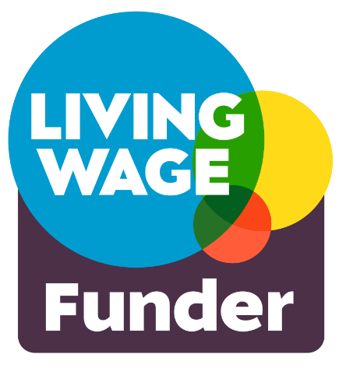
Questions 7-8) – We are keen to support all staffed organisations that pay a minimum wage of at least £12.60 per hour as set by the Living Wage Foundation. We also actively encourage organisations to become an accredited Living Wage Employer. If you don’t employ staff, please tick the ‘not applicable’ box (N/A).

The cost of Living Wage Employer accreditation fees varies according to the size of your organisation, starting at £71 per year for those with fewer than 10 employees. This includes regular third-party contractor staff.

For full details of the costs please contact the Living Wage Foundation via their website.

Question 9)– If your organisation pays all staff at the real living wage rate of £12.60 or more, but is not accredited as a Living Wage Employer, you can request support from Salford CVS to meet your first year’s accreditation fees.

Question 10) – We expect all organisations to have relevant policies in place at the time of application. Please note that that Public Liability Insurance costs can form an element of your bid. If you need advice or support on developing policies, please see the ‘What support is available to applicants?’ section above.

Please note that you will need to submit copies of the following documents along with your application:
- Safeguarding Adults Policy (only if applicable to your project)
- Safeguarding Children Policy (only if applicable to your project)

Project summary

Question 11) – Please give your project a memorable name. This helps us identify the project should your application be successful.

Question 12) – Please give a brief description of the project that sums up what you plan to do (140 characters max). This will be used in our publicity about the fund, including on our website, so please ensure the summary is a clear and meaningful representation of the activities and you plan to do with the grant.

Question 13) – Please give your proposed project start and finish dates. Approximate delivery periods are provided on page 5 of these guidance notes.

Question 14) – Please indicate the areas of Salford which will receive support from your project. If it is across the whole of Salford, please tick ‘Salford city-wide’.
See the map below showing Salford’s new ward boundaries:

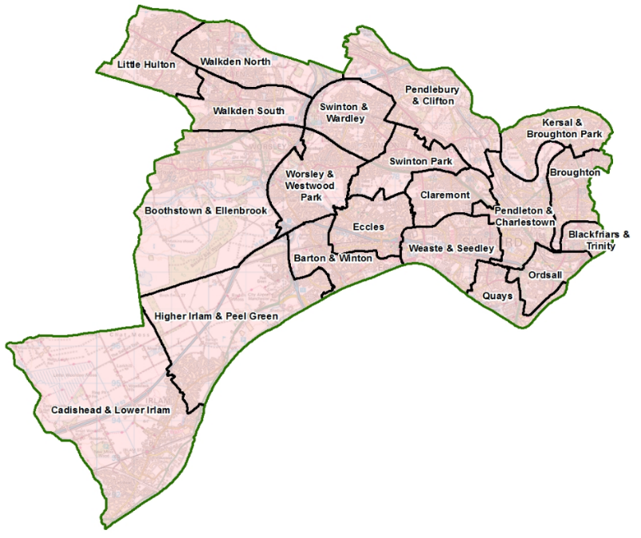
Question 15) – If your project is delivered from a single location (e.g. a community centre or park) please provide a postcode. If your activity will happen at more than one location, please provide all the postcodes. If this proves too difficult or isn’t applicable, please give details. All activity should take place in Salford unless there is a clear and compelling reason to deliver it elsewhere.

Completing Application Form - Part 2

Question 16) – Please tell us how women and girls are represented within your organisation. Please use the relevant box to describe the number of women and girls represented in each level of your organisation and if relevant, the positions they hold.

Question 17) – Please tell us what activities or programmes your organisation has delivered to support women and girls, and the impact these have had.

Question 18) – Please tell us which priority or priorities of the fund (A-C) your project is most focused on addressing. The priorities are described in more detail on page 3 of the guidance notes. Please note, selecting more than one priority does not increase the likelihood of receiving funding.

Example 1
For a project focused on providing peer-to-peer support group for women who have experienced gender-based violence, you would place a check (X) next to priority B.

Example 2
For a project focused on providing women affected by domestic violence with a range of workshops including financial literacy education and leadership skills, you would likely place a check (X) next to priorities B and C.

Question 19) – Please indicate using the relevant box whether this project is new, a continuation of an ongoing project, or expanding a project you are currently running.

Question 20) – Please use simple language to tell us who will benefit from the project. Mention anything you think we should know about them or that they have in common, for example they might live in the same area, have a shared background or culture, or have similar hobbies or interests.

Question 21) – We want to know how many activities with the community are being funded with this grant. If you plan to deliver different types of activities e.g. group and one-to-one sessions, you may wish to provide a breakdown as well as the total number.

Question 22) – Please tell us how many people will benefit directly from the project. Be realistic – we are interested in funding organisations delivering good projects with a manageable number of beneficiaries. We are not looking to understand the number of times people interact with your project – so if someone will attend more than once, they should only be counted once in this figure.

If you plan to run very different sorts of activities e.g. one-to-one sessions and a mass participation event, you may wish to provide a breakdown for clarity.

Question 23) – Please tell us what you intend to do with the grant if successful. Please give details of the practicalities involved in delivering your project, for example how you will use the money, what you plan to do, who will deliver the activities, the frequency of activities, when and where they will happen, how they will be promoted, etc. This activity must be recognisable in your project budget.

What difference will the project make?

Question 24 – Please explain how your project will benefit women living in Salford. It should be clear how these benefits link to the priorities of the fund chosen in question 18.

Question 25 – Please describe the specific changes (outcomes) you expect the project to achieve. For example,’ ‘increased confidence and self-esteem,’ ‘raised personal aspirations,’ ‘increased social participation in local community,’ etc. The way these outcomes are measured and assessed might be very simple (e.g. number of people involved) or involve collecting evidence about the impact of the project (e.g. before and after survey, interviews, case studies, focus groups).

Just getting started with measuring outcomes? Helpful resources and advice are available on the NPC website: https://www.thinknpc.org/starting-to-measure-your-impact/ Alternatively, please contact the Grants Team for support before applying (see page 8 of Guidance notes, ‘Support with your application’).

Question 26) – As well as the direct impact on people’s health and wellbeing, your project might also achieve other social, economic, or environmental benefits for Salford. We refer to these wider benefits as social value.

Purchasing from local independent suppliers
As leading member of the Social Value Alliance, Salford CVS wants to ensure that as much of its grant monies as possible are spent in Salford. If possible, please try and avoid large chains or corporations, and especially Amazon who have been identified as the worst company for aggressive tax avoidance which deprives our government of much-needed funds for schools, hospitals, local services etc. If you do feel pressured to occasionally use Amazon, then buy from Amazon Marketplace which supports independent suppliers.

About the money

Question 27) – Please give an accurate breakdown of your project costs by describing each item. You’ll need to research some prices or obtain quotes (i.e. you can’t just guess the costs). Please break down your calculation so we can see how you’ve arrived at the cost for each item. See some examples below.

Example 1
Acceptable: Venue hire – 4hrs/wk @ £10ph x 10 weeks = £400
Not acceptable: Venue hire – £400

Example 2
Acceptable: Refreshments @ £1.50/person x 10 people x 10 events = £150
Not acceptable: Refreshments = £150

If other money is being used to support this project:
If you have other sources of money, it may be you’re only looking for a contribution to certain costs (see the example below).

Description of item | Breakdown of calculations | Item cost | Amount requested
Venue Hire | 4 hours per week @ £10ph x 10 weeks | £400 | £250

Full cost = £400
Amount requested = £250
Amount from alternative sources = £150 (e.g. an annual raffle)

Therefore, the total cost of the project may be more than the amount you’re requesting from this fund. If this is the case, please include the other sources of funding which will support this project and whether the money has been secured or whether an application is pending (see example below). Such match funding is desirable but not essential.

If applicable, where is the rest of the money coming from?
Source of funding | Amount | Funding Secured?
Annual raffle | £150 | Yes

Please attach
- If the project involves working with children or adults at risk, we need to review copies of the relevant policies. Please answer Yes or No. If Yes, you must attach the relevant policy
- Scan or photo of a recent bank statement or paying-in slip if not submitted previously in the last 6 months (for example, if you have recently received another grant from Salford CVS)

Declaration
Please confirm that you have read the Terms and Conditions of this grant by giving the name and role of the lead applicant.

