Salford CVS
Community Resilience Fund
Guidance for Applicants
2025



Contents
- About the fund
- Priorities of the fund
- Important dates
- Who can apply?
- How much funding can we apply for?
- What can the grant be spent on?
- What can the grant not be spent on?
- Examples of projects
- What policies and other documentation are required?
- What support is available for applicants?
- How do we apply?
- How will applications be assessed?
- What happens if we are awarded a grant?
- How will our project be monitored and evaluated by Salford CVS?

About the fund
The Community Resilience Fund is offering grants of up to £1,500 for activity to support community resilience and cohesion in wake of the Synagogue attack in Crumpsall in October 2025.

This fund recognises the important role that the voluntary, community and social enterprise (VCSE) sector plays in bringing people together, fostering connection, and building cohesion and resilience at the local level.

It is open to voluntary, community and social enterprise (VCSE) groups and organisations, which are full members of Salford CVS. Groups and organisations must be embedded in and have a track record working with the Jewish Community in Salford to apply.

The Community Resilience Fund is supported by Salford City Council with funding from the Ministry of Housing, Communities and Local Government.

Priorities of the fund
Your project should address one (or more) of the following priorities, which are aligned with the Salford City Council Community Cohesion Strategy:

A | Supporting Community Cohesion
 | - Bringing people from different backgrounds together to foster connection and belonging
B | Supporting Community Safety
 | - Increasing feelings of safety and security, including through making adaptions to community buildings
C | Supporting Community Wellbeing and Resilience
 | - Providing support for people affected by the attack and the wider community, to help improve wellbeing and resilience

Applications for projects addressing more than one priority are welcomed, however this will not increase the likelihood of receiving funding.

Unsure if your project is a good fit for the Community Resilience Fund? Please contact the Grants Team for an informal conversation before applying (contact details are available on page 8, ‘Support with your application’).
Feedback from the Jewish Community in Salford

We want to support the VSCE sector to develop projects or adapt their activities to support those affected by the Synagogue attack in Crumpsall, considering the feedback from Jewish community members below.

In November 2025, Salford CVS surveyed Jewish-led VCSE groups and organisations to identify the areas they feel the community would most benefit from support, the following are the four answers that were chosen most often:

- Community Safety (For Community Buildings): Ensuring that buildings are safe and secure for community use

- Social Activities: Providing opportunities for community members to come together and build connections

- Psychological Support (1-2-1 Therapeutic Support for Adults): Providing individual mental health and wellbeing support for community members

- Psychological Support (Group support for Adults): Providing mental health and wellbeing support for community members to in a group setting

Important dates
Organisations receiving a grant will have until 31st March 2026 to spend the grant.
Fund opens | Mid December 2025
Application deadline | Friday 2nd Jan 2026
Decisions expected | Within 4 weeks of the closing date
Approximate delivery period | Late January 2026 – 31st March 2026
End of project report due | Within one month of project completion

How much funding can be applied for?
Applications are welcomed for projects up to a maximum of £1,500.
Who can apply?
To apply, you group or organisation must meet the following eligibility criteria:
- Constituted as a voluntary, community or social enterprise (VCSE) group or organisation
- Currently adhere to the eligibility criteria for full membership of Salford CVS
– more details available at https://www.salfordcvs.co.uk/membership-0
- Groups are embedded in and have a track record of working with the Jewish Community in Salford
- Based in Salford OR have a strong track record of delivery in Salford
- Have an organisational bank account with two signatories who are not related to each other OR a holding account at Salford CVS
- Fully up to date with grant reporting to Salford CVS (if applicable)

What can the grant be spent on?
Most reasonable costs that are necessary to run your group or project, including (but not limited to):
- Venue hire
- Purchase or hire of equipment/materials
- Sessional worker/facilitator and/or staffing costs
- Volunteer expenses (linked to a project)
- Refreshments (including for participating staff and volunteers)
- Promotion
- Public liability insurance
- A contribution to overheads/management costs (must be proportionate to the project)
- Adaptions to buildings that meet the priorities of the fund
- Costs for one-off events

What can the grant not be spent on?
- Alcohol
- Retrospective costs (i.e. costs that have already been incurred or for activities that have already happened before a grant has been awarded)
- Costs for work that statutory bodies (such as schools or local authorities) have a duty to fund
- Projects or activities taking place outside Salford, unless a clear rationale is given
Examples of projects
Please note this is not an exhaustive list, and we recognise groups and organisations embedded in communities are best placed to identify specific challenges and opportunities to offer support.

Fund Priority | Example Project
Supporting Community Cohesion | A community art initiative designed to bring people from different backgrounds together and encourage lasting friendships
Supporting Community Safety | Installing a CCTV system in a community space
Supporting Community Wellbeing and Resilience | Facilitating a peer-to-peer support group centred on providing tools for emotional wellbeing and resilience

What policies and other documentation are required?
All organisations will be expected to have the following policies in place at the time of application:
a) Health and Safety policy
b) Equality/Diversity Statement or Policy
c) Public Liability Insurance (cost can be included in budget)
d) Risk assessments

…and if applicable to project activities:

e) Volunteer Policy
f) Safeguarding Adults policy
g) Safeguarding Children policy

Please note: If your project involves working with children or adults at risk, you will need to include a copy of the Safeguarding Policy.

How do we apply?
Download and complete the application form for a grant. Submit the completed form by email to grants@salfordcvs.co.uk in Word format before the application deadline. Alternatively, applications can be posted to: Salford CVS, The Old Town Hall, 5 Irwell Place, Eccles, M30 0FN

What support is available for applicants?

Accessibility
We want our grants programme to be accessible to everyone. If any part of our application process is a barrier to applying, please contact the Grants Team at grants@salfordcvs.co.uk or phone 0161 787 7795.

Support with your application
If you have any questions or concerns about completing the application form, or you would like to discuss your project proposal with a member of the Grants Team, please contact the Grants Team at honor.johnstone@salfordcvs.co.uk or phone 0161 787 7795. The Grants Team are also available to provide a pre-application read-though and feedback.

Wider development support
The Development Team at Salford CVS offer practical support to VCSE organisations with developing policies, accessing volunteers, and accessing wider funding. For further information, visit our website at:
www.salfordcvs.co.uk/development-support

See our online Safeguarding in Salford resources: www.salfordcvs.co.uk/safeguarding-salford

You can also contact our Development Team by phone 0161 787 7795 or email at: office@salfordcvs.co.uk

How will applications be assessed?
- On receipt of applications, Salford CVS will undertake eligibility checks
- All applications that are eligible will be independently scored by a panel consisting of representatives from Salford City Council, the Jewish Community in Greater Manchester, and Salford CVS
- The assessment panel will meet to agree the awards
- Unsuccessful applicants will be provided with a summary of feedback from the assessment panel

What happens if we are awarded a grant?
Successful applicants will be notified of their grant by email. Please read the offer letter attached to the email in full, which contains important information about the grant including the amount awarded, any conditions, and next steps to claim the grant. Once the required documents have been received we aim to issue the grant by bank transfer within 5-10 working days.

How will our project be evaluated by Salford CVS?
Salford CVS has a three-fold approach to evaluation:
- Assessing impact – the difference your project made in words, numbers, stories, quotes and photos
- Gathering learning – what you have learned as an organisation, how your organisation has developed and what you would do differently next time
- Providing assurance – demonstrating good management of public money

In practical terms, this means providing feedback to Salford CVS in the shape of a simple report form when your project is complete. We may also select your project for a monitoring visit (in person or remotely) to help us understand how you are getting on and if you’re in need of any support.

As guardians of public money, Salford CVS requires all funded organisations to keep receipts for all project spend. We undertake spot-audits every year and you may be asked to provide evidence of your spending.

With your help in providing simple feedback Salford CVS can demonstrate how grants and investments can make a real difference to the health and wellbeing of local people. This is important in helping us report back to our funders and wider partners, and helps secure investment in our sector over the years to come.

Any further questions?
Please contact the Grants Team by phone 0161 787 7795 or email at: grants@salfordcvs.co.uk

Completing Application Form - Part 1
Contact Information

Question a) – Please give the name of the lead contact for this application / project. They will be the primary point of contact for all matters relating to this application and any successful project award.

Question b) – Please give a secondary contact. They will only be contacted if we have difficulty reaching the lead contact.

Unincorporated Associations (community/voluntary groups): both contacts should be members of your management committee.

Organisations: at least one contact must be a board member or senior member of staff.

About your organisation

Question 1) – Please give the full name of your organisation.

Question 2) – Please give the registered address of your organisation. If you don’t have a registered address as such, please provide the address of your Chair.

Question 3) – Please give your organisation’s turnover for the last full financial year.

Question 4) – Please tell us how your organisation is constituted, for example:
- Unincorporated Association or Community Group
- Company Limited by Guarantee
- Registered Charity
- Charitable Incorporated Organisation
- Community Interest Company
- Community Benefit Society
- Cooperative Society
- Other (give details)

Please note:
- All organisations must be not-for-private-profit
- Companies Limited by Guarantee must have an ‘asset lock’ to prevent the transfer of assets to individuals
- Some charities might also be a company limited by guarantee

Question 5) – Please give your organisation number (i.e. registered with the Charity Commission or Companies House). Please note that Unincorporated Organisations / Community Groups will not have an Organisation Number.

Questions 6) – Please provide links to your organisation’s website and social media accounts (if applicable).

Questions 7-8) – We are keen to support all staffed organisations that pay a minimum wage of at least per hour as set by the Living Wage Foundation. We also actively encourage organisations to become an accredited Living Wage Employer. If you don’t employ staff, please tick the ‘not applicable’ box (N/A).

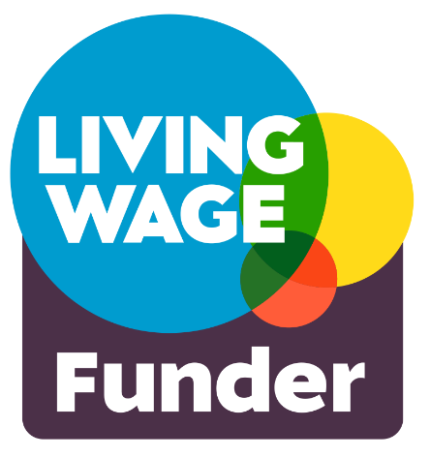
The cost of Living Wage Employer accreditation fees varies according to the size of your organisation.

For full details of the costs please contact the Living Wage Foundation via their website.

Question 9)– If your organisation pays all staff at the real living wage rate of £13.45 or more, but is not accredited as a Living Wage Employer, you can request support from Salford CVS to meet your first year’s accreditation fees.

Question 10) – We expect all organisations to have relevant policies in place at the time of application. Please note that that Public Liability Insurance costs can form an element of your bid. If you need advice or support on developing policies, please see the ‘What support is available to applicants?’ section above.

Please note that you will need to submit copies of the following documents along with your application:
- Safeguarding Adults Policy (if applicable to your project)
- Safeguarding Children Policy (if applicable to your project)

About the project

Question 11) – Please give your project a memorable name. This helps us identify the project should your application be successful.

Question 12) – Please give a brief description of the project that sums up what you plan to do (50 words max). This may be used in our publicity about the fund.

Question 13) – Please give your proposed project start and finish dates. Approximate delivery periods are provided on pages 4-5 of these guidance notes.

Question 14) – Please indicate the areas of Salford which will receive support from your project. If it is across the whole of Salford, please tick ‘Salford city-wide’.
See the map below showing Salford’s new ward boundaries:

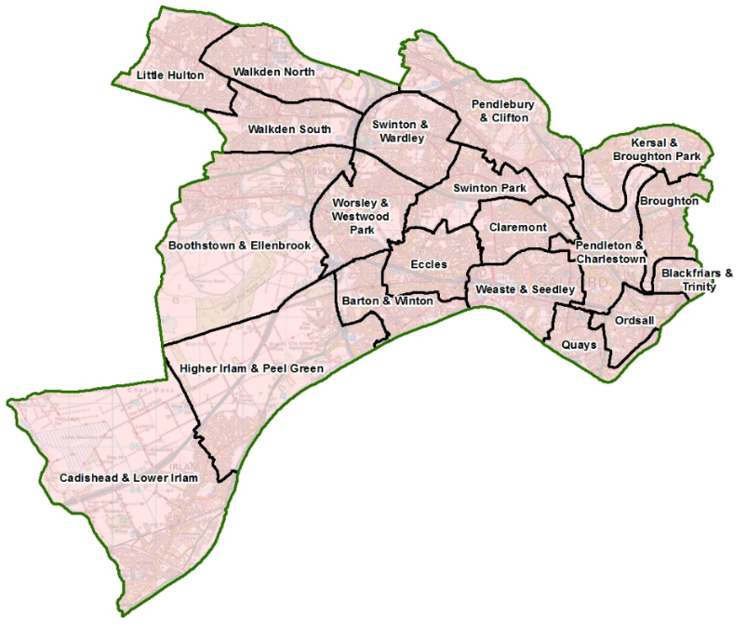

Question 15) – If your project is delivered from a single location (e.g. a community centre or park) please provide a postcode. If your activity will happen at more than one location, please provide all the postcodes. If this proves too difficult or isn’t applicable, please give details. All activity should take place in Salford unless there is a clear and compelling reason to deliver it elsewhere.
Completing Application Form - Part 2
About the project

Question 16) – Please tell us which priority or priorities of the fund (A-C) your project is most focused on addressing. The priorities are described in more detail on page 2 of these guidance notes. Please note, selecting more than one priority does not increase the likelihood of receiving funding.

Question 17) – Please tell us if this is a new or enhanced/expanded project. By ‘new,’ we mean a project that has never happened before. By ‘enhanced’, we mean an existing project that would be scaled up with this grant or a new element added.

Question 18) – Please tell us what activities or programmes your organisation has delivered to support the Jewish Community in Salford and (briefly) the impact these have had.

Question 19) – Please explain how you know the project is needed in the community. Provide any evidence you have, for example conversations with the people who will benefit, survey results, learning from similar projects, local data, etc. You might be trying to address a particular issue, for example social isolation, or meet a need in your community that isn’t being met currently.

Question 20) – Please tell us what you intend to do with the grant if successful. Please give details of the practicalities involved in delivering your project, for example how you will use the money, what you plan to do, who will deliver the activities, the frequency of activities, when and where they will happen, how they will be promoted, etc. This activity must be recognisable in your project budget.

Question 21) – Please explain how your project will support the Jewish Community in Salford. It should be clear how these benefits link to the priorities of the fund chosen in response to question 16.

Question 22) – Please tell us how many people will benefit directly from the project. Be realistic – we are interested in funding organisations delivering good projects with a manageable number of beneficiaries. We are not looking to understand the number of times people interact with your project – so if someone will attend more than once, they should only be counted once in this figure.

About the money

Question 23) – Please give an accurate breakdown of your project costs by describing each item. You’ll need to research some prices or obtain quotes (i.e. you can’t just guess the costs). Please break down your calculation so we can see how you’ve arrived at the cost for each item. See some examples below.

Example 1
Acceptable: Venue hire – 4hrs/wk @ £10ph x 10 weeks = £400
Not acceptable: Venue hire – £400

Example 2
Acceptable: Refreshments @ £1.50/person x 10 people x 10 events = £150
Not acceptable: Refreshments = £150

If other money is being used to support this project:
If you have other sources of money, it may be you’re only looking for a contribution to certain costs (see the example below).

Description of item | Breakdown of calculations | Item cost | Amount requested
Venue Hire | 4 hours per week @ £10ph x 10 weeks | £400 | £250

Full cost = £400
Amount requested = £250
Amount from alternative sources = £150 (e.g. an annual raffle)

Therefore, the total cost of the project may be more than the amount you’re requesting from this fund. If this is the case, please include the other sources of funding which will support this project and whether the money has been secured or whether an application is pending (see example below). Such match funding is desirable but not essential.

If applicable, where is the rest of the money coming from?
Source of funding | Amount | Funding Secured?
Annual raffle | £150 | Yes
Please attach
- All applicants need to submit a scan or photo of a recent bank statement or paying-in slip (dated in the last 6 months)
- If the project involves working with children or adults at risk, your Safeguarding Children and/or Safeguarding Adults policy must be submitted along with the completed application form. Please answer Yes or No. If Yes, you must attach the relevant policy

Declaration
Please confirm that you have read the Terms and Conditions of this grant by giving the name and role of the lead applicant.

