Salford CVS
Impact Fund
Tackling Health Inequalities
Wider Determinants of Health

Guidance for Applicants
2025/26


Grants of up to £30,000 for VCSE-led projects focused on tackling health inequalities by addressing the wider determinants of health.

Salford CVS
Impact Fund
Tackling Health Inequalities
Wider Determinants of Health

Contents
- Who can apply
- About the fund
- Priorities of the fund
- Fund Focus One
- Fund Focus Two
- Fund Focus Three
- How much can be applied for
- What the grant can be spent on
- Policies and other requirements
- Support for applicants
- How to apply
- Closing date
- How applications will be assessed
- Monitoring and evaluation requirements
- Completing the application form

Who can apply?
This fund is open to organisations that meet the eligibility criteria below:

- Constituted as a voluntary, community or social enterprise (VCSE) organisation
- Must be a FULL member of Salford CVS
- Based in Salford OR have a strong track record of delivery in Salford
- With a minimum turnover of £200,000 and a maximum turnover of £5m
- With an organisational Bank Account with 2 signatories who are not related to each other
- Fully up to date with grant reporting to Salford CVS

Organisations can apply as a partnership; each partner needs to meet the eligibility criteria above. The organisation applying to the fund should be the lead partner and if successful will be the accountable body for the grant monies.

About the Impact Fund (Wider Determinants of Health)
Salford residents spend a higher proportion of their lives in poor health than average for England, and this typically affects the more deprived parts of the city to a greater extent (Salford Locality Plan, 2020-2025).

Health is not simply the result of individual behaviours, genetics, and medical care. Factors like income, housing, jobs, education, relationships, access to green spaces and air quality all impact on our health. These are the “causes of the causes” of poor health – also known as the wider determinants of health.

It is how the wider determinants of health are distributed across different groups of people that leads to health inequalities. These factors often overlap, meaning people can fall into combinations of these categories and compound the severity of inequalities experienced (GM Integrated Care Partnership, 2024).

The Impact Fund (Wider Determinants of Health) is offering grants of up to £30,000 to established VCSE organisations for new or enhanced / expanded projects addressing one or more of the wider determinants of health below.

The fund is supported by NHS Greater Manchester (Salford) as part of the Third Sector Fund.

Priorities of the fund
All proposals are required to address one or more of the following wider determinants of health:
- Poverty and inequality
- Creating vibrant places and spaces
- Tackling the climate emergency
- Skills and education (A Learning City)
- Housing and homelessness
- Transport and digital connectivity

These priorities are aligned with the Fairer Health for All Framework, developed by Greater Manchester ICB in response to the Build Back Fairer report (2021) by Marmot and colleagues, as well as Salford City Council plans and strategies. They also compliment the Greater Manchester Live Well work and approach.

Please note, applicants must also address three additional focus areas through their project. See pages 6-8 for more information.
How the Funding Priorities relate to VCSE sector beneficiaries | Ideas for potential projects
A) Poverty and inequality
Poverty is associated with worse long-term physical and mental health, increased mortality of all ages, and lower than average life expectancy. As well as placing decent housing, sufficient food and heating out of reach, reducing access to employment and other resources, and harming educational attainment, poverty is stressful.  High levels of personal debt (aside from mortgages), low wages, insecure or temporary work, and poor working conditions can also be harmful to health. | - Money management course for adults who are in debt, plus wrap around advice and support.  - Warmer homes energy efficiency project to support people struggling to afford energy or living in a cold home.
B) Creating vibrant places and spaces
The physical, economic and social characteristics of places and communities have an important influence over people’s physical and mental health and wellbeing, and inequalities in these are related to inequalities in health.  Community assets are directly and indirectly important to health: directly through the services and opportunities they offer that support physical and mental health, and indirectly through a sense of control and empowerment and levels of community cohesion and social interaction, all of which support good health. | - Social inclusion project for migrants and asylum seekers, including visits to local community assets and creation of a community mural.  - Creation or enhancement of a community meeting space or initiative, for example a community hub offering activities, refreshments, and social interaction.
C) Tackling the climate emergency
Improving access to good quality green space is a vital mental and physical health intervention as well as supportive of efforts to mitigate climate change impacts and protect biodiversity. Access and use of green spaces tends to reduce as the level of deprivation increases, which was highlighted during the COVID-19 pandemic.  Poor air quality also damages health and people in more deprived areas are more affected by air pollution. | - Community outreach project utilising members of the community as co-researchers and community champions, mapping key environmental concerns and taking action to mitigate them.  - Redevelopment of a community space in a deprived area for enhanced public amenity, greater biodiversity and/or food growing.

How the Funding Priorities relate to VCSE sector beneficiaries | Ideas for potential projects
D) Skills and education (A Learning City)
Positive experiences early in life are closely associated with better performance at school, better social and emotional development, improved work outcomes, higher income and better lifelong health, including longer life expectancy. Persisting socioeconomic inequalities in attainment during primary and secondary school have lifelong impacts on health inequalities. | - Work readiness project for young people with special educational needs and disabilities (SEND).  - Coding course for children & young people at risk of poor educational attainment, including looked after children.
E) Housing and tackling homelessness
Unaffordable housing harms health – it increases homelessness and reduces income available for other essential services and food. The effects of unaffordable housing increase stress and the risk of suffering from poor mental health.  The homelessness problem is much larger than rough sleeping and includes those living in temporary accommodation, sofa surfing and other forms of insecure housing. The factors that drive homelessness – including poverty, a shortage of affordable housing, and high rates of eviction in the private rental sector – need to be addressed. | - Specialist advice and advocacy service for people who are homeless or living in temporary or insecure housing.  - Supporting the development of affordable housing solutions for local people.
F) Transport and digital connectivity
Increases in both active transport (cycling and walking) and public transport are needed to improve health and reduce health inequalities. Research into transport poverty in Greater Manchester found those with low incomes felt local transport was too expensive, unreliable and slow, making it harder for them to attend job interviews or continue in low paid employment.  15% of residents lack basic digital skills in Salford. Just like reading and writing, digital skills, connectivity, and access to devices have become essential for everyday life. Without them, individuals are being left behind by society. | - Digital literacy project for older adults who are isolated and experiencing, or are at risk of, digital exclusion.  - Purchase of electric cargo bikes to deliver goods or services to people with disabilities and long-term health conditions.

For more information on Salford’s approach to tackling health inequalities and the wider determinants of health, see:

Addressing Health, Wellbeing and Health Inequalities
Salford Locality Plan, 2020-25

Employment and Skills Strategy
Salford Employment and Skills Strategy, 2023-28

Tackling the Climate Emergency
A Greener Salford

As well as addressing one or more of the priorities of the fund, all projects must:
- evidence how those most in need will be targeted
- focus on geographical communities, communities of identity or other beneficiary groups known to the applicant organisation
- aim to achieve measurable improvements in health outcomes and/or behavioural change.

FUND FOCUS 1: Targeting those most in need
Your proposal will need to evidence how you’ll address health inequalities. Local Super Output Areas (LSOAs) data is a good indicator of the geographical concentrations of health deprivation.

The Ministry of Housing, Communities and Local Government’s Local Deprivation Explorer allows users to look up deprivation data for their area, explore comparisons across England using an interactive map, and download data — with the option to download deprivation data for specific postcodes.

While it is true that not all those living in deprived areas are deprived, and that not all those who are deprived, live in deprived areas, LSOA data can provide a strong steer for location of activities and recruitment of beneficiaries.

Data is also broken down by different indicators, for example Health & Disability, Income, and Education & Skills. See an example for M30 0FN postcode below.
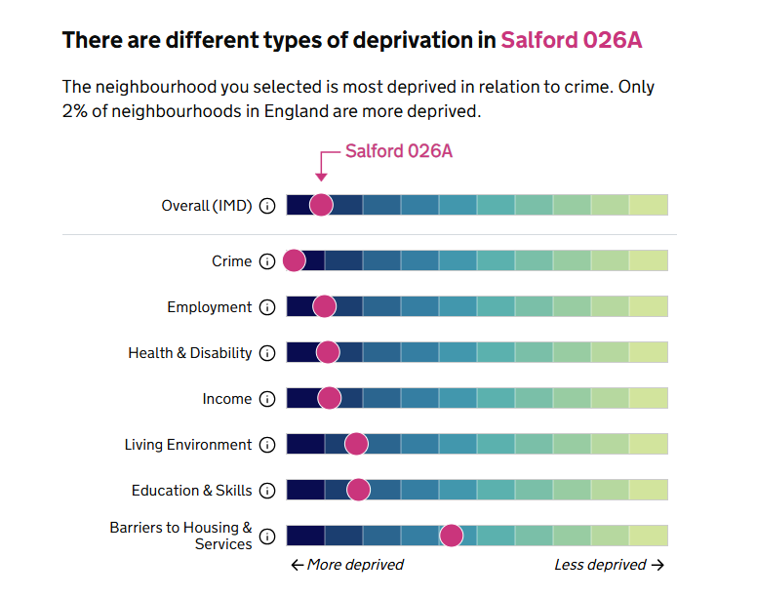

In addition to people living in areas of high deprivation, those from Black, Asian and minority ethnic communities and those from inclusion health* groups are also at risk of experiencing health inequalities.

*Inclusion health is an umbrella term used to describe people who are socially excluded, who typically experience multiple overlapping risk factors for poor health, such as poverty, violence and complex trauma. This includes people who experience homelessness, drug and alcohol dependence, vulnerable migrants, Gypsy, Roma and Traveller communities, sex workers, people in contact with the justice system and victims of modern slavery.

https://www.gov.uk/government/publications/inclusion-health-applying-all-our-health/inclusion-health-applying-all-our-health

FUND FOCUS 2: Knowing your target beneficiary group
Proposals will need to be focused on specific geographical communities, communities of identity, or other beneficiary groups already known to your organisation. Evidence of a track record of working with these groups will strengthen your bid.

FUND FOCUS 3: Measurable impact
Proposals must demonstrate how improvements in outcomes and/or behavioural change will be delivered and how these will be measured or assessed. It is essential that appropriate tools / techniques are proposed (see page 15 for further information).

How much can you apply for?
Applications are invited for projects up to a maximum of £30,000. Only one application per organisation may be submitted.

What can you spend the money on?
The grants can be used for staffing / volunteer costs, venue hire, project materials, promotion and publicity, refreshments, public liability insurance and any other reasonable project costs.

Note re. purchasing food: Please note that applications seeking funding exclusively for food (e.g. from food banks and clubs or provision of food parcels) will not be considered. Project costs for refreshments and/or ingredients for healthy eating projects can be included. Please contact the Grants Team if you are unsure if this applies to your proposal.

What policies / other documentation are required?
All organisations will be expected to have the following policies in place at the time of application:

a) Health and Safety Policy
b) Equality/Diversity Statement or Policy
c) Public Liability Insurance (Cost can be included in budget)
d) Risk Assessments

…and if applicable to project activities:

e) Volunteer Policy
f) Safeguarding Adults Policy
g) Safeguarding Children Policy

Please note: If your project involves working with children or adults at risk you will need to include a copy of the Safeguarding Policy.

What support is available to applicants?
Support with your application
If you have any questions or concerns about completing the application form, or you would like to discuss your project proposal with a member of the Grants Team, please contact the Grants Team at grants@salfordcvs.co.uk or phone 0161 787 7795.

Wider development support
Salford CVS can also offer practical support to VCSE organisations with developing policies, accessing volunteers, and accessing wider funding. For further information, visit our website at:
www.salfordcvs.co.uk/development-support

See our online Safeguarding in Salford resources: www.salfordcvs.co.uk/safeguarding-salford

You can also contact our Development Team by phone 0161 787 7795 or email at: office@salfordcvs.co.uk

How to apply
Salford CVS is anticipating very high levels of demand for the Impact Fund. Please read this guidance in full to ensure your application meets the criteria.

Organisations that wish to apply will need to complete the application form and submit it by email to grants@salfordcvs.co.uk in WORD format together with an accompanying budget in EXCEL format. Alternatively, they can be printed and posted to: Salford CVS, The Old Town Hall, 5 Irwell Place, Eccles, M30 0FN

When is the closing date for applications?
The fund will close to applications at 12:00 noon on Friday 13th February 2026. Late applications will not be considered.

How will applications be assessed?
On receipt of applications Salford CVS will undertake several eligibility checks. All applications that are eligible will be independently scored by a panel consisting of representatives from NHS Salford ICP, Public Health and Salford CVS. The assessment panel will then meet to agree the awards and provide feedback on unsuccessful applications.

All applicants will be informed by email within 6 weeks of the closing date. Unsuccessful applicants will be provided with a summary of feedback from the assessment panel.

If successful, when will we receive the grant?
On receipt of an offer letter from Salford CVS organisations will need to complete and return an ‘Acceptance of Grant Form’ together with an invoice for the full grant amount.

For organisations that have not received a grant from Salford CVS in the last 12-months (or have changed bank account since their last award) we will also require proof of bank details. This can take the form of a scan or photo of a bank statement or paying-in slip.

On receipt of these documents Salford CVS will then issue the grant by bank transfer within 5-10 working days. The full grant amount will be paid upfront in line with the ‘Principles of Good Grant Giving’ which Salford CVS adheres to.

How long will we have to spend the grant?
All organisations receiving a grant will have up to 12 months from the date of the offer letter to spend the grant.

How will our project be evaluated by Salford CVS?
Salford CVS’ has a three-fold approach to evaluation:

- Assessing impact – the difference your project made in words, numbers, stories, quotes and photos
- Gathering learning – what you have learned as an organisation, how your organisation has developed and what you would do differently next time
- Providing assurance – demonstrating good management of public money

In practical terms this will mean providing feedback to Salford CVS in the shape of a report form when your project is complete. We may also select your project for a monitoring visit (in person or remotely) to help us understand how you are getting on and if you’re in need of any support.

As guardians of public money Salford CVS requires all funded organisations to keep receipts for all project spend after your project completes. Salford CVS undertakes a number of spot-audits every year and you may be asked to provide evidence of your spending.

With your help in providing simple feedback, we can demonstrate how grants and investments can make a real difference to the health and wellbeing of local people. This is important in helping us report back to our funders and wider partners and helps secure investment in our sector over the years to come.

Any further questions?
Please contact the Grants Team by phone 0161 787 7795 or email at: grants@salfordcvs.co.uk

Completing Application Form - Part 1
Contact Information

Question a) – Please give the name of the lead contact for this application / project. They will be the primary point of contact for all matters relating to this application and any successful project award.

Question b) – Please give a secondary contact. They will only be contacted if we have difficulty reaching the lead contact.

About your organisation

Question 1) – Please give the full name of your organisation.

Question 2) – Please give the registered address of your organisation. If you don’t have a registered address as such, please provide the address of your Chair.

Question 3) – Please give your organisation’s turnover for the last full financial year.

Question 4) – Please tell us how your organisation is constituted. Examples are provided below:
- Unincorporated Association or Community Group
- Company Limited by Guarantee
- Registered Charity
- Charitable Incorporated Organisation
- Community Interest Company
- Community Benefit Society
- Cooperative Society
- Other (give details)

Please note:
- All organisations must be not-for-private-profit
- Companies limited by guarantee must have an ‘asset lock’ to prevent the transfer of assets to individuals
- Some charities might also be a company limited by guarantee.

Question 5) – Please give your organisation number (i.e. registered with the Charity Commission or Companies House).

Questions 6-8) – Please provide your organisation’s website and social media page links (if applicable).

Questions 9 & 10) – We are keen to support all staffed organisations that pay a minimum wage of at least £13.45 per hour as set by the Living Wage Foundation. We also actively encourage organisations to become an accredited Living Wage Employer. If you don’t employ staff, please tick the ‘not applicable’ box (N/A).

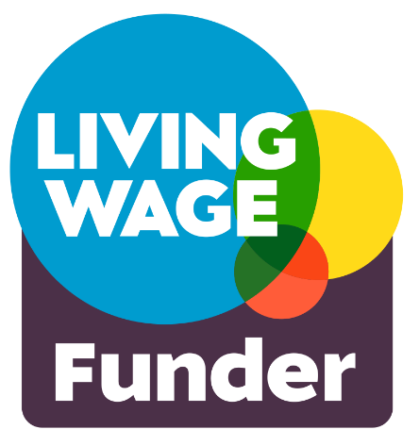
The cost of Living Wage Employer accreditation fees varies according to the size of your organisation.

For full details of the costs please contact the Living Wage Foundation via their website.

Question 11) – If your organisation pays all staff at the real living wage rate of £12.60 or more, but is not accredited as a Living Wage Employer, you can request support from Salford CVS to meet your first year’s accreditation fees.

Question 12) – We expect all organisations to have relevant policies in place at the time of application. If you need advice or support on developing policies, see the ‘What support is available to applicants?’ section above.

Please note that you will need to submit copies of the following documents along with your application:

- Safeguarding Adults Policy (if applicable to your project)
- Safeguarding Children Policy (if applicable to your project)

Question 13) – Please tell us about your organisation’s core purpose or activities. This helps us understand the context for this project and what you plan to do.

Project Summary

Question 14) – Please give your project a memorable name. This helps us identify your project should your application be successful.

Question 15) – Please give a brief description of your project that sums up what you plan to do (50 words max). This may be used in our publicity to publicise the award.

Question 16) – Please give your proposed project start and finish dates. Realistically, the earliest that funded projects can commence is April 2026 and must be completed by the end of March 2027.

Question 17) – Please indicate the areas of Salford which will receive support from your project. If it is across the whole of Salford, please tick ‘Salford city-wide’.
See the map below showing Salford’s new ward boundaries:

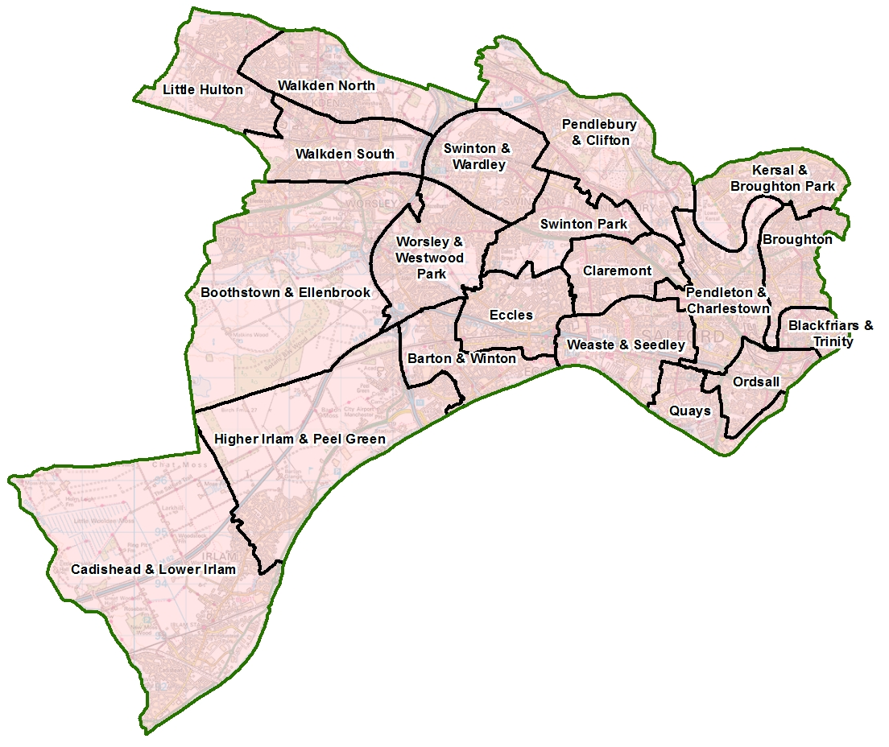

Question 18) – If your project is delivered from a single location (e.g. a community centre or park) please provide a postcode for this.
If your activity at more than one location, please provide all the postcodes.
If this proves too difficult or isn’t applicable, please give details.
Completing Application Form - Part 2

About the project

Question 19) – Please indicate the priority of the fund your project is most looking to address. You may choose more than one priority however we are looking to support targeted projects, so this will not increase the likelihood of funding.

Question 20) – Please tell us if this is a new or enhanced / expanded project. By ‘new,’ we mean a project that has never happened before. By ‘enhanced/expanded,’ we mean an existing project that you want to scale up, refine or add a new element with this grant.

Question 21) – Perhaps the project is aimed at people who live in the same area of Salford, who come from the same ethnic or cultural background, who are a similar age, or who have shared life experiences.
Please provide evidence to support how you know the people you plan to work with face health inequalities, for example your own research or research conducted by another organisation.

Question 22)– Proposals will need to be focused on specific geographical communities and/or groups of people already known to your organisation. Evidence of a track record of working with these groups will strengthen your bid.

Question 23) – Please estimate how many people who live in Salford will directly benefit from the project over the delivery period.

Question 24) – Please provide practical details about the activities, services or events you plan to deliver and how the project will address the priority (or priorities) chosen in your response to question 18. Please include:
- The activities, services or events you will deliver (number and duration)
- Where and when they will take place
- Who will be responsible for planning and delivering the project
- What this grant will pay for

Question 25) – Please use the Project Delivery Plan table to show the main elements or activities of the project and the expected timeline, including any key milestones.

Question 26) – Please explain how the intervention(s) you are proposing will tackle health inequalities by addressing the priority of the fund selected in Question 18. Please include any research or evidence you have, for example published reports, the results of work you’ve undertaken previously, etc.

Question 27) – We want you to tell us how you plan to monitor and evaluate the impact of the project. What practical changes (outcomes) can you measure to evidence success? Two simple examples could be ‘increased physical fitness’ or ‘improved confidence and self-esteem’ of the people you plan to work with.

How outcomes are measured can be very simple (e.g. hours of additional exercise, amount of weight lost) or more in-depth (e.g. before and after surveys, observation, focus groups, creative methods, etc.). The methods you choose will depend on your activities and the people involved.

For one-to-one support answering this question please contact the Salford CVS Grants team on grants@salfordcvs.co.uk or Telephone: 01617877795

Question 28) – As leading member of the Social Value Alliance, Salford CVS wants to ensure that as much of its grant monies as possible are spent in Salford, ideally through buying goods and services from local independent businesses or fellow VCSE sector organisations. This helps to support our local economy.

If possible please try and avoid large chains or corporations, and especially Amazon who have been identified as the worst company for aggressive tax avoidance which deprives our government of much-needed funds for schools, hospitals, local services etc. If you do feel pressured to occasionally use Amazon, then buy from Amazon Marketplace which supports independent suppliers.

Also, whilst your project may be focused on particular health and wellbeing outcomes, the way you deliver it might provide wider benefits for the people, economy and environment of Salford. For example, you might be supporting the mental health of people via a food growing or tree planting project; or you might provide volunteering or training opportunities that boost people’s chance of employment. These are all great examples of added social value where you can make lots of positive change by applying creative ideas from your project team.

Question 29) – Please complete the accompanying Excel spreadsheet. A simplified project budget is shown on the second tab. Please note, it is essential you adequately describe your budget items AND break down your calculations.

All proposed spend should be well described, based on accurate costings / estimates from suppliers, and take account of current inflation rates. Match funding is desirable but not essential.

Please attach
Please confirm you are attaching:
- your project budget (Excel spreadsheet)
- scan or photo of recent bank statement or paying-in slip
- any relevant safeguarding policies (if working with children or adults at risk)

Declaration
Please confirm that you have read the Terms and Conditions of this grant by giving the name and role of the lead applicant.

