Role Profile – Board Member for the Brookhouse & Peel Green Area Neighbourhood Board
Neighbourhood Boards are being set up across the country as part of the Pride in Place Programme.

The Pride in Place Programme is a flagship community initiative that empowers local people to shape the future of their neighbourhoods. Providing up to £20 million in funding for the Brookhouse & Peel Green area over 10 years, it gives communities the resources, tools, and decision-making power to deliver lasting improvements in their area.

The programme is designed to be community-led, with Neighbourhood Boards working alongside local authorities and MPs to identify priorities, co-create plans, and oversee investment. Beyond funding, the Programme introduces new powers and approaches that allow residents to restore and enhance their neighbourhoods, from public spaces to local infrastructure. Its ultimate aim is to support long term, resident-led change that strengthens our community and leaves a lasting legacy.

The areas covered by the programme are based on boundaries used by the Government to measure levels of need in a local community. Locally, the area is centred on Brookhouse and Peel Green. You can see a map of the area below.

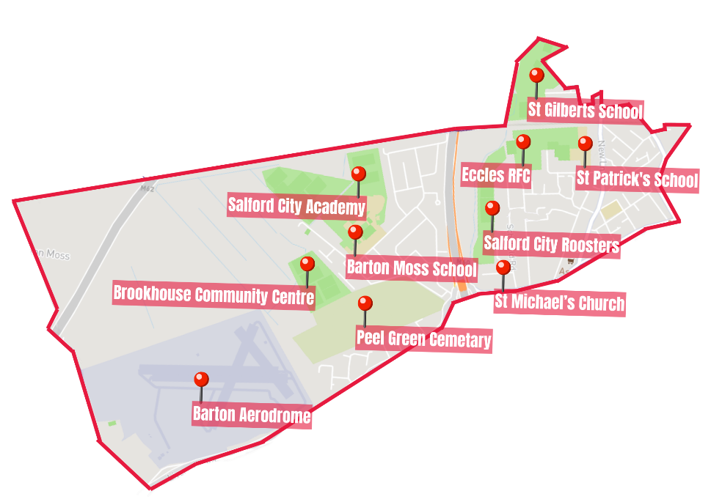

Each Board will have an independent Chair who will live, work or have a strong attachment to the Brookhouse & Peel Green area. The Chair’s role is to provide leadership to the Neighbourhood Board ensuring that they listen to local ideas and keep the Board’s focus on delivering positive change.

Board members will contribute to the decisions made about Pride in Place funding, they will hold the board to account and ensure that it engages with a wide range of local voices. Board members should care deeply about the community and be committed to improving it. They do not need previous experience. What matters most is passion, fairness, and community spirit.

Skills and qualities of a good Neighbourhood Board Member

A good board member is:

• Fair and balanced.
• Able to contribute calmly to discussions, even during disagreements.
• Open to feedback and willing to learn.
• Friendly, welcoming, and a good listener.
• Open, positive and wanting the best for their area.
• Able to commit the necessary time to the role.

Role Profile

The role of a Board Member will most likely require at least 6 hours a month but might be more at busy times. Board Members are likely to need to attend meetings of the board on a regular basis, training and possibly other meetings related to their role.

Board Members will:

- Act as a credible, trusted member of the board with strong links to the community.
- Contribute to open, engaging and collaborative conversations among residents and stakeholders.
- Help to seek agreement amongst fellow board members about short and long term goals.
- Champion the long-term vision of the Pride in Place programme for the Brookhouse & Peel Green area.
- Represent the Board publicly and strengthen partnerships across the community.
- Guide the delivery of a Pride in Place Plan for the Brookhouse & Peel Green area.
- Contribute to the decision-making process on the provision of grants and funding for groups working in the Pride in Place area.

Person Specification

Essential criteria include:
- A deep connection to, or knowledge of the Brookhouse & Peel Green area.
- Ability to work with diverse groups and a wide range of community representatives.
- A willingness to learn new skills.

Desirable criteria include:
- Previous experience on a board or in a community organisation (not essential).
- Experience in community development or regeneration (not essential).
- Experience in assessing, judging and prioritising funding bids for community organisations (not essential).

Neither the Chair nor the Board Members will be paid for the role, however, volunteers are encouraged to claim any out-of-pocket expenses incurred while carrying out their role, including travel (car mileage, bicycle allowance, bus fares), lunch expenses, and childcare costs, using a simple expenses form and providing receipts where required.

Application Process

To apply for the Board Member for Brookhouse &Peel Green please visit www.salfordcvs.co.uk/pride-place-peel-green

Here you will find an application form which you should download, complete and return the website also contains details on how to apply via video submission.

Forms should be sent to PeelgreenPIP@salfordcvs.co.uk

Videos should be sent via whatsapp 07442 423988

The deadline is Sunday 31st May 2026 at 5pm.

Informal interviews for this role will be held on Friday 26th June 2026

To help ensure the Neighbourhood Board operates in an open, transparent and trusted way, successful applicants will be asked to take part in some standard background checks as part of our due diligence process. These checks are routine for community governance roles and will include verification of identity and address, eligibility to serve under organisational rules, right to work or volunteer in the UK (where relevant), and basic financial probity checks such as bankruptcy checks.

