Role Profile – Chair of the Brookhouse & Peel Green Area Neighbourhood Board
Neighbourhood Boards are being set up across the country as part of the Pride in Place Programme.

The Pride in Place Programme is a flagship community initiative that empowers local people to shape the future of their neighbourhoods. Providing up to £20 million in funding for the Brookhouse & Peel Green area over 10 years, it gives communities the resources, tools, and decision-making power to deliver lasting improvements in their area.

The programme is designed to be community-led, with Neighbourhood Boards working alongside local authorities and MPs to identify priorities, co-create plans, and oversee investment. Beyond funding, the Programme introduces new powers and approaches that allow residents to restore and enhance their neighbourhoods, from public spaces to local infrastructure. Its ultimate aim is to support long term, resident-led change that strengthens our community and leaves a lasting legacy.

The areas covered by the programme are based on boundaries used by the Government to measure levels of need in a local community. Locally, the area is centred on Brookhouse and Peel Green. You can see a map of the area below.
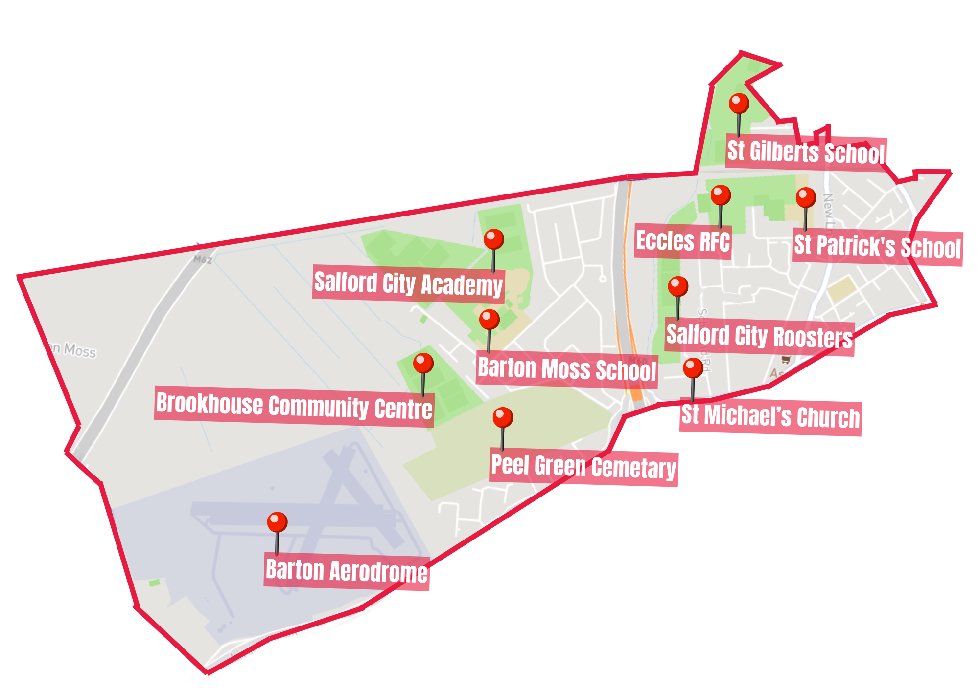

Each Board will have an independent Chair who should live, work or have a strong attachment to the Brookhouse & Peel Green area.

The Chair’s role is to provide leadership to the Neighbourhood Board ensuring that they listen to local ideas and keep the Board’s focus on delivering positive change. They should care deeply about their community and be committed to improving it.

They do not need previous experience. What matters most is passion, fairness, and community spirit.

Skills and qualities of a good Chair

A good Chair is:

• Fair and balanced.
• Skilled at guiding discussions, even during disagreements.
• Open to feedback and willing to learn.
• Friendly, welcoming, and a good listener.
• Calm under pressure and able to manage conflict.
• Able to commit the necessary time to the role.

Role Profile

The role of the Chair of the Board will most likely require at least 10 to 12 hours a month but might be more at busy times. Board Members are likely to need to commit around 6 hours a month, but the Chair plays a key role and is likely to require more time.

The Independent Chair will:

- Act as a credible, trusted leader for the Neighbourhood Board with strong links to the community.
- Facilitate open, engaging and collaborative conversations among residents and stakeholders.
- Navigate conflict calmly and impartially, working to bring people together.
- Champion the long-term vision of the Pride in Place programme for the Brookhouse & Peel Green area.
- Represent the Board publicly and strengthen partnerships across the community.
- Guide the delivery and implementation of a Pride in Place Plan for the Brookhouse & Peel Green area.
- Work closely with the MP and local authority and other organization who may support the work of the Board.
- Lead the Board’s decision making process on the provision of grants and funding for groups working in the Pride in Place area.

Person Specification

Essential criteria include:

- A deep connection to the Brookhouse & Peel Green area (lives, works or strong local ties to Brookhouse & Peel Green).
- Strong communication and facilitation skills.
- Ability to bring together diverse groups and community representatives.
- Calm under pressure and able to resolve conflicts.
- A willingness to learn new skills and accept feedback.

Desirable criteria include:

- Previous leadership or chairing experience (not essential).
- Experience in community development or regeneration (not essential).
- Understanding of local government or neighbourhood governance structures (not essential).
- Experience in compiling or assessment funding bids for community organisations (not essential).

Neither the Chair nor the Board Members will be paid for the role, however, volunteers are encouraged to claim any out-of-pocket expenses incurred while carrying out their role, including travel (car mileage, bicycle allowance, bus fares), lunch expenses, and childcare costs, using a simple expenses form and providing receipts where required.

Application Process

To apply for the Chair of the Board role for Brookhouse & Peel Green please visit www.salfordcvs.co.uk/pride-place-peel-green

Here you will find an application form which you should download, complete and return to email - PeelgreenPIP@salfordcvs.co.uk by the deadline Sunday 17th May 2026 at 5pm.

Informal interviews for this role will be held on the morning of Friday 5th June 2026

To help ensure the Neighbourhood Board operates in an open, transparent and trusted way, successful applicants will be asked to take part in some standard background checks as part of our due diligence process. These checks are routine for community governance roles and will include verification of identity and address, eligibility to serve under organisational rules, right to work or volunteer in the UK (where relevant), and basic financial probity checks such as bankruptcy checks.

