Little Hulton Big Local
Small Grants – Spring/Summer 2018
The Little Hulton Small Grants Fund aims to support community activity delivered by and for the community of the Little Hulton Big Local Area.
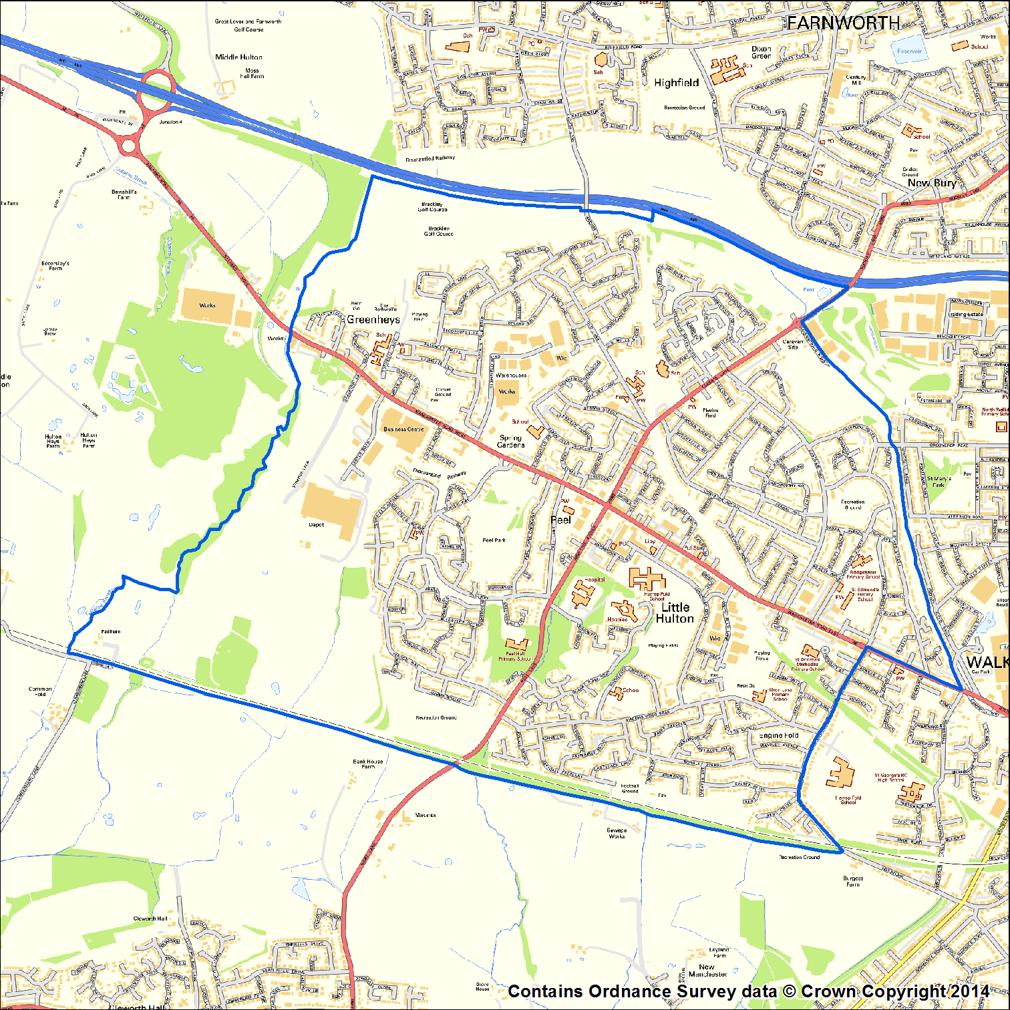
Grants must directly benefit the community of the Little Hulton Big Local area.
Organisations seeking funding must involve residents in the management, planning or delivery of the activity you are seeking funding for.
We will be accepting applications between 12th February 2018 and 30th July 2018 – noon deadline.
If you have any queries or would like support with completing the application please contact Sue Owen, Little Hulton Big Local Community Organiser 0161 790 7072. susan.owen@salfordcvs.co.uk.
Priority will be given to new groups, new initiatives and groups who have not had a Big Local grant previously.
Groups with an income of £100,000 plus will not be eligible for funding.

Decisions will be made at our Little Hulton Big Local Board Meetings. For your application to be considered by the Board it must be received the week prior to the Board meeting.
Deadline for grant applications | Board Meeting
Monday 26th February 2018 - NOON | Monday 5th March 2018
Monday 2nd April 2018 - NOON | Monday 9th April 2018
Monday 7th May 2018 - NOON | Monday 14th May 2018
Monday 28th May 2018 - NOON | Monday 4th June 2018
Monday 25th June 2018 - NOON | Monday 2nd July 2018
Monday 23rd July 2018 – NOON | Monday 6th August 2018

What we are looking to fund:
      - Community activities and services for people living in the Little Hulton Big Local area
      - Activities that positively make a difference to the community of Little Hulton
      - Activities that will be taking place between 12th March 2018 – 31st August 2018
      - The maximum grant is £500 per group plus £250 extra if you can demonstrate your activity or service meets the following priorities:
    - Older people and intergenerational activities
    - The environment
    - Activities that support people’s mental health, wellbeing and happiness
To be eligible for funding:
- Activities must directly benefit residents of the Little Hulton Big Local area
- Residents of the Little Hulton Big Local area must be involved in the management of the organisation seeking funding, or in the planning and delivery of the activity, the organisation is seeking funding for.

To receive a cash award organisations must:
      - Have a governing document (e.g. a Constitution)
      - Have a Management Committee / Board
      - Have a Bank Account (with 2 signatories who are not related to each other)
(We will consider applications from more informal groups for equipment, training or other items that will support community activity but these will be purchased directly by Little Hulton Big Local)
- Agree to returned a report on how you used the grant by the 30th September 2018

N.B. We are unable to give money to the following: Individuals; any activities that promote the advancement of religion or politics; proposals that are in breach of equalities or other relevant legislation; applications from freelance consultants; improvements to land or buildings that are either privately owned or the responsibility of a statutory authority.
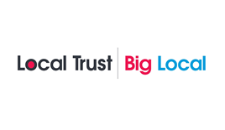

Little Hulton Big Local Small Grant Application Form
Please complete the application form below. Typed text must be Arial font 12.

Q 1 | Does your activity directly benefit Little Hulton Residents?
Yes |  | No  If no, please note your application is ineligible.

Q 2 | What do you want the money for?
Provide details of what your project will be doing and/or the activities you will be organising, tell us the story of how the money will be spent.

Q 3 | How are Little Hulton Big Local area residents involved in the management of your organisation or involved the planning and delivery of the activity you are seeking funding for.

Q 4 | How many people from Little Hulton will benefit from this activity or project?
We want the Big Local funding to reach a wide range of Little Hulton residents.
- Tells who will benefit from your activities.
- For example what ages do you think they will be, are they likely to be male or female or people with disabilities.
- Finally what areas of Little Hulton will people benefitting from your activities live in? (postcodes, streets)

Q 5 | If you are applying for the additional £250 please tell us how your activity or service meets the following priorities  - Older people and intergenerational activities  - The environment  - Activities that support people’s mental health, wellbeing and happiness

Q 6 | Delivery Period
Please estimate the start date of your project or activity:
Please estimate the completion date of the project or activity:

Q 7 | Tell us what Policies and Procedures you have in place to promote the safety of everybody involved in your organisation and in this activity or project?
For example do you have insurance, a health and safety policy/plan, risk assessments, child protection procedures and or what are your first aid arrangements?

Q 8 | What difference will your project make to people of Little Hulton?  Little Hulton Big Local has agreed a vision that ‘In ten years’ time we would like Little Hulton to be a great place to live, where everyone comes together and feels proud to belong here’  How will this grant help us achieve this vision?

Q 9 | Budget
Please indicate how much money you need and provide a detailed breakdown of your planned expenditure and details of how the costs have been worked out. Please note amounts should include VAT where applicable.
Budget heading |  | Total Cost £ | Amount requested from Small Grants Fund £
1
2
3
4
5
6
Total amount requested from the Small Grants Fund |  |  | £
Total cost of project |  |  | £
If relevant where is the rest of the money coming from? Please specify the funder and amount.

Little Hulton Big Local will ask you to complete a report on the activity or project this grant funded, including details of how you spent the money. We will ask you to return this report to us by 30th September 2018. So please keep copies of all your receipts.

Part 2
Q 1 | Contact details
Name of organisation
Your name
Your telephone number
Your mobile number
Your email address
Address details
Post code

Q 2 | What type of organisation are you? (Please tick all that apply)
Community Group (Unincorporated Association)
Company Limited by Guarantee |  | Number:
Registered Charity |  | Number:
Community Interest Company |  | Number:
Other (please specify)
Type:

Q 3 | Has your organisation got its own bank account?
Yes |  | No

Q 4 | Declaration
I confirm that the details on this application form are correct.
I agree that the group’s contact details can be entered onto a database (for use solely by Little Hulton Big Local) and that the group will receive regular updates from Big Local.
I am authorised to apply for this money on behalf of my organisation.

N.B. We require two signatures from people who are not related to each other or share the same household and are authorised to sign on behalf of your organisation.

Scanned signatures are acceptable.
\
Person 1 |  | Person 2
Name |  | Name
Role |  | Role
Signature |  | Signature
Date |  | Date
What does your group or organisation want to achieve during the next twelve months and how could Little Hulton Big Local help?
Please return the completed application to:
Email: littlehultonbiglocal@yahoo.co.uk. An acknowledgement email will be sent.
Post: Community Hub, 27 -29, Hulton District Centre, Little Hulton, M28 0BA
You can contact Little Hulton Big Local for queries on 0161 790 7072
Checklist
Please ensure you have enclosed the required documentation / evidence
Checklist | Tick to confirm
Completed all sections of the application
Application is signed

