Little Hulton Big Local Small Grants – 2018 - 2019
The Little Hulton Small Grants Fund aims to support community activity delivered by and for the community of the Little Hulton Big Local Area.
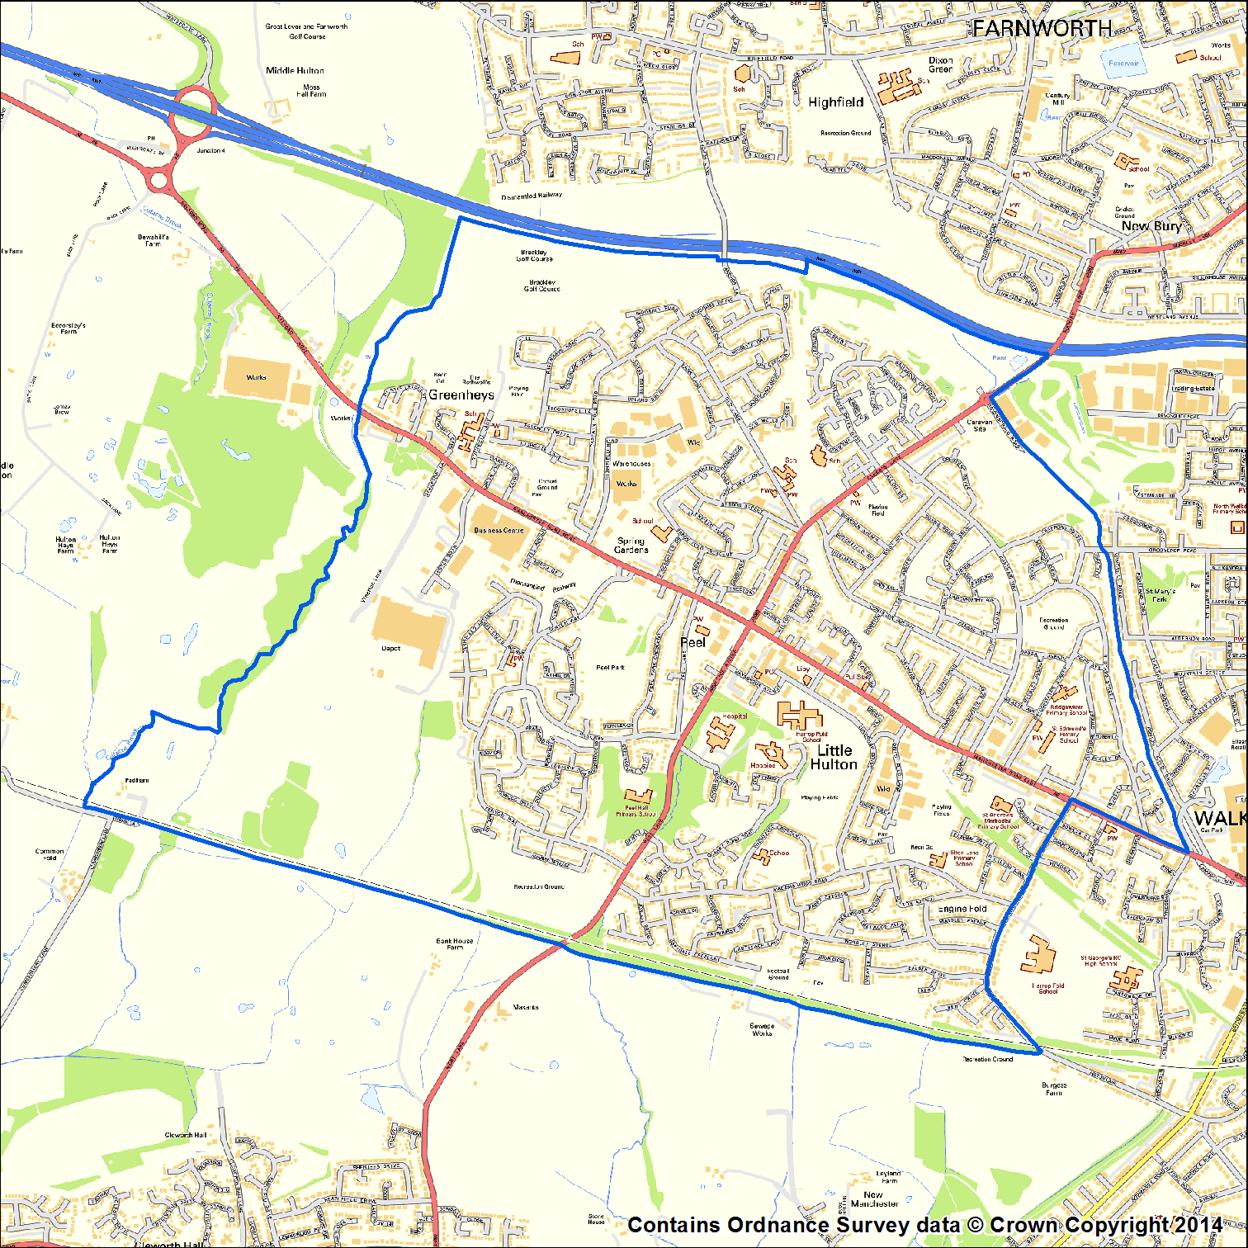
Grants must directly benefit the community of the Little Hulton Big Local area.
Organisations seeking funding must involve residents in the management, planning or delivery of the activity you are seeking funding for.
We will be accepting applications between 19th November 2018 and 29th July 2019 – noon deadline.
If you have any queries or would like support with completing the application please contact Sue Owen, Little Hulton Big Local Community Organiser 0161 790 7072. susan.owen@salfordcvs.co.uk.
Priority will be given to new groups, new initiatives and groups who have not had a Big Local Small grant previously.
Groups with an income of £100,000 plus will not be eligible for funding.

Decisions will be made at our Little Hulton Big Local Board meetings. For your application to be considered by the Board it must be received the week prior to the Board meeting.
Please note that grant applications will not be considered at the Board meeting in January due to the Christmas and New Year holiday closure.
Deadline for grant applications | Board Meeting
Monday 26th November 2018 - NOON | Monday 3rd December 2018
Monday 28th January 2019 - NOON | Monday 4th February 2019
Monday 25th February 2019 - NOON | Monday 4th March 2019
Monday 25th March 2019 - NOON | Monday 1st April 2019
Monday 6th May 2019 - NOON | Monday 13th May 2019
Monday 27th May 2019 - NOON | Monday 3rd June 2019
Monday 24th June 2019 - NOON | Monday 1st July 2019
Monday 29th July 2019 – NOON | Monday 5th August 2019

What we are looking to fund:
      - Community activities and services for people living in the Little Hulton Big Local area
      - Activities that positively make a difference to the community of Little Hulton
      - Activities that will be taking place between 10th December 2018 – 31st August 2019
      - The maximum grant is £750 and each group will only be able to make one application between November and July (though the application can include a range of activities and/or events spread over the time period)
To be eligible for funding:
- Activities must directly benefit residents of the Little Hulton Big Local area
- Residents of the Little Hulton Big Local area must be involved in the management of the organisation seeking funding, or in the planning and delivery of the activity, the organisation is seeking funding for.
To receive a cash award organisations must:
      - Have a governing document (e.g. a Constitution)
      - Have a Management Committee / Board
      - Have a Bank Account with 2 signatories who are not related to each other
- Agree to returned a report on how you used the grant by the 30th September 2019

We will consider applications from more informal groups for equipment, training or other items that will support community activity but these will be purchased directly by Little Hulton Big Local.

N.B. We are unable to give money to the following: Individuals; any activities that promote the advancement of religion or politics; proposals that are in breach of equalities or other relevant legislation; applications from freelance consultants; improvements to land or buildings that are either privately owned or the responsibility of a statutory authority.
Privacy Notice
- The contact details submitted as part of this application will be used to communicate with you about your grant with us but also to let you know about related funding opportunities for your organisation as part of our service to local groups.
- We are required to share information about your organisation and its activities to the funder of the programme (i.e. Big Local). However, no personal information will be shared.
- We will share information about your organisation and the grant activities in our annual reports and online (on our website) and share with 360 Giving. www.threesixtygiving.org. No personal or contact information is shared through this process.
- If you would like more information about how Little Hulton Big Local and Salford CVS handle your data then feel free to read our full privacy statement (www.salfordcvs.co.uk)

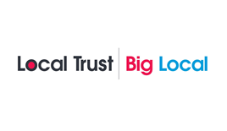

Little Hulton Big Local
Small Grant Application Form
Please complete the application form below. Typed text must be Arial font 12.

Q 1 | Does your activity directly benefit Little Hulton Residents?
Yes |  | No  If no, please note your application is ineligible.

Q 2a | What do you want the money for?
Provide details of what your project will be doing and/or the activities you will be organising, tell us the story of how the money will be spent.

Q 2b | How will you ensure value for money?
Provide details of what your project will be doing to ensure value for money and ways of keeping costs down. Also please tell us if you are making a charge to offset costs and if you are what measures will there be so that those who can’t afford the charge can be still be included.

Q 3 | How are Little Hulton Big Local area residents involved in the management of your organisation or involved the planning and delivery of the activity you are seeking funding for?

Q 4 | How many people from Little Hulton will benefit from this activity or project?
We want the Big Local funding to reach a wide range of Little Hulton residents.
- Tells who will benefit from your activities.
- For example what ages do you think they will be, are they likely to be male or female or people with disabilities.
- Finally what areas of Little Hulton will people benefitting from your activities live in? (postcodes, streets)

Q 5 | Delivery Period
Please estimate the start date of your project or activity:

Please estimate the completion date of the project or activity:

Q 6 | Tell us what Policies and Procedures you have in place to promote the safety of everybody involved in your organisation and in this activity or project.
For example do you have insurance, a health and safety policy/plan, risk assessments, child protection procedures and or what are your first aid arrangements?

Q 7 | What difference will your project make to people of Little Hulton?  Little Hulton Big Local has agreed a vision that ‘In ten years’ time we would like Little Hulton to be a great place to live, where everyone comes together and feels proud to belong here’  How will this grant help us achieve this vision?

Q 8 | Budget
Please indicate how much money you need and provide a detailed breakdown of your planned expenditure and details of how the costs have been worked out – include quotes if you have them. Please note amounts should include VAT where applicable.
Budget Heading |  | Total Cost | Amount requested from Small Grants Fund
1
2
3
4
5
6
7
8
9
10
Total amount requested from the Small Grants Fund |  |  | £
Total cost of project |  |  | £
If relevant where is the rest of the money coming from? Please specify the funder and amount.

Little Hulton Big Local will ask you to complete a report on the activity or project that this grant funded, including details of how you spent the money so please keep copies of all your receipts.
We will ask you to return this report to us by 30th September 2019

Part 2
Q 1 | Contact details
Name of organisation
Your name
Your telephone number
Your mobile number
Your email address
Address details
Post code

Q 2 | What type of organisation are you? (Please tick all that apply)
Community Group (Unincorporated Association)
Company Limited by Guarantee |  | Number:
Registered Charity |  | Number:
Community Interest Company |  | Number:
Other (please specify)
Type:

Q 3 | Has your organisation got its own bank account?
Yes |  | No

Q 4 | Declaration
I confirm that the details on this application form are correct.
I agree that the group’s contact details can be entered onto a database (for use solely by Little Hulton Big Local) and that the group will receive regular updates from Big Local.
I am authorised to apply for this money on behalf of my organisation.

N.B. We require two signatures from people who are not related to each other or share the same household and are authorised to sign on behalf of your organisation.

Scanned signatures are acceptable.

Person 1 |  | Person 2
Name |  | Name
Role |  | Role
Signature |  | Signature
Date |  | Date
What does your group or organisation want to achieve during the next twelve months and how could Little Hulton Big Local help?
Please return the completed application to:
Email: littlehultonbiglocal@yahoo.co.uk. An acknowledgement email will be sent.
Post: Community Hub, 27 -29, Hulton District Centre, Little Hulton, M28 1BA
You can contact Little Hulton Big Local for queries on 0161 790 7072

Checklist
Please ensure you have enclosed the required documentation / evidence
Checklist | Tick to confirm
Completed all sections of the application
Application is signed

