
Aims of the Awards:
- To recognise the difference these organisations make to the people of Salford

- To raise the profile of the work done by nominated organisations in supporting their communities

The awards are open to organisations:
- Whose activities benefit local people
- Who are not-for-private-profit groups that operate in Salford

Organisation Nomination Form

2013

- Small Community Group
Open to small community groups who are making a real difference in their local area.

- Social Enterprise
Salford social enterprises that are fulfilling their social mission and adding value to this city.

- Charity
Registered charities who are making a positive difference to the people of Salford.

- Innovative Project
Projects of voluntary, community or social enterprise organisations that have made a difference through new and innovative ways of working.
Organisation Categories

- Equalities Award
Voluntary, community or social enterprise organisations that address equality issues, challenge discrimination or help to develop community cohesion.

Please complete this nomination form and return to Salford CVS by Friday 3rd November 2017.

If you are unsure of which category to nominate in please contact us for guidance.

Nominee organisation:

Address:

Postcode:

Telephone:

Email:

Award Category:

Nomination Form

Your name (‘the Nominator’):

Your address:

Postcode:

Telephone:

Email:

Please tell us here why you feel the organisation should receive this award. Please provide as much information as possible as the judges will use this information to help make their decision. Minimum 200 words, maximum 500 words. You can attach an additional sheet.

Signature ......................................................................... Date .....................................

All nominations will go before the shortlisting panel unless notified otherwise.

Completed applications should be signed, dated and returned by Friday 3rd November 2017
to: Salford CVS, The Old Town Hall, 5 Irwell Place, Eccles M30 0FN.
Email: volunteer@salfordcvs.co.uk Tel: 0161 787 7795

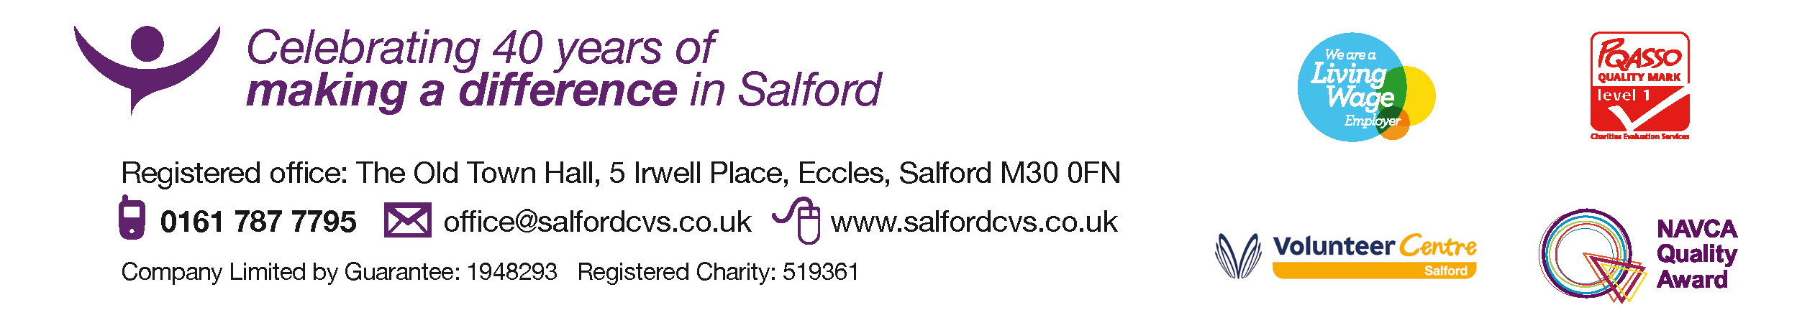

The Awards Ceremony will be held on Monday 11th December 2017 at AJ Bell Stadium, Stadium Way, Eccles M30 7EY.
Making a difference in Salford since 1973

