Health and care re-organisation in Greater Manchester- March 2021
The purpose of this briefing is to provide local VCSE infrastructure bodies and VCSE organisations with an overview of the development of new health and care structures in Greater Manchester.
The National Picture
On 11th February 2021 the Government published ‘Integration and Innovation: working together to improve health and social care for all’- a white paper outlining new legislative proposals to bring health and care services closer together to improve care and tackle address health inequalities. The proposals aim to make the legal framework more pragmatic, remove unnecessary legislative bureaucracy, and capture learning from the Covid-19 pandemic.
The legislative proposals follow on from the publication of the NHSEI guidance outlining the next steps to building strong and effective integrated care systems across England.
In an integrated care system, NHS organisations, in partnership with local councils and others, take collective responsibility for managing resources, delivering NHS standards, and improving the health of the population they serve.
What does it mean for GM? (key information taken from the February 2021 VCSE Assembly on integrated care systems)
Warren Heppolette, Executive Lead - Strategy & System Development at Greater Manchester Health and Social Care Partnership (GMHSCP) outlined in February 2021 that Greater Manchester has already been working in this way since 2016, as the GMHSCP is responsible for the devolved £6 billion health and social care budget for Bolton, Bury, Oldham, Manchester, Rochdale, Salford, Stockport, Tameside, Trafford and Wigan.
He noted that the recently published NHSEI guidance for integrated care systems across England is similar to ways of working that are now established in Greater Manchester- most notably the ability to allow resources and responsibilities to flow from national bodies to system level.
Greater Manchester therefore sees this new national guidance as a way of continuing work that has already started, and have stated a key objective of ‘completing the journey to place based working., recognising that this is the foundation of our GM model.’.
The Greater Manchester Health and Social Care Partnership have recently reviewed their original objectives from 2016 and have identified four priority areas of work going forward:
- Tackling inequalities and transforming population health
- Guaranteeing Constitutional Standards and eliminating unwarranted variation in care
- Connect health, social care, academia and industry to discover, develop and deploy innovation at pace and scale
- Achieve comprehensive system Sustainability across health and social care for the long term.
Greater Manchester’s aim in completing the journey to place-based working is to become a genuine population health system. As a defining principle, place based working will focus on prevention through empowering and supporting communities, with a focus on prevention and wellbeing that takes into account the wider determinants of health such as employment, education, early years and housing to close the inequalities gap within the city region.

Next steps for GM
GMHSCP noted that whilst significant progress has been made with regards to moving to a fully integrated, place based way of working, implementation of integrated care is at varying stages across the 10 GM localities. Therefore, a key priority is to establish a simpler more consistent approach to place based working.
This means that in each locality the following will be established:
- A single local System Board
- A Place Based Provider Collaborative model
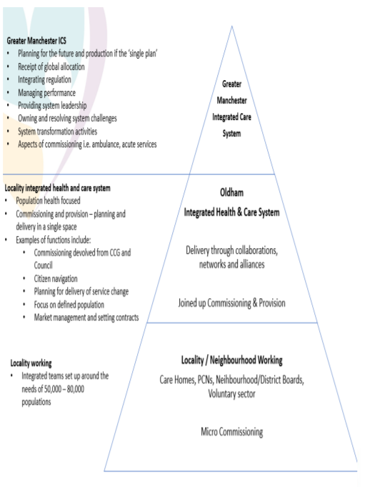
Here’s a helpful example of what ‘locality based working’ will look like in Oldham.

Relevance for the VCSE sector in GM
The latest NHS guidance on the development of ICSs states that ‘the voluntary, community and social enterprise (VCSE) sector is a critical strategic partner in ICSs and brings skills and a perspective than can help improve systems’ work.’
10GM believes it is vitally important that local VCSE organisations are represented and included within the locality integrated health and care systems. The VCSE sector plays a key role in reducing health inequalities experienced by communities by providing services, programmes, and activities which help to improve health and wellbeing, often with a focus on prevention as well as crisis intervention.
As organisations close to the communities they serve, the VCSE sector has a deep understanding of the barriers to health and care experienced by some communities, and hold the trust and confidence of the people they work with, particularly groups who experience health inequalities and poorer health outcomes.
10GM believes that system transformation will not be possible without the meaningful involvement and representation of the VCSE sector. It’s therefore really important that VCSE organisations and their service users are included in local Covid recovery and rebuild plans, local health and care service design and development, and population health initiatives.
The changes to health and care organisation within Greater Manchester and its localities offer a real opportunity to deepen existing partnerships with the VCSE sector, and develop them where they are absent.
The Government has confirmed that they will be setting out further guidance and support later in 2021 to help all systems involve the VCSE sector in their work at every level, and 10GM will provide further briefings and information on this once published.
At present, the priority action for Greater Manchester will be to set out the road map to shadow operation for the new model to be ready for April 2021, and move to formal operation by April 2022. Each locality has a single accountable officer in charge of the implementation of these changes.
10GM suggests that local VCSE infrastructure organisations begin dialogue with relevant health system leads in their localities with a focus on the following:
- A role for the VCSE sector as part of the accountability and commissioning structures in the health and care system (at both locality and neighbourhood level)
- Recognise and fund the key role of the VCSE in reducing health inequalities and improving long term health outcomes
- Recognise and fund the role of the VCSE sector in locality Covid recovery plans, building on best practice from the last 12 months
- Embed the principles into practice from the VCSE commissioning framework within local health and care commissioning under the new structure
- Ensure co-production and co-design principles are embedded within local health and care planning

More information and advice
For further information and support in influencing the journey to place-based working in your locality, please get in touch with us at emma.meehan@10gm.org.uk.
GMCVO recently held a virtual VCSE Assembly on the development of integrated care systems and its relevance for the VCSE sector. You can watch a recording of the event here.
GMCVO are also planning a follow-up event which will focus more specifically on the VCSE sector role in the development of locality integrated health and care systems. If you are interested in this event please let me know and I will let you know once a date has been confirmed for this.
About 10GM
10GM is a joint venture by local VCSE sector infrastructure organisations in Greater Manchester: Bolton CVS, Salford CVS, Macc and Action Together. These local organisations provide a range of support including; organisational and group development; run accredited Volunteer Centres; facilitate locality and thematic networks, action groups and provide strategic representation across a wide range of Partnerships. We work strategically strengthen support for the VCSE sector at borough level and ensure connectivity and engagement across the whole of Greater Manchester. We represent a combined membership of thousands of local voluntary, community and social enterprise organisations working in communities and neighbourhoods all across the city-region.

