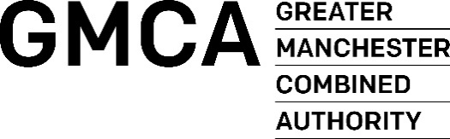

Greater Manchester Women & Girls Equality Panel
Application Form

Contact details
Your Name:

Organisation Name (if applicable):

Telephone Number:

Address:

Post code:

Email address:

Website:

Do you need support to complete this form?
If you require support to fill out this application form or in a different format or you want to learn more about the Panel before you make a decision to apply, please feel free to email Hannah Hatton hannah.hatton@greatermanchester-ca.gov.uk

- Why do you / your organisation want to be on the Panel?

- What value will you / your organisation bring to the Panel?

- We are keen to hear from those who have lived experience of gender inequality issues. If you have personal experience or your organisation directly supports those with lived experience, and you feel comfortable doing so, please provide further detail below:

- How will you engage with your networks to ensure that the views from other individuals / organisations working in the same field are accurately represented?

- What borough(s) of Greater Manchester do you / your organisation cover? (please put a tick against the relevant boroughs)

Bolton Bury Manchester Wigan
Oldham Rochdale Salford Outside GM
Stockport Trafford Tameside

- Do you / your organisation have skills, knowledge or expertise in any of the following areas? (please tick the relevant boxes)

Equalities Welfare rights Employment/skills
Education Transport Access to the built environment
Health and Social Care Culture
Housing Safe and strong community
Any others (please state)

Organisations: If you are applying to join the Panel on behalf of a specific organisation, please answer questions 7 - 9 below.

- Briefly describe what your organisation does and specifically what experience your organisation has in championing women and girls equality / the rights of women and girls?

- How are groups supporting women and girls represented by your organisation?

- What type of organisation are you? (please tick the relevant boxes
Charity Community Interest Company Co-Operative
Company Limited By Guarantee Social Enterprise
Other (Please state)

Commitment and core values
Completing this form and returning it to us acts as your signature on the application. Please ensure that you have read the accompanying cover letter with particular reference to the selection criteria. All information submitted will be kept on a secure database in compliance with GDPR.

Please return this form by post or email to hannah.hatton@greatermanchester-ca.gov.uk by Sunday 16th August
Thank you for your interest!

