Salford CVS
Wellbeing Matters -
Community Asset Fund
Expression of Interest

Guidance for Applicants
September 2021

Summary of the Fund Criteria

- Specialist grants of up to £15,000 for Salford-based VCSE organisations to receive connections from the Wellbeing Matters programme
- Delivery period: February 2022 – December 2022
- Turnover limit for organisations of £2m
- Closing date for Expressions of Interest:
12:00 noon on Friday 29th October 2021
- Closing date for Full Applications:
12:00 noon on Monday 20th December 2021

The Wellbeing Matters’ Community Asset Fund is delivered by Salford CVS
with financial support from NHS Salford CCG
Salford CVS
Wellbeing Matters - Community Asset Fund
Guidance for Applicants – September 2021

What is the Wellbeing Matters’ Community Asset Fund?

The Wellbeing Matters’ Community Asset Fund represents a significant opportunity for Salford-based VCSE organisations to become an integral part of Salford’s ‘Social Prescribing’ landscape through the Wellbeing Matters programme.

Led by Salford CVS, the Wellbeing Matters programme is a partnership with Salford Third Sector Consortium that brings together a network of VCSE organisations, who employ a team of staff known as Community Connectors.

Those staff receive referrals from primary care (e.g. GPs) and then spend time establishing what matters to those individuals (using a person-centred approach), before onwardly connecting them into community-based provision.

This fund is seeking to resource local VCSE groups and organisations to establish themselves as providers of community activities and services that Wellbeing Matters can connect people into, which in turn will support those individuals to lead happier and healthier lives.

All successful applicants will be required to:

- Establish welcoming and supportive opportunities for who are people referred / connected to them by the Wellbeing Matters’ team of Community Connectors
- Use agreed systems to track individuals’ attendance and progress
- Report on progress in an agreed format to Salford CVS on a quarterly basis.
Our team will be on hand to support with these requirements.

The delivery period for work funded through this grant is February 2022 – December 2022.

Please note that applicant organisations must be FULL MEMBERS of Salford CVS to be eligible for funding. To apply for membership you can complete a simple online form.

Wellbeing Matters’ Social Prescribing model
The diagram below outlines the Wellbeing Matters’ social prescribing process and where funded activities support the model.

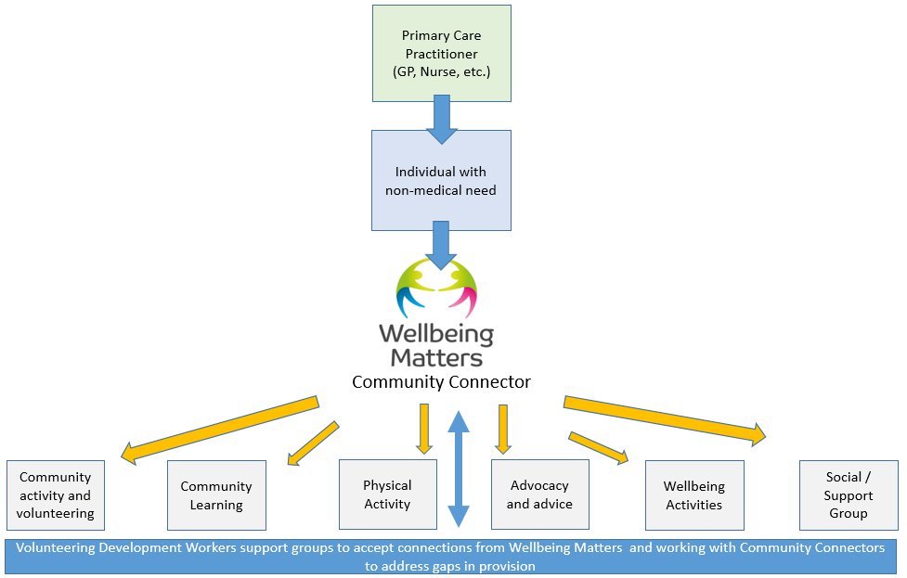
What sort of proposals can be funded?
- Services or activities that create new / additional opportunities for Wellbeing Matters to connect people into.
- Expansion of existing opportunities to provide additional capacity for Wellbeing Matters to connect people into.
- Geographical expansion of existing programmes to support Wellbeing Matters connections in new areas of Salford.

All activities must take place in Salford in one or more of Salford’s Primary Care Networks (PCNs) – see map below.

Salford’s Five Primary Care Networks:
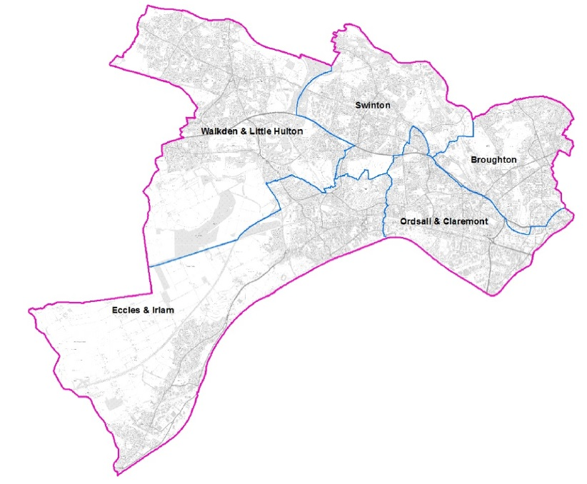
The Wellbeing Matters’ Community Asset Fund will fund reasonable costs including: direct staffing, venue hire (in Salford), materials to deliver activities, refreshments, volunteers’ expenses, etc.

We will not fund activities supporting political or religious beliefs or one-off events or activities.

Priority Themes
All proposals must look to address already identified need in communities.
The priority themes to be addressed are:

- Social isolation
- Low mood / poor mental health
- Physical inactivity

- Advocacy needs (e.g. domestic abuse, housing, debt advice)
- Drug and alcohol dependency
- Support for families

The activities proposed to address these themes can be many and varied and could include art or craft sessions, walk and chat sessions, inclusive sports activities, 1:1 buddy support, housing liaison support, lifelong learning, etc.

Please note that a separate fund will be launched later in the year to support ‘green and blue’ Wellbeing Matters social prescribing opportunities. i.e. supporting connections for activities with a green & growing theme or making use of the natural environment.

Who can apply?
Only organisations that meet the criteria below will be eligible to apply:
- This fund is open to Salford-based voluntary, community or social enterprise (VCSE) sector organisations.
- All organisations must be full members of Salford CVS.
- Only organisations in a position to support social prescribing connections.
- Of those people being supported through this fund (the beneficiaries) 100% must be Salford residents.
- The turnover limit for organisations applying is £2m per year.
- Only one application per organisation may be submitted.

What policies / other documentation is required?
All organisations will be expected to have the following policies in place at the time of application:
- Health and Safety policy
- Equality/Diversity statement or policy
- Public Liability Insurance (Cost can be included in budget)
- Risk Assessments (incl Covid-19 precautions)
- Safeguarding Adults policy
- Safeguarding Children policy (if applicable to activities)
- Volunteering policy (if volunteers are involved)
Please note: If your proposal involves working with children or vulnerable adults you will need to include a copy of the relevant Safeguarding Policy at full application stage.

You’re invited to a ‘Meet the Funder’ session
If you want to find out more this fund and how to apply, you’re welcome to attend one of our virtual ‘Meet the Funder’ sessions on ZOOM - outlined below:

a) Tuesday 5th October
6pm – 7pm on ZOOM

b) Monday 11th October
1pm – 2pm on ZOOM

To book your place please email grants@salfordcvs.co.uk with your name, organisation name and state which session you wish to attend.

What’s the process for applying?
Applying to the Wellbeing Matters’ Community Asset Fund is a 2-stage process:

Stage 1 – Expression of Interest – deadline 12:00 noon, Fri 29th October 2021
This involves completing a simple form telling us about your organisation and your specific offer in support of social prescribing. All expressions of interest will then be assessed by a panel and a shortlist drawn up of organisations invited to submit a full application.

Development support meeting – all shortlisted organisations will be invited to a meeting on the afternoon of Wednesday 1st December to talk through what is expected in a full application and address any questions from applicants.

Stage 2 – Full Application – deadline 12:00 noon, Monday 20th December 2021
All shortlisted organisations will then be invited to submit a full application with full details of their proposed offer and costed budget. Applications will then be assessed by a panel who will take final decisions on grants awarded.

What support is available to applicants?
Salford CVS can offer practical support to your organisation with developing policies, accessing volunteers, accessing wider funding, pre-application read-throughs/feedback etc.

If you need guidance or help in developing the required policies, please contact our Development Team by phone 0161 787 7795 or email at: office@salfordcvs.co.uk

For further information, visit our website at:
www.salfordcvs.co.uk/development-support
Also see our online Safeguarding in Salford resources: www.salfordcvs.co.uk/safeguarding-salford

If you have any questions or concerns regarding completing the application please contact the Grants Team by phone 0161 787 7795 or email at: grants@salfordcvs.co.uk

How to apply
Please read this guidance in full to ensure your organisation and proposal application meets the criteria. Also please ensure you have read our Terms and Conditions of Grant Funding

Organisations that wish to apply will need to complete the expression of interest form and submit it by email to grants@salfordcvs.co.uk in WORD or PDF format (ideally not as a scanned PDF). Alternatively, they can be posted to: Salford CVS, The Old Town Hall, 5 Irwell Place, Eccles, M30 0FN

When is the closing date for Expressions of Interest?
The fund will close to expressions of interest at 12:00 noon, Fri 29th October 2021. Late expressions of interest will not be considered.

Any further questions?
Please contact the Grants Team by phone 0161 787 7795 or email at: grants@salfordcvs.co.uk

Completing the Expression of Interest Form
About your organisation

Question 1) – Please state the name of your organisation.

Questions 2 & 3) – Please give two contact names, telephone numbers and email addresses.

Question 4) – Only organisations that are FULL MEMBERS of Salford CVS are eligible to apply. If No, you need to apply to join Salford CVS as soon as possible at: www.salfordcvs.co.uk/membership-signup

Question 5) – Please provide your organisation’s turnover (revenue / income) for the most recent financial year. The turnover limit on this fund is £2m.

Question 6) – Please restate the name of your organisation.

Question 7) – Please tell us how your organisation is constituted. Unincorporated Organisations / Community Groups will not have an Organisation Number.

Question 8) – Please tell us which policies, procedures and insurances you currently have in place. If you don’t have all of these in place, development support is available from Salford CVS.

About your proposal

Question 9) – Please give your proposal a memorable name. This helps us identify your offer should your application be successful.

Question 10) – Please give a full explanation of what you plan to offer and what you hope to achieve. Also please describe the priority theme(s) your proposal will address.

Question 11) – Please tell us how your proposal came about, who was involved and what informed your plan (e.g. recent experience, research or consultation).

Question 12) – Please explain why your organisation is in a good position to support those in need individuals connected by the Wellbeing Matters social prescribing programme.

Question 13a&b) – Please estimate what this proposal will cost in total and how much you are looking for from this fund.

Question 14) – Please explain where the activity will place.

Question 15) – Please tell us which health neighbourhood (or neighbourhoods) the activity will take place in.

Question 16) – If successful, when is your offer likely to start and finish?

Question 17) – How many unique individuals (Wellbeing Matters’ Social Prescribing connections) will your proposal support?

Declaration
Please confirm that you have read the Terms and Conditions of this grant by giving the name and role of the lead applicant.

