Development Worker
(Support and development for disabled people’s groups)

Recruitment Pack

Closing Date: 7th January 2022
Interview Date: 18th January 2022
Reference: DW / 2022

salfordcvs.co.uk
Contents
- Introducing Salford CVS
- Information specific to the post
- Job description
- Person specification
- How to apply and selection process

Introducing Salford CVS
Thank you for your interest in the role of Development Worker here at Salford Community & Voluntary Services (Salford CVS).
We want applicants to be able to understand who we are as an organisation and also to be able to demonstrate how their skills and experience meet the requirements of the advertised role.
We have provided you with information and guidance to help you through the process but should you have any difficulties please do not hesitate to contact recruitment@salfordcvs.co.uk

Who we are and what we do
Salford Council for Voluntary Services was established in 1973. However, our roots go back to 1919 when Manchester and Salford Council of Social Service (MSCSS) was established to address poverty and social need after World War 1. In 1973 MSCSS split into two entities, thus creating Salford CVS and Manchester CVS. 2019 saw us celebrating 100 years since our creation – a century of Making a Difference in Salford!
Salford CVS was incorporated as a Company Limited by Guarantee in 1985 and registered as a Charity in 1988. For much of that time our offices have been based in Eccles, although our work covers the whole of the City of Salford.
In 2008 the organisation was renamed Salford Community and Voluntary Services and this remains our legal name today, although inevitably we shorten this to Salford CVS.
Salford CVS is the city-wide infrastructure organisation for the voluntary, community and social enterprise sector; providing specialist information, advice, development support and opportunities for influence and collaboration. We provide support for organisations to establish and develop including training for their staff, volunteers and trustees.
Volunteer Centre Salford provides support for individuals who want to volunteer and assistance for organisations developing volunteer programmes.
Salford CVS operates within a wider framework in terms of our membership of NAVCA, NCVO, Social Enterprise UK and Charity Finance Group nationally and our membership of 10GM, GMCVO and GM Chamber of Commerce at city-region level.
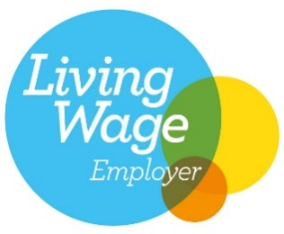

Mission Statement
Making a Difference in Salford
Vision
A robust voluntary, community and social enterprise sector that meets the diverse needs and aspirations of the people of Salford
Values
MAKING A DIFFERENCE through:
PASSION | Passionate about the Voluntary, Community and Social Enterprise Sector
INNOVATION | Innovative in our approach
QUALITY | Quality at the heart of all our activities
COOPERATION | Stronger when we work cooperatively with others to achieve our vision
DIVERSITY | Celebrating diversity and promoting equality in Salford
IMPACT | Demonstrating impact and making a difference every time

Salford CVS: Strategic Priorities 2018 - 2023
THEME | WORK STRANDS
INVESTMENT | Funding / Fundraising | Contracts / Commissioning | Trading
VOICE | Representation | Influencing | Campaigning
SHARE | Resources | Information | Collaboration
VOLUNTEER | Governance | Good Practice | Brokerage
COMMUNITY | Poverty | Inequality | Wellbeing
IMPACT | Compliance | Quality | Social Value

Salford CVS has a proud history of making a difference in Salford. We are a well-respected partner in this city and have excellent relationships with both VCSE and public sector organisations. We are financially stable with a clear business plan and a highly skilled and motivated staff team and board of trustees. As a membership organisation we work hard to address the needs and represent the interests of our hundreds of Voluntary, Community and Social Enterprise (VCSE) member organisations.
Information specific to the post

Aim
To promote and enable better access to local services for disabled people* living in Salford by capacity-building local D/deaf / disabled people-led, and impairment focused, VCSE groups and organisations.

To increase the capacity. resilience and voice of local groups and organization supporting disabled people in Salford.
This project will strengthen the voice, influence and impact of these groups as they advocate for full access to services for D/deaf and disabled people in Salford.
The aim of this work is to increase the capacity of local organisations that support:
- Blind and visually impaired people or people with sight loss.
- d / Deaf people
- People who are hard of hearing, have a hearing impairment or with hearing loss.
- People with physical disabilities

For ease of reference and use from here on, these organisations will be referred to as Disabled People’s groups.
Definition of Disability
We use the words ‘disabled people’, ‘we’, ‘us’ and ‘our’ to mean disabled people facing disabling societal barriers due to their impairments or conditions and this includes physical impairments, mental ill health/mental distress, hearing including deaf and Deaf with BSL as first language, or visual impairments, learning disability/difficulty, neurodiversity people, and those with chronic illness or fatigue."
DPO Forum England definition

Objectives
- Strengthen community and voluntary groups / organisations in Salford who are led by - or work with - D/deaf people, people with sensory impairments and/or people with physical impairments. This will be achieved by providing bespoke development / capacity-building support over a 12-month period (Salford CVS)

- Create, develop and support an accessible Network for groups / organisations to participate in with the aim of it becoming self-sustaining after 12 months

- To work with a range of partners including, but not exclusively, Salford Disability Forum, Beyond Empower, Healthwatch Salford, GMCDP (Greater Manchester Coalition for Disabled People) and Breakthrough UK.

- Develop communication and engagement plans to support this work

- Facilitate VCSE groups learning to develop accessible information

- Support Network members with mapping / collating barriers disabled people have faced accessing services due to Covid and using data and insights to inform future inclusive and accessible practice / services

- To influence system partners with regard to data collection / gathering insight / informing JSSNAs (Joint Strategic Strengths & Needs Assessment)

- To deliver a range of accessible training and awareness-raising sessions for the Network

- To produce an evaluation summary that captures feedback on barriers and key learning in order to influence future practice
* We use the words ‘disabled people’ to mean disabled people facing disabling societal barriers due to their impairments or conditions. For this project, this includes people with physical impairments, hearing including deaf and Deaf with BSL as first language, or visual impairments, and those with chronic illness or fatigue.

Job Description

Job title: Development Worker (Support and development for disabled people’s groups)

Grade: NJC Point 23 £27,741 per annum + 7% pension contribution

Hours: 37.5 hours per week (Monday – Friday; core hours between 8am – 6pm)

Contract: 12 months fixed-term

Accountable to: Director of Delivery

Overview of the area of work

Duties & Responsibilities:
- Develop the offer of services and groups across Salford with a defined approach to the inclusion of groups working with people with sight, hearing impairments, deaf people and physical disabilities/impairments

- Deliver accessible information sessions, and manage discussions across Salford using online and face to face mechanisms

- Provide information, advice and guidance 1-2-1 sessions and activities to capacity build groups and organisations using an asset based community development approach

- Represent the organisation and undertake networking activities

- Carry out related administrative support tasks, record work, add to existing database and maintain contacts systematically and appropriately

- To work collaboratively, inclusively and positively with disabled people led groups, partnership agencies, a wide range of stakeholders and organisations
- Undertake information / project analysis

- Communicate information and insights, including briefings and reports

- Contributing to accessible training and development workshops

- Any other duties as specified and agreed with Manager

Please note Salford CVS and the partners in this project have specialist knowledge, expertise and networks, which will be available to ensure you have all the tools and support you need to successfully deliver this project.

Generic Responsibilities (all Salford CVS staff)

- To prioritise attendance at and actively participate in Salford CVS staff meetings

- To attend and contribute to regular line management sessions with your designated line manager

- To be responsible for the completion of work as set out in an agreed action plan, ensuring targets are met and delivered to timescale

- To write a detailed monthly report – as required by the Chief Executive

- To manage own time and workload effectively, whilst also working as part of a team

- To promote the mission, vision, values and strategic priorities of Salford CVS

- To fulfil all responsibilities in accordance with Salford CVS’ policies and procedures, as set out in the Terms and Conditions of Employment and in related policy documents; and actively implement and promote Salford CVS’ Equal Opportunities Policy

- To undertake any other duties as appropriate to the nature and grading of the post – as required by the Chief Executive

The above duties are not intended to be an exhaustive list, but an indication of the requirements of the post. The duties within this may be varied from time to time to reflect the changing needs of the organisation and its services.

Person Specification

Skills, knowledge, experience and abilities |  | Essential / Desirable | Assessment method
1. | Experience of working within disability services and/or disabled people’s organisations, ideally with knowledge of disability rights and inclusion. | E | Application; Interview; Presentation
2. | Lived experience of disability | D | Application; Interview
3. | Understanding of the Social Model of Disability and committed to removing barriers to participation experienced by members of marginalised groups. | E | Application; Interview
4. | Experience of planning and delivering projects and delivering to agreed objectives/goals within specific timescales. | E | Application;  Interview
5 | Knowledge, understanding and experience of capacity-building techniques and asset-based community development | E | Application; Interview
6. | Experience of delivering information, advice and guidance. | E | Application; Interview
7. | Ability to write reports and produce engaging promotional materials for a variety of audiences and communication channels. | E | Application; Interview
8. | Experience capturing, collating and analysis of monitoring and evaluation for projects | E | Application; Interview
9. | Experience of building positive relationships and working collaboratively with a diverse range of partners | E | Application; Interview
10. | Experience of organising and delivering accessible training, workshops, events, meetings and/or project groups | E | Application; Interview
11. | An appreciation of the VCSE Sector and experience of working with community groups and/or disabled people, families and carers | E | Application; Interview
12. | Experience of using MS Office programmes such as Word, Outlook, PowerPoint and Excel. Also social media, web-based tools, ZOOM and TEAMS | E | Application
13. | Experience of any of the following is advantageous:  - Project design  - Co-production  - Bid writing and fundraising  - Legal structure and governance  - Business / project planning  - Safeguarding | D | Application; Interview
14. | Commitment to flexible working as part of a team in a busy environment and to meet the needs of the community including unsocial hours (evenings and weekends) | E | Interview
15. | Willingness and ability to undertake frequent travel throughout Salford | E | Interview
16. | Self-motivating, creative and energetic attitude to fulfilling a professional role | E | Interview
17. | Knowledge of the City of Salford | D | Application; Interview

Are you looking for a challenging yet rewarding role that contributes to improving the lives of local disabled people?

Are you keen to develop your skills and apply them to the best of your ability?

If yes, then you could be the person we are looking for!

Salford CVS especially welcomes applications from disabled people.

If you would like further information about the post, please contact anne-marie.marshall@salfordcvs.co.uk

If you would like to apply for the position of Disability Development Worker, please submit your application via email to recruitment@salfordcvs.co.uk by 7th January 2022

Interviews will take place in person on 18th January at our offices in Eccles

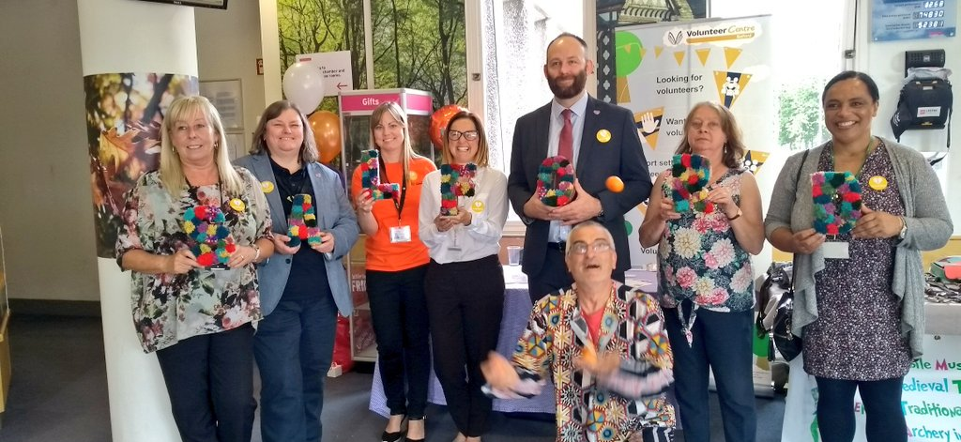
100 Years Celebration Event
Salford VCSE Conference

How to apply and selection process

Salford CVS aims to ensure that comparison between applicants for posts is thorough, fair and in line with our equal opportunities policy. It is therefore essential that you complete the application form fully as it will be used to assess whether or not you are shortlisted for interview.

All applicants are advised to read fully the job description and person specification for the post before completing the application form.

The application form is separated into three parts. Part A and Part C will be separated from the application before distribution to the recruitment panel. Your application will then be assessed against the responses you provide in Part B. Please ensure you match your responses in Part B to the requirements of the person specification that are indicated for assessment in the application form (points 1 – 17) and ensure you number your answers accordingly.

Salford CVS champions technical, practical and vocational education, which we believe should be valued equally with academic forms of learning. Consequently, we have signed up to Children England’s Open to All recruitment campaign. We therefore do not ask for academic or professional qualifications unless we really do believe that they are essential to the specific role.
https://www.childrenengland.org.uk/open-to-all

Please do not send us a separate CV or any additional information that we have not asked for. We will only consider candidates who have completed the application form. If there is insufficient space in one or more of the boxes, you may attach supplementary sheets provided they are headed with your name and the position you are applying for.

Please use black ink or print when completing the application form. If completing electronically, please use Arial font 12.

Eligibility to Work in the UK

Salford CVS complies fully with the guidance issued by UK and Visa Immigration to ensure the prevention of illegal working in the UK.

All job applicants are required to demonstrate their entitlement to work in the UK by providing one or more of the documents specified by UKVI before taking up post.

The organisation does not sponsor job applicants from outside the European Economic Area. However, it may offer employment for those who hold either a Tier 4 or Tier 5 visa subject to any applicable restrictions. Those whom we employ who have been granted visas are kept under review to ensure they remain entitled to hold employment in the UK.

Deadline for receipt of applications

This vacancy closes at 12 Noon – 7th January 2022

Please note late applications will not be accepted.

Your completed application form and equal opportunities form should be returned by one of the following methods:

Email: Please email recruitment@salfordcvs.co.uk

There is no need to post an additional copy. If successful at shortlisting stage you will be asked to sign your application form at interview.

Post: Recruitment, Salford CVS, The Old Town Hall, 5 Irwell Place, Eccles, Salford, M30 0FN.

Acknowledgement of receipt

Email applications will be acknowledged when we receive them. Should you wish to receive an acknowledgement for a postal application, please include a stamped, self-addressed envelope with your completed application form and we will return this to you.

Interviews will be held on 18th January 2022 and will be held at the Salford CVS offices in Eccles, Salford.

