Referral form for employability placement
Positive pathways is a new initiative that will deliver a person centred one to one mentoring programme, which will directly support and engage with young people aged 16-24 with SEND who are currently unemployed/economically inactive.

Participants information:
Name: |  | D.O.B:
Disability: |  | Gender:
Contact Number: |  | Contact Email:
Address:
 |  | Postcode:

Referral information:
Is this young person currently NEET? | YES | NO
What is the highest level of education qualification gained:
Tell us about why the young person is suited to this course:
How would this provision benefit the young person?
Summary of the young person's current needs:
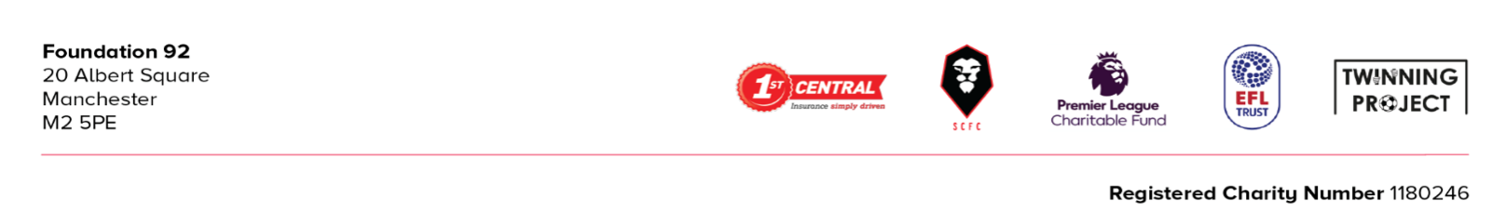

What work experience has this young person done to date:
What career is the young person looking to get into:
Who is the first point of contact for this referral: | Young Person | Person Referring

Person making the referral:
Name: |  | Organisation:
Contact number: |  | Contact Email:
Date of referral: |  | Authorising Manager:

Thank you for your referral.
Please return this completed form to Adam at: Adam.Blears@Foundation92.co.uk. If you are having any issues with the referral, please get in touch.
Once we have read through the information you have provided we will get back in touch regarding the next steps to access this course.

Thanks,
Adam Blears
Community Mentor

