Salford CVS
Wellbeing Matters
Green Asset Fund
Guidance for Applicants
January 2022

Summary of the Fund Criteria

- Specialist grants for VCSE organisations to receive connections from the Wellbeing Matters programme for activities utilising the natural environment - green or blue (waterways) to promote emotional wellbeing and mental health.
- Maximum awards of:
  - £15,000 for established VCSE organisations providing staff-led activities several days per week
  - £5,000 for smaller VCSE organisations undertaking regular activities every week
- Delivery period: April 2022 – December 2022
- Turnover limit for organisations of £2m
- Closing date for Applications:
12:00 noon on Monday 28th Feb 2022
- Decision expected by:
Thursday 31st Mar 2022

Find out more at our Meet the Funder Sessions on ZOOM
- Monday 31st Jan 13.00–14.00
- Thursday 3rd Feb 18.00-19.00
- Tuesday 8th Feb 18.00-19.00
- Friday 11th Feb 13.00–14.00

Book your place at the session that suits your availability at this link

The Wellbeing Matters’ Green Asset Fund is delivered by Salford CVS
with financial support from NHS Salford CCG
Salford CVS
Wellbeing Matters - Green Asset Fund
Guidance for Applicants – January 2022

What is the Wellbeing Matters’ Green Asset Fund?
The Wellbeing Matters’ Green Asset Fund represents a significant opportunity for Salford-based VCSE organisations to become an integral part of Salford’s ‘Social Prescribing’ landscape through the Wellbeing Matters programme.

Led by Salford CVS, the Wellbeing Matters programme is a partnership with Salford Third Sector Consortium that brings together a network of VCSE organisations, who employ a team of staff known as Community Connectors.

Those staff receive referrals from primary care (e.g. GPs) and then spend time establishing what matters to those individuals (using a person-centred approach), before onwardly connecting them into community-based provision.

This fund is seeking to resource local VCSE groups and organisations to establish themselves as providers of outdoor community-based activities - utilising the Green or Blue (waterways) spaces in the city – in order to help improve emotional wellbeing and mental health of local people, that Wellbeing Matters can connect people into, which in turn will support those individuals to lead happier and healthier lives.

Support for VCSE organisations providing Green and Blue space social prescribing destinations is provided by a small team of Development Workers, based at Salford CVS.

All successful applicants will be required to:

- Establish welcoming and supportive opportunities for people who are referred / connected to them by the Wellbeing Matters’ team of Community Connectors
- Use agreed systems to track individuals’ attendance and progress
- Report on progress in an agreed format to Salford CVS on a quarterly basis.
Our team will be on hand to support with these requirements.

Wellbeing Matters’ Social Prescribing model
The diagram below outlines the Wellbeing Matters’ social prescribing process and where funded activities support the model.
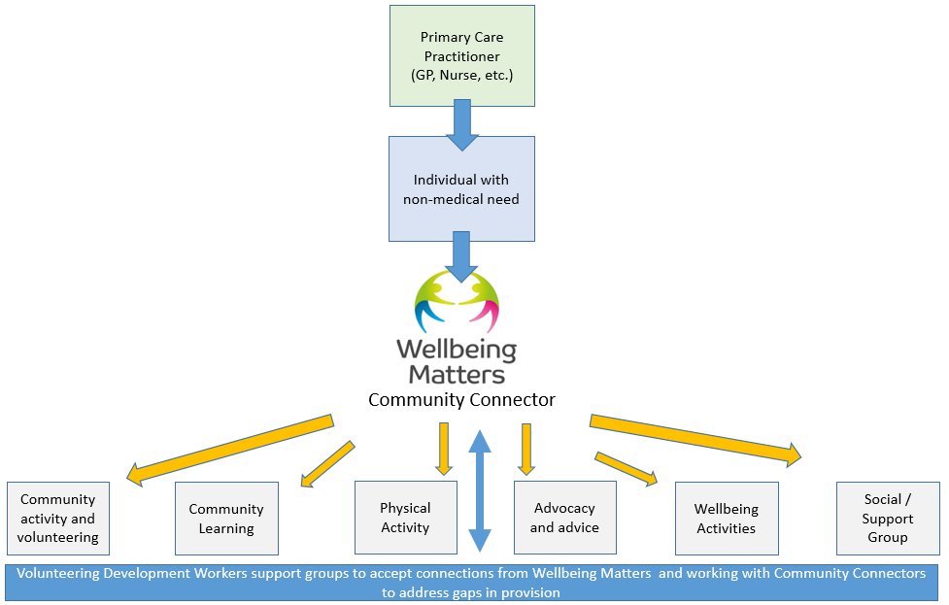

Location of Activities
All activities must take place in Salford in one or more of Salford’s Primary Care Networks (PCNs) – see map below. They can also be citywide activities.

Salford’s Five Primary Care Networks:
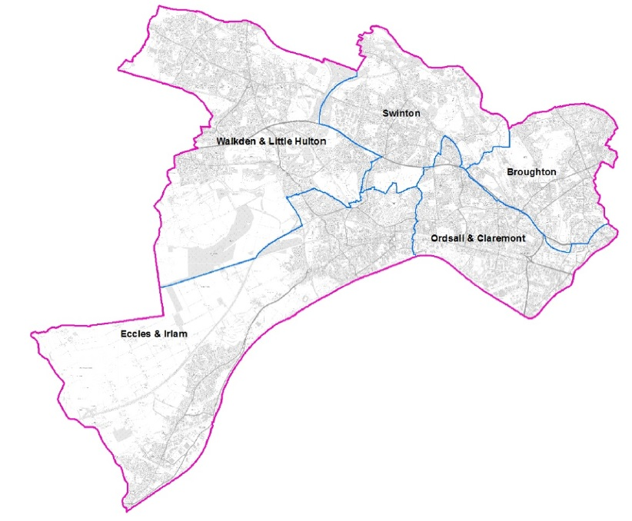

What expenditure is eligible?
The Wellbeing Matters’ Green Asset Fund will fund reasonable costs including: direct staffing, sessional staff, materials to deliver activities, insurance, refreshments, volunteers’ expenses, etc. We will not fund activities supporting political or religious beliefs or one-off events or activities.

What sort of proposals can be funded?
- Services or activities that create new / additional Green or Blue (waterways) Social Prescribing activities for Wellbeing Matters to connect people into.
- Expansion of existing opportunities to provide additional capacity for outdoor activities that Wellbeing Matters to connect people into.
- Geographical expansion of existing programmes to support Green or Blue Social Prescribing activities in new areas of Salford.

Priority Theme: Emotional Wellbeing & Mental Health
All proposals must look to address already identified need in communities.
The priority theme to be addressed is Green or Blue activities that promote emotional wellbeing and enable individuals to manage their mental health.
This may include activities that promote social inclusion, increase physical activity as well as promoting emotional wellbeing.

The activities proposed to address these themes must demonstrate how these priorities are addressed through participation in Green or Blue projects to deliver activities.

These can be many and varied and include:

- Green and growing: Horticulture projects, food growing, community gardening, tree / wildflower planting etc.
- Natural environment: Wildlife protection, habitat management, footpath construction, community clean-ups etc.
- Outdoor activities: Walking or running group activities, nature walks, group fishing activities, outdoor arts, cycling etc.

For case study examples of Green and Blue social prescribing activities see:
Green Walking in mental health recovery | Centre for Sustainable Healthcare
Growing Well Together - Our Members In Action | Social Farms & Gardens
Who can apply?
Only organisations that meet the criteria below will be eligible to apply:
- This fund is open to Salford-based voluntary, community or social enterprise (VCSE) sector organisations – i.e. organisations with a track record in Salford
- All organisations must be full members of Salford CVS.
- Only organisations in a position to support social prescribing connections.
- Of those people being supported through this fund (the beneficiaries) 100% must be Salford residents.
- The turnover limit for organisations applying is £2m per year.
- Only one application per organisation may be submitted.
- Please note: Organisations in receipt of a Wellbeing Matters Community Asset Fund award are not eligible to apply

How much can we apply for?
There are two different tiers of funding that VCSE organisations are eligible to apply for:

TIER 1 - Established voluntary, community and social enterprise organisations employing staff (including freelance) and typically delivering activities 2-4 days per week or more. Tier 1 organisations may bid for up to £15,000

TIER 2 – Smaller voluntary, community and social enterprise organisations undertaking regular activities, typically weekly. Tier 2 organisations may bid for up to £5,000

What policies / other documentation is required?
All organisations will be expected to have the following policies in place at the time of application:

- Health and Safety policy
- Equality/Diversity Statement or Policy
- Risk assessments (inc Covid-19)
- Safeguarding Adults policy
- Safeguarding Children policy (if applicable to activities)
- Public Liability Insurance (Cost can be included in budget)
- Personal Accident Insurance (if applicable to activities - cost can be inc in budget)
- Volunteering policy (if volunteers are involved)

Special note on safeguarding
If your proposal involves working with children and/or vulnerable adults, you will need to include a copy of the relevant Safeguarding Policy at full application stage. For advice, guidance and support see:
www.salfordcvs.co.uk/development-support Also see our online Safeguarding in Salford resources: www.salfordcvs.co.uk/safeguarding-salford

Special note on managing risk and insurance

Insurance - All organisations must have public liability insurance and, if appropriate, personal accident insurance that covers proposed activities.
The National Council for Voluntary Organisation (NCVO) recommends Zurich Insurance as a ‘trusted supplier’: see this link for further information.
Also, your organisation may be eligible to join The Conservation Volunteers’ (TCV) Community Network. It is free to join and offers a range of benefits including discounted group insurance with Zurich. Insurances costs can be included in your project budget.

Managing risk – all activities have risks which need to be mitigated and managed. Outdoor or countryside activities may have additional risks for participants such as involving use of tools, proximity to open water, extreme weather etc. Full risk assessments must be undertaken and mitigation measures put in place (e.g. training, supervision and first aid cover).

What’s the process for applying?
Applying to the Wellbeing Matters’ Green Asset Fund is a 2-stage process:

Stage 1 – Contacting Salford CVS – as soon as possible
This involves emailing Martyn Willcock, Green Space Development Worker: Martyn.Willcock@salfordcvs.co.uk to register project idea and set up a phone meeting to establish the tier classification for your organisation and discuss your proposal. All organisations proposing activities which are eligible for support will then be sent an application form together with accompanying guidance.

Stage 2 – Application Form – deadline 12:00 noon, Monday 28th Feb 2022
All organisations proposing eligible projects will be invited to submit an application with full details of their proposed offer and costed budget. Applications will then be assessed by a panel who will take final decisions on grants awarded.

What support is available to applicants?
All organisations can request 1:1 project development support via Martyn Wilcock. This may be delivered by Martyn himself or a Grants Development Worker (Ashley Chapman or Ella Bulbeck).

Salford CVS can also offer practical support to your organisation with developing policies, accessing volunteers, accessing wider funding, pre-application read-throughs/feedback etc.

Please contact Martyn Willcock, Green Space Development Worker on email at Martyn.Willcock@salfordcvs.co.uk Please note that Martyn may refer you to wider Development Team colleagues for any relevant specialist support.

If you have any questions or concerns regarding completing the application please contact the Grants Team by phone 0161 787 7795 or email at: grants@salfordcvs.co.uk

How to apply
Please read this guidance in full to ensure your organisation and proposal application meets the criteria. Also please ensure you have read our Terms and Conditions of Grant Funding

As soon as possible then contact Martyn Willcock, Green Space Development Worker by emailing Martyn.Willcock@salfordcvs.co.uk to discuss your project idea.

Any further questions?
Please contact the Grants Team by phone 0161 787 7795 or email at: grants@salfordcvs.co.uk

