Hate Crime Awareness Week 2022
Application Form

About your organisation

1) Organisation Name
2) Contact Details | Lead Contact | Secondary Contact
Name:
Tel Number:
Mobile Number:
Email address:
Address
(inc. postcode)

3) Is your organisation a member of Salford CVS? |  | Yes |  | No
If No, you need to apply to join Salford CVS at: www.salfordcvs.co.uk/membership-signup

4) What type of organisation are you?  (tick all that apply) | ✓ | Organisation Number
Unincorporated Association |  | Not applicable
Company Limited by Guarantee
Registered Charity
Charitable Incorporated Organisation
Community Interest Company
Community Benefit Society
Cooperative Society
Other (please specify)

5) Does your group support a particular section of the community?
e.g. Black, Asian or Minority Ethnic, LGBTQ+, Disabilities, Religious groups, Women etc.
If Yes, please give details below:

About your project
6) Project Name:
7) What will your activity involve and how it will help address Hate Crime in Salford.
- Prevent Hate Crime
- Encourage the reporting of Hate Crime Offer/improve support to victims of Hate Crime
- Help reduce its impact on victims & the wider community
- Celebrate diversity in our communities
(250 words max)

8) Please describe the actions your organisation has implemented to ensure that any activities being delivered are Covid Safe (100 words max)
9) Has your organisation completed a Risk assessment in relation to the above? | Yes: |  | No:

10) If there are further COVID restrictions in February 2022 how would you adapt your activity to deliver a COVID-safe project?

11) How will you engage with a wider audience than your members and who will they be? (100 words max)

12) Approximately how many people do you hope to engage through this project?

13) When will your activities will take place? Please tick ✓
A) During Hate Crime Awareness week (7th – 13th February 2022) |  | OR | B) Throughout the month of February 2022

14) Please give details of any venue(s) and date(s) if known at this stage:

15) Where in Salford will your activity take place? Please tick all wards that apply ✓
Barton & Winton |  |  | Kersal & Broughton Park |  |  | Walkden North
Blackfryers & Trinity |  |  | Little Hulton |  |  | Walkden South
Boothstown & Ellenbrook |  |  | Ordsall |  |  | Weaste & Seedley
Broughton |  |  | Pendlebury & Clifton |  |  | Worsley & Westwood Park
Cadishead & Lower Irlam |  |  | Pendleton & Charlestown
Claremont |  |  | Quays
Eccles |  |  | Swinton & Wardley
Higher Irlam & Peel Green |  |  | Swinton Park |  |  | OR CITY-WIDE

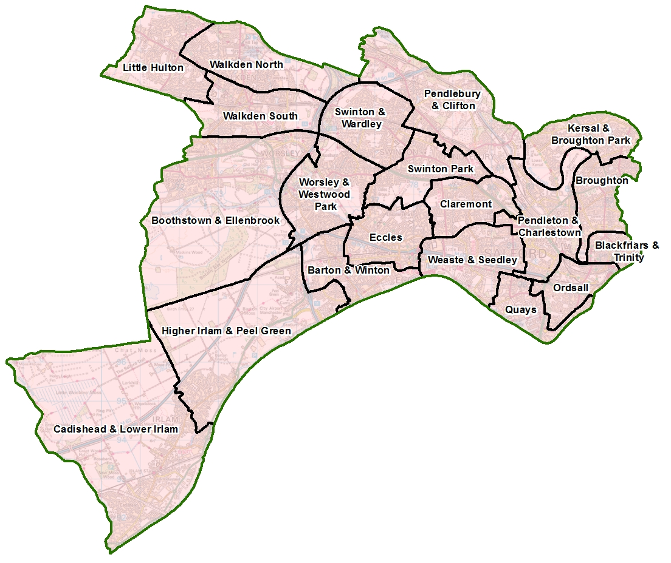
Salford’s new Ward Boundaries

Maximising the benefits for Salford  We expect all projects to help contribute towards  making Salford a better place for all. | 

16) Paying the Living Wage – if you employ staff | Yes: | No: | N/A:
If you employ staff, do you pay all your staff the at the Living Wage Foundation’s minimum rate of £9.50/hour?
If you employ staff, is your organisation registered with Living Wage Foundation as a Living Wage Employer?
For details see: https://www.livingwage.org.uk/become-a-living-wage-employer

17) Supporting local businesses and VCSE sector organisations
In delivering your project how will you prioritise buying of goods and services from local independent businesses / VCSE sector organisations?

18) Added social-value What other social, environmental or economic benefits will be delivered through your project? (e.g. volunteer opportunities, enhanced greenspace, training opportunities etc.)

About the money
19) Item description with calculation |  | Total cost |  | Amount requested
 |  | £ |  | £
 |  | £ |  | £
 |  | £ |  | £
 |  | £ |  | £
 |  | £ |  | £
 |  | £ |  | £
 |  | £ |  | £
 |  | £ |  | £
 |  | £ |  | £
 |  | £ |  | £
 |  | £ |  | £
Total cost project |  | £
Total amount requested from the Hate Crime Awareness Week Fund  (Maximum £500) |  |  |  | £
If applicable, where is the rest of the money coming from?
Funding source | Amount |  | Funding Secured?
Please retain all financial records.
Salford CVS reserves the right to audit your project expenditure.

Which policies do you have in place?

20) Please tell us which policies you have in place Please tick  | We have this in place | We need to develop this | Not applicable
a) Health and Safety policy
b) Equality/Diversity Statement or Policy
c) Public Liability Insurance
(Cost can be included in budget)
d) Risk assessments (inc Covid-19 precautions)
e) Safeguarding Adults policy
(if applicable to project activities)
f) Safeguarding Children policy
(if applicable to project activities)

Declaration
Please read our Terms and Conditions of grant aid:

We have read and understood the Terms and Conditions of grant aid and confirm to adhere to these conditions if our application is successful:

Name: (signature not required)
Role:
Date:

Closing date for applications: 12:00 noon, Fri 15th November 2021

Please return completed application form by email to: grants@salfordcvs.co.uk in Word or PDF format (no scanned PDFs).

