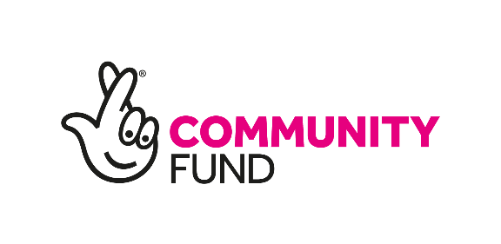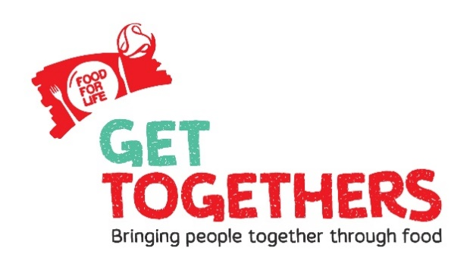

Food for Life Get Togethers
Local Partner Funding Application Form and Guidance – Northern England
October 2019

Funding Application Guidelines
Background
With the support of the National Lottery Community Fund, Food for Life Get Togethers bring people of all ages together through growing, cooking and eating good food.
Food for Life is about making good food the easy choice for everyone – making healthy, tasty and sustainable meals the norm for all to enjoy, reconnecting people with where their food comes from, teaching them how it’s grown and cooked, and championing the importance of well-sourced ingredients.
Rooted in partnerships with groups of schools, nurseries, community groups and organisations, Food for Life Get Togethers is for people of all ages and backgrounds.
Having the chance to get together and have a chat whilst sharing fresh, healthy food, by growing or cooking food together can change people’s day to day lives for the better.
A Get Together can be any activity that brings different generations together through food. You can also link to established national food events and be part of something huge! This includes Grandparent Gardening Week in Spring and The Big Lunch in Summer. These events bring generations and communities together to grow, share and cook food and have the potential to stimulate regular and sustained activity.

Local Partner offer
We would like you to get involved by partnering with us to test out innovative approaches or develop existing initiatives which bring generations and people from different backgrounds together through food. You can apply for up to £10 000. We expect this work to start in January 2020 and run until no later than May 2021.
We are looking for partners that can demonstrate genuine understanding of what is needed in their communities and have the skills and energy to use food as a tool to bring people together across different generations.
We want partners to work innovatively within their local communities to achieve some of the following outcomes:
- Different generations have stronger connections with each other in communities through cooking, growing and sharing good food leading to a happy, healthy relationship with food and improved health and wellbeing.
- Improved understanding of how to support and engage disadvantaged and diverse communities in cross-generational food activities
- Organisations and settings supporting different generations across the UK have increased knowledge, confidence, networks and resources to sustain cross-generational food activities.
- People of different generations have a more positive attitude to ageing in society as a result of being more connected through food.
- Increased impact and learning by ensuring project sustainability and embedding activities within communities.

As well as testing new approaches, we would encourage and support you to:

Promote engagement in Get Togethers to local settings (community partners or groups, schools, early years, care homes etc)
Provide practical support and advice in how to take part in intergenerational growing/cooking projects
Work with us to monitor, evaluate and identify best practice and challenges by completing feedback forms, regular reporting and case studies
Attend training to develop skills and cascade to community – Intergenerational training and a choice of training in cooking and growing available.
Who can apply?
The funding is available to not for profit settings including, but not limited to; community groups, nurseries, schools, care homes, community health and social care settings, housing associations, charities and local groups. Food for Life Get Togethers should be used to connect different age groups and be inclusive of diverse communities so you will need to consider this when planning your activities.
The funding will only be open to groups and organisations in the Food for Life Get Togethers ‘test and learn regions’ which are for the North of England; Rochdale, Salford, Wigan, Hull, Calderdale and Kirklees and Sheffield. A map of eligible areas is shown in the terms and conditions section of this document. Organisations can be any size (local, county wide, regional, national) but projects must only be in one local authority area of the test and learn regions.
We are particularly interested in partners who already work with diverse and/or disadvantaged communities.

Financial arrangements
To apply, you must have a bank account in the name of your organisation/community group. We can not make payments to individuals.
Payments for this funding will be made in 3 instalments following reporting. This will be in: January 2020, July 2020 and January 2021.

Sending us your application
Use the form below to apply to be a local partner. You will need to email your application to vjones@soilassociation.org by 12pm Friday 29th November 2019. Please clearly specify in the email subject line ‘Partner funding Application’ and include the name of your organisation.
Alternatively, you can post your application to; Victoria Jones, Soil Association, Spear House, 51 Victoria Street, Bristol, BS1 6AD. We must receive postal applications no later than Friday 29th November 2019.

How we will process your application
You will receive an email from us confirming that we have received your application. Application decisions are agreed by the Food for Life Get Together Steering Group and all decisions are final. We may ask you for further information. We aim to deal with all applications in a friendly and efficient manner, if we fall short of these aims, please let us know.

Timeline
22nd October 2019 Local partner applications open
29th November 2019 12pm deadline for applications
w/c 9th December 2019 Decision letters sent

w/c 16th December 2019 Contracts signed
January 2020 Workplan, regional induction and
delivery starts
May 2021 Evaluation report due

Contact
For more information about Food for Life Get Togethers please visit https://www.foodforlife.org.uk/get-togethers

If you require any assistance to apply for this funding please let us know and we would be happy to help.

Please contact Kerry Page, Programme Manager for the North, kpage@soilassociation.org , or 07584 035807 for enquiries.

Local Partner Form
All applicants must fill in this form.

Personal Details
Name of organisation, group or setting applying:
Name of individual making application on behalf of the above:
Email address:
Phone Number:
Address (please include the postcode):
Address of organisation head office (leave blank if same as above)
Which of the Food for Life Get Together test and learn areas are you based in?*
Rochdale, Salford, Wigan, Hull, Calderdale and Kirklees and Sheffield.
*The map in the guidance point 17 shows which areas are test and learn areas.
Funding request
How much are you applying for?
If successful, how would you spend the funding and what would you deliver (please be specific)?
What changes do you expect to see as a result?
How will you know if the funding has delivered what you expect?
Who will benefit from your project?
Will you be working with other local partners to deliver your project? (please list)
How will your project build on/enhance work currently happening in your area?
How will you sustain the project after the funding?
Communications and Marketing
How will you promote the project?
Evaluation and Monitoring
Have you already registered your organisation on the Food for Life Get Togethers website? | Yes/No
How will people in your community be involved in planning and evaluating the project?
How will you show the difference or change your project has made?

Supporting information (optional)
Please use this space to provide links to pictures, blogs, videos or websites that you feel may support your application.

Print name:
Signature
Position/Job Title:
Date:
Local Partner Terms and Conditions
- The funding may be used only for the purposes outlined in the SLA as approved by the Food for Life Get Togethers Steering Group. We understand that activities sometimes change as they develop. If you are unable to use the funding for the specific purpose for which it was intended and significant changes are likely to be made please contact us before spending any portion of the funding.
- The maximum amount you can apply for is £10 000. There is no minimum. This can cover costs such as, but not limited to: equipment, staff time or training. Should part of the funding be used to pay for staff time, the employer will need to be in agreement prior to this application being submitted. The employer must have all legal and financial agreements in place and capacity to manage and support staff.
- The project must start in January 2020 and be finished by May 2021.
- Successful organisations will be required to provide a workplan outlining what they will be delivering over 16 months in January 2020. At least one member of staff from each successful organisation will be required to attend an induction with key stakeholders in early 2020.
- The funding cannot be transferred to another third party.
- Payment will be released on receipt of project reports being received in the agreed timeline.
- We will decline any funding applications where there is no organisational or community group bank account to transfer the funding into.
- You will work with Food for Life and key stakeholders in your area to ensure that good food will be promoted and provided in your intergenerational food activities.
- We won't consider any applications which involve promoting any corporate organisation, political activities or promoting any religious beliefs. We will consider projects led by religious organisations if they're for the good of the whole community.
- If you are successful, you will not be able to apply for any other Get Togethers funding in future years. If you have already applied for and received funding for a Food for Life Get Togethers small grant, you can apply to be a partner.
- We expect that any press releases referencing the work funded be forwarded to the Food for Life Get Togethers Team.
- Partners must comply with GDPR and data sharing agreements.
- Any publicity of the funded activity must reference Food for Life Get Togethers and The National Lottery Community Fund.
- You agree that we can use any of the information and images you've given us in any of our publicity or marketing.
- We may use your reports for reporting purposes or for publicity. We may also ask you for updates after the project is over.
- We will require repayment of the money if you become insolvent or go into administration, receivership or liquidation.
- If your organisation does not meet the requirements set out in this document, then we reserve the right to reclaim some, or all, of the money at any time.
- The safety of everyone involved in your intergenerational food activities is extremely important. Use your own organisation’s policies and procedures to ensure you think about the related risks, including the safeguarding of children or young people or adults at-risk attending your event. You must also comply with any additional related policies and procedures provided by Food for Life Get Together
17. Below is the map of the eligible areas for partner applications:
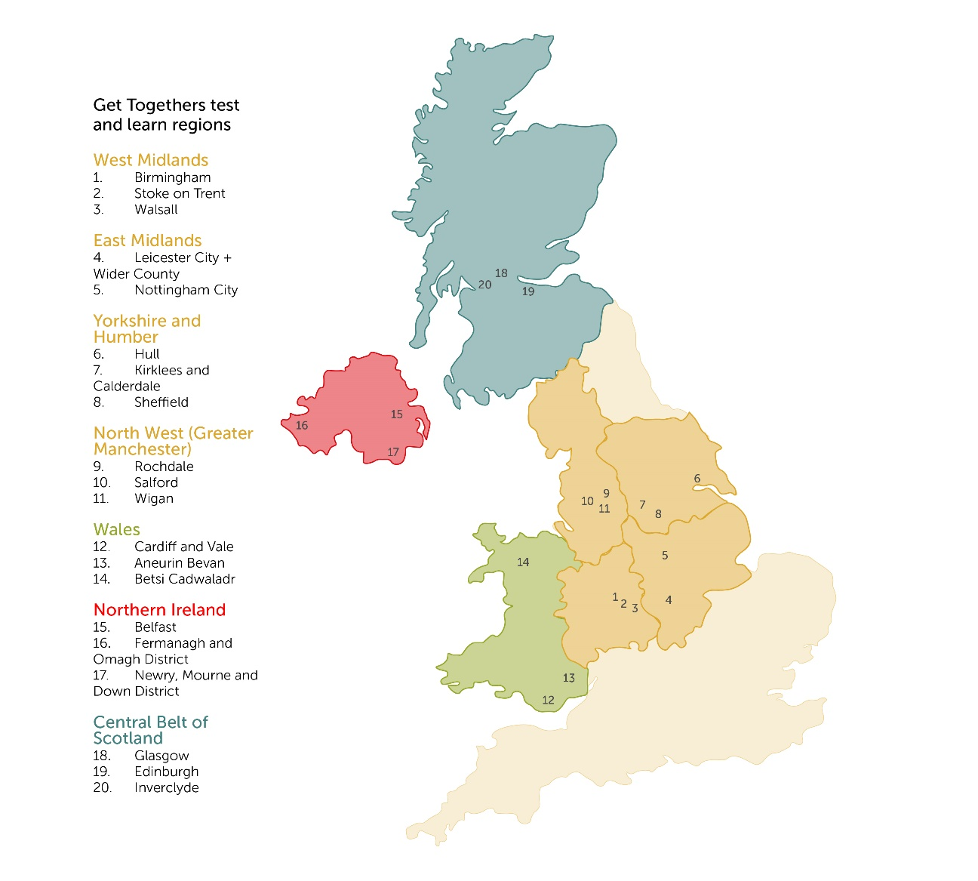

Privacy Notice

1. As part of the requirements of The National Lottery Community Fund, Food for Life Get Togethers is required to keep any information for 7 years. An extract of this retention policy is available on request. Unsuccessful applicant’s information will be destroyed once notified of the decision.
2. We may share your details with others internally working for Food for Life Get Togethers who help us assess, manage and process your partner application.
What else we may do with your data if your partner application is successful?
1. You will be added onto our database so we can access your contact details.
2. You may be contacted for further evaluation.
3. We may contact you for future communication and marketing opportunities, for example a case study on best practice.
If you have any worries or complaints about the way we use your information, please don’t hesitate to get in touch with us.

