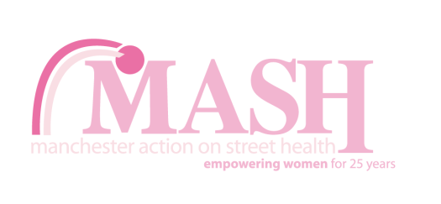 | Equal Opportunities Monitoring Form  This information will remain confidential.

- Which of the following options best describes how you think of yourself?
Woman (including trans woman) Man (including trans man) Non-binary

In another way
(Please state):

- Is your gender identity the same as that you were assigned at birth?
Yes No

- Which of the following options best describes how you think of yourself?

Bisexual Gay/Lesbian Heterosexual/Straight

In another way (Please state)

- What is your age?

- What is your religion or belief, even if you’re not currently practising?
(Please tick one option)

Buddhist  Christian (inc all denominations)  Hindu  Humanist  Jewish  Muslim | Sikh  Agnostic  No religion (Atheist)  Other (please write in)

7. Which of the following best describes how you think of yourself? Please tick one option

 | White British |  | Mixed White & Asian |  | Any other Asian or Asian British Background
 | White Irish |  | Other Mixed Background |  | Black or Black British Caribbean
 | Other White Background |  | Asian or Asian British Indian |  | Black or Black British African
 | Mixed White & Black Caribbean |  | Asian or Asian British Pakistani |  | Any other Black or Black British Background
 | Mixed White & Black African |  | Asian or Asian British Bangladeshi |  | Chinese

Any Other Ethnic Group (Please state)

- Do you consider yourself to be a disabled person?  (This may also include long-term medical conditions) | Yes No

- Where did you hear about this role?

 | MASH website |  | Social media |  | Volunteer mailing
Other (please specify)

