Criminal records that don’t show (stay) on standard and enhanced DBS checks (filtering and protected cautions and convictions)

Aim of this information
In July 2020 the government announced plans to change the rules on what is disclosed on (and removed from) standard and enhanced criminal record checks issued by the Disclosure and Barring Service (DBS). This was in response to a Supreme Court ruling in 2019. This information sets out the filtering process incorporating the changes made by the government that came into effect on 28 November 2020. Find out more about the changes on our main website.
This forms part of our information on criminal record checks for employment.
Note – This information focuses on how the filtering process works in England and Wales

Why is this important?
If you are applying for a job or role which is ‘exempt’ from the Rehabilitation of Offenders Act and which requires a standard or enhanced DBS check, your DBS certificate will disclose details of all spent and unspent cautions and convictions unless they are eligible for removal (often referred to as filtered or protected).
If your criminal record meets the criteria set out below it will automatically be removed from your DBS certificate at the time an application is made.
Many organisations ask individuals for some kind of criminal record self-disclosure at application stage and it’s important therefore to know whether your offence will be removed from your DBS certificate to ensure that you do not disclose it to an employer if, legally, you don’t need to.

Background
Since May 2013, standard and enhanced DBS checks stopped disclosing all cautions and convictions after the introduction of a process referred to as ‘filtering’.
In July 2020, in response to a Supreme Court ruling in 2019, the government announced further changes to the process which came into force on 28 November 2020. These changes will see more people benefiting from having cautions and/or convictions removed from standard and enhanced certificates, allowing them to apply for jobs without the need to disclose old cautions and/or convictions.
‘Filtering’ is similar to the rehabilitation periods under the Rehabilitation of Offenders Act 1974. However, instead of establishing what is ‘spent’ and doesn’t get disclosed on a basic check, ‘filtering’ establishes what doesn’t get disclosed on a standard or enhanced DBS check.
Information that is filtered will be removed from a DBS check automatically at the point you apply for one. However, cautions and convictions do not get ‘removed’ or ‘wiped’ from the Police National Computer (PNC).

Recent changes to the criminal records disclosure regime
The changes which have been made to the criminal records disclosure regime apply to jobs and voluntary roles that involve a standard or enhanced check issued by the Disclosure and Barring Service (DBS). The new rules mean that:
- Warnings, reprimands and youth cautions (including conditional cautions) will no longer be automatically disclosed on a DBS certificate.
- The multiple conviction rule has been removed. This means that individuals with more than one conviction will have each conviction considered individually against the criteria, rather than all being automatically disclosed.

How filtering works

What will be disclosed on a standard or enhanced DBS check?
The rules around what cautions and/or convictions are automatically disclosed are set out in legislation. The table below provides details of what a standard or enhanced certificate must include:
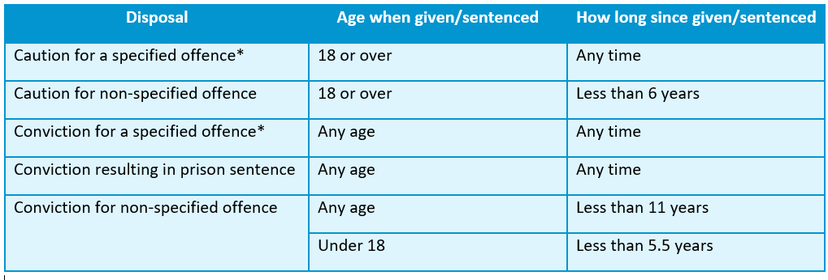
* A full list of specified offences can be found on the DBS list of offences that will never be filtered.

What will not show up? Cautions
- Reprimands, final warnings and youth cautions (including conditional cautions) received when under the age of 18 will be removed from standard and enhanced checks immediately, regardless of the offence. This means that even if your caution was for a specified offence it would still be removed.
- Adult cautions will be removed from standard and enhanced checks if 6 years have passed since the date of issue, providing it is not for a specified offence.
The process applies no matter how many cautions you have. Cautions will be removed even if you have others which are not (for example where others are for a specified offence or they are too recent).

What will not show up? Convictions
Convictions received when 18 or over will be removed from standard and enhanced checks if:
- 11 years have passed since the date of conviction.
- they did not result in a prison sentence (or suspended sentence).
- they were not for a specified offence.
The process applies no matter how many convictions you have. They will be removed even if you have others which are not (for example where others are for specified offences or they are too recent).
For a conviction received when under 18, the same rules apply as for adult convictions, except that the elapsed time period is 5.5 years.

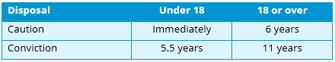

Offences that stay on (‘specified offences’)
A ‘specified offence’ is one which is on the list of offences that will never be filtered from standard and enhanced DBS checks. The list includes a range of offences which relate to sexual or violent offences, or are relevant in the context of safeguarding.
The table below provides a summary of the types of offences which are eligible for removal and those that are not.

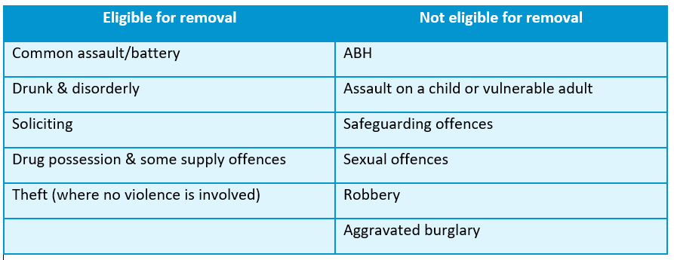

Offences that can come off
A Freedom of Information request made by Unlock to the DBS revealed a full list of offences which had been removed from standard and enhanced DBS checks.

Find out whether your conviction/caution will be filtered
To establish whether your caution and/or conviction is going to be removed from your standard or enhanced check and, doesn’t need to be disclosed to an employer, you can use our flowchart below:

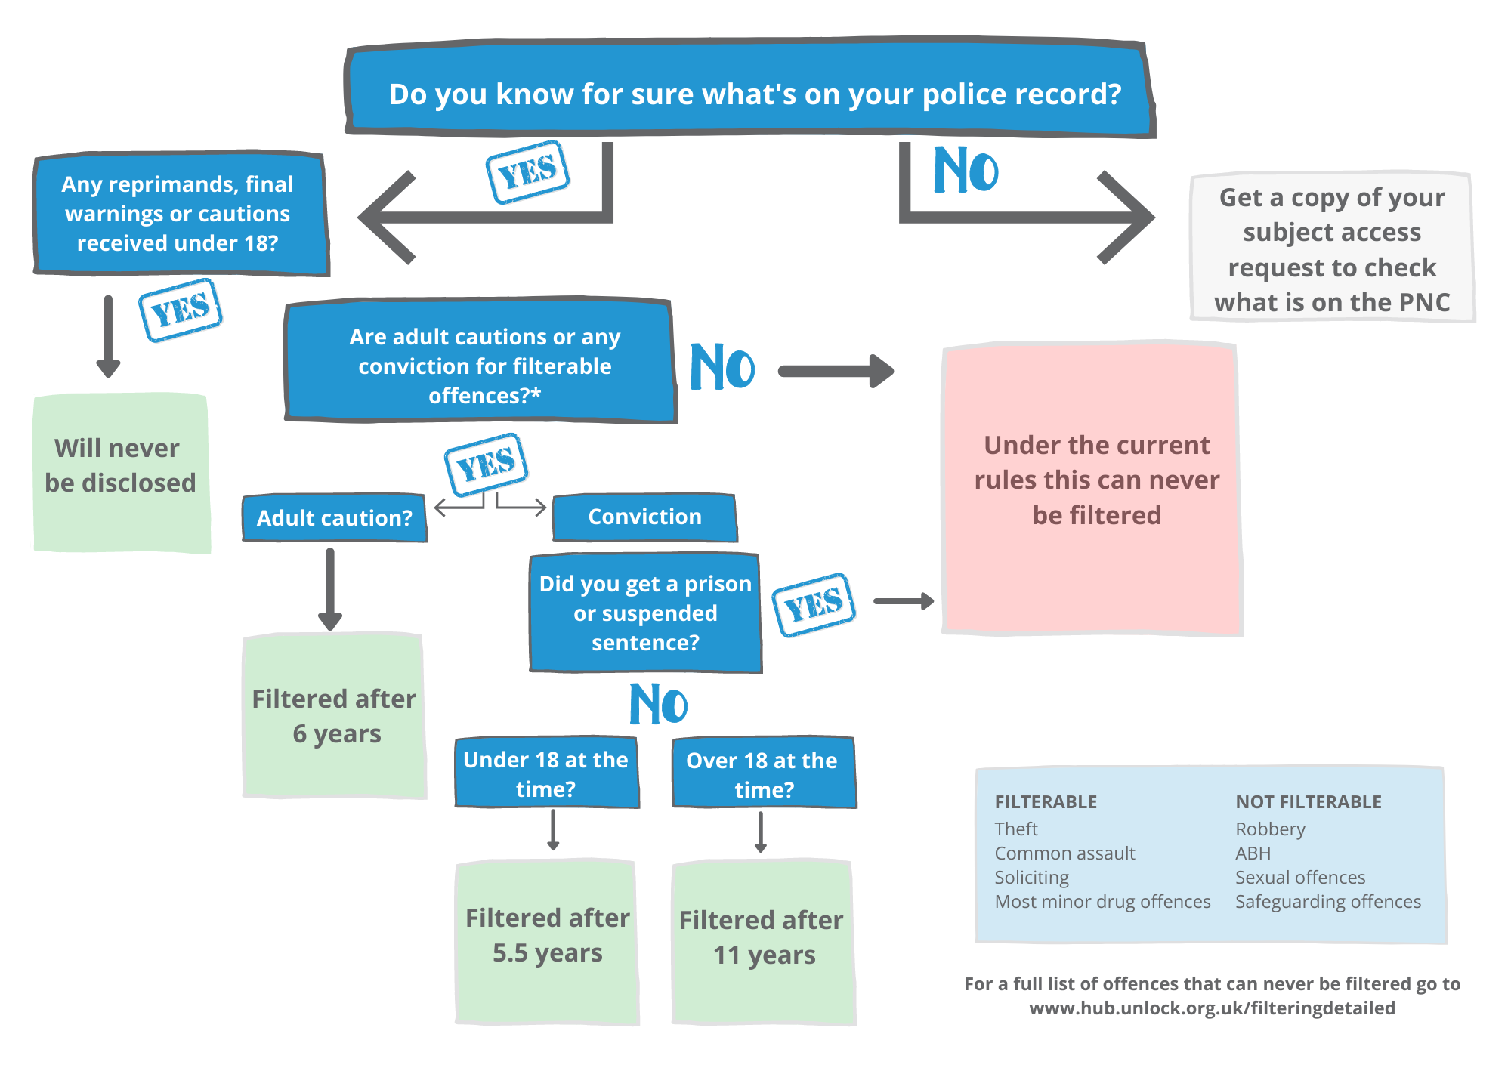

Positions not covered by filtering
There are a small number of jobs where filtered cautions and/or convictions can be taken into account. Some examples of this include police vetting for police constables and cadets. A court ruling in 2017 established that the filtering rules should be applied by the police when recruiting for other roles such as service support officers.

other positions include:
- Judicial appointments;
- Constables and persons appointed as police cadets to undergo training with a view to becoming constables and naval, military and air force police;
- Any office or employment in the Serious Fraud Office or in the National Crime Agency;
- The Commissioners for Her Majesty’s Revenue and Customs and any office or employment in their service;
- The Official Solicitor and his deputy;
- Certain appointments to the office of Public Trustee;
- Any office, employment or other work which is concerned with the establishment of, operation of, or access to a database under section 12 of the Children Act 2004;
- Firearms dealer; and
- A person who is required to obtain an explosives certificate.
Disclosure of criminal records in these instances is not provided by the DBS.
Prison and probation roles are not exempt from the filtering rules and applicants can therefore legally withhold details of cautions/convictions which are removed from standard and enhanced DBS checks.

Other information disclosed on enhanced DBS certificates
In addition to cautions and convictions recorded on the PNC, enhanced certificates may also include police intelligence (approved information) if a chief officer of a police force considers it relevant. The disclosure of this information is subject to statutory guidance but the police could, in principle, disclose information about offences which have been filtered from an enhanced certificate if they felt that it was relevant to the position applied for and ought to be disclosed.
We have not previously seen any evidence of this but we would be interested in hearing from anybody who has had filtered cautions/convictions disclosed on their enhanced DBS certificate. Please email us at policy@unlock.org.uk.

If you use the DBS Update Service
If you are signed up to the DBS Update Service it is important to note that the filtering of a caution or conviction would not lead to a status change. A status change is only prompted when there is new information to be added, or an offence needs to be changed or amended, or because you have become barred. An offence which has been filtered would mean the removal of information from your certificate.
If you require a new certificate which does not show cautions or convictions which have been removed, you will need to apply for a new DBS check.

If an organisation currently holds information about your criminal record
In order to comply with data protection legislation any organisation that keeps criminal record information will need to consider how they manage the data they hold.
If you have previously disclosed details of your criminal record to an employer, university etc we recommend that you ask them to amend or delete their records as soon as your caution and/or conviction is filtered under your rights of rectification.

Information for employers
Where a role is included in the ROA Exceptions Order, employers can ask about cautions and convictions which are ‘not protected’ (filtered). In light of the changes introduced in November 2020, employers will need to review the questions they ask on application forms together with any guidance they provide.
Further information can be found here.
If an employer takes into account a conviction or caution which has been removed (possibly because it was disclosed in error) then they could be acting unlawfully. You can find further information on our spent and unspent convictions and employment law page.

