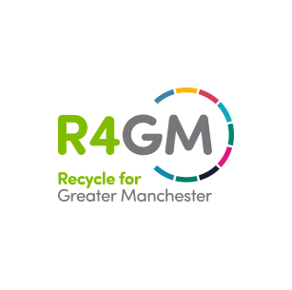

24th March 2020

Temporary closure of all Greater Manchester Household Recycling Centres

Following the Prime Minister’s briefing on Monday 23rd March, GMCA has closed all 20 Household Waste Recycling Centres (HWRCs) across Greater Manchester with immediate effect. The government guidance is clear that everyone should stay at home except for basic necessities such as food shopping, collecting medication and daily exercise.
The sites are operated by our waste contractor SUEZ who will still be operating the waste treatment sites which are where council vehicles deliver waste and recycling from your household bin collections. We will be reviewing the situation and will open the Recycling Centres as soon as it is safe to do so and following the government advice.
Residents are to be advised not to leave any waste outside the Recycling Centres – leaving waste outside the Recycling Centres or anywhere else is classed as fly tipping and is a criminal offence for which people will be prosecuted.
Content to include on your website
Following on from the Prime Ministers announcement on 23rd March, all household waste recycling centres are now closed. Please visit https://recycleforgreatermanchester.com/ for more information
Please find below some FAQ’s for your reference:
Why are HWRCs closing?
The government guidance is clear that everyone should stay at home except for basic necessities such as food shopping, collecting medication and daily exercise.

What do I do with my waste?
Please minimise your waste as much as possible by avoiding doing any large DIY projects or decluttering.
If it’s possible, please store your waste (for example waste from DIY or decluttering) in a safe place either in a garage or shed. Make sure you do not block any fire escapes.

Are all SUEZ weighbridges closing?

All weighbridges are closed to members of the public, but remain open to the local councils’ waste collection vehicles. This is so we can support the local councils to continue operating vital services.

What are the SUEZ staff doing who worked on the HWRC?
The SUEZ staff will be moved to work on our other waste treatment sites and weighbridges which is where the council vehicles go to deliver in the waste and recycling collected from your household bins. Our main priority now is to support the council so they can continue to offer a bin collection service.

What should I do with electrical items?
Please store them safely at home. Please do not put these in any of your wheelie bins as they can cause fires and damage to waste sorting equipment.
What should I do with batteries?
Please store them safely at home. Please do not put these in any of your wheelie bins as they can cause fires and damage to waste sorting equipment. They can be taken to most supermarkets and to the recycling centres when they reopen.
What do I do with garden waste?
We know this is a difficult situation and due to the nice weather many of you will be doing some gardening. Some councils are still collecting garden waste, however you can consider composting at home or store any garden waste at home until we are able to open the recycling centres.
I have hazardous waste to dispose of what do I do?

Weighbridges are not open to the public therefore you currently cannot dispose of hazardous waste such as asbestos, plasterboard and gypsum from your home. Our advice would be please do not carry out DIY projects that would involve the removal of these materials unless you have safe and secure storage.

