Grants Programme
Schedule of Grants for 2021/22
Updated 20th August 2021

The calendar below shows the launch dates and closing dates for confirmed funds. Approximate timescales are also outlined for funds still to be confirmed

Please note that dates may be subject to change for operational reasons.

Confirmed for 2021/22 | May | Jun | Jul | Aug | Sep | Oct | Nov | Dec | Jan | Feb | Mar
Wellbeing Fund (R1) | 10th | 7th
Volunteers’ Expenses Fund (R1) | 10th | 7th
Healthy Holidays Fund | 14th | 21st
Grow Well Fund (2-stage) | 10th |  | 5th | 16th |  |  | 1st
Volunteers’ Activities Week Fund |  | 2nd | 26th
Wellbeing Fund (R2) |  |  |  | 9th |  | 4th
Volunteers’ Expenses Fund (R2) |  |  |  | 9th |  | 4th
Healthy Schools Fund |  |  |  |  | 13th |  | 15th
Wellbeing Fund (R3) |  |  |  |  |  |  |  | 13th |  | 7th
Volunteers’ Expenses Fund (R3) |  |  |  |  |  |  |  | 13th |  | 7th
Youth Wellbeing Fund |  |  |  |  |  |  |  |  | 3rd | 21st
To be confirmed | May | Jun | Jul | Aug | Sep | Oct | Nov | Dec | Jan | Feb | Mar
Achieve Asset Fund |  |  |  |  | ? | ?
Healthier, Fairer, Greener Fund |  |  |  |  | ? | ?
Neighbourhood Social Prescribing |  |  |  | ? | ? | ?
Green Care Social Prescribing |  |  |  |  | ? | ? | ?
Hate Crime Awareness |  |  |  |  | ? | ? | ?

See overleaf for an outline of each fund.

Grants and Investments from Salford CVS

PLEASE NOTE: Only organisations which are FULL MEMBERS of Salford CVS are eligible to apply for Salford CVS managed grants.

To apply for membership you'll need to complete a simple online form here. Applications for membership are considered by Salford CVS' Board of Trustees, which typically meets on a monthly basis.

Confirmed grants for 2021/22

Wellbeing Fund
Grants of up to £1,000 for VCSE organisations (with <£100k turnover), for projects which help to improve the health and wellbeing of Salford residents. Supported by NHS Salford CCG.

Volunteers’ Expenses Fund
Grants of up to £750 small VCSE (<£100k pa turnover), to meet the cost of paying out-of-pocket expenses to support volunteers. Supported by NHS Salford CCG.

Volunteers’ Week Activities Fund
This fund is for voluntary, community or social enterprise sector organisations who want to put on activities or events to recruit, retain or recognise volunteers between. These small grants of up to £500 are supported by NHS Salford CCG.

Healthy Holidays Fund
Grants of up to £5,000 (to be confirmed) to tackle holiday hunger and improve child nutrition. This fund will support summer holiday activity costs, combined with provision of healthy food. Supported by NHS Salford CCG and Salford City Council.

Grow Well Fund
Grants of up to £2,000 for VCSE organisations to support new, or expand existing, community growing projects which promote wellbeing. There is a 2-stage process to apply for these grants. Supported by RHS Garden Bridgewater & NHS Salford CCG.
Youth Wellbeing Fund
Grants of up to £2,500 for youth-led projects supported by VCSE organisations, schools or colleges. All projects must be inspired and developed by a group of at least 3 young people aged 8-21, or up to the age of 25 if the young people have additional needs. There is no turnover threshold for the host organisation. Supported by NHS Salford CCG.

Anticipated Grants for 2021/22
The grants listed below are currently being developed by Salford CVS in consultation with commissioners

Achieve Asset Fund – Specialist Fund – Bolton, Salford & Trafford
Grants of £5,000 (per borough) available to VCSE organisations working to support people recovering from drug or alcohol dependency. Open to organisations across Salford, Bolton and Trafford. Supported by NHS GMMH Foundation Trust.

Healthier, Fairer, Greener Fund
This will be a large grant fund directly linked to the priorities outlined in Salford’s Locality Plan and The Salford Way. Supported by NHS Salford CCG.

Neighbourhood Social Prescribing Fund – Specialist Fund
This fund will be targeted at organisations in a position to receive and support social prescribing referrals from the Wellbeing Matters programme. Supported by NHS Salford CCG.

Green Care Social Prescribing Fund – Specialist Fund
This fund will be targeted at organisations in a position to receive and support social prescribing referrals for activities focused on utilising greenspace. Supported by NHS Salford CCG.

Hate Crime Awareness Week – Feb 2022
Grants of up to £500 for projects to raise awareness of hate crime, encourage reporting and support community cohesion. Supported by Salford City Council / Greater Manchester Combined Authority

Grants from other organisations

For wider local, regional and national grants (e.g. Lottery, Children in Need etc.) see our Funding Portal. Also see our latest Funding Bulletin - you can sign-up up to receive regular emails on the latest funding opportunities (and other topics) at this link.

Support with funding applications

Our Development Team provides advice and guidance on identifying sources of funding for your organisation, and support in making applications. To find out more see this link or contact the Development Team on 0161 787 7795.

A wide variety of FREE training is also available; this includes: writing successful bids, trustee development, safeguarding and risk assessment

Salford CVS is a Living Wage Funder and actively encourages grant recipients to pay the Living Wage Foundation’s recommended minimum of £9.50 per hour.
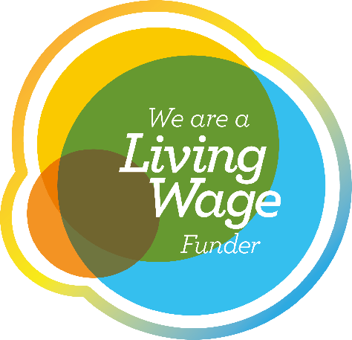

Find out more at: www.livingwage.org.uk

