START WEEKLY 5 WAYS 5 DAYS TO WELLBEING

NEWS L ET T ER

3 JULY 2020

Start Inspiring Minds www.startinspiringminds.org.uk sarah@startinspiringminds.org.uk
Keeping us connected

Welcome to the new edition of Start's Five ways to Wellbeing newsletter.
Sharing daily inspiring activites to keep your mind and body healthy during lockdown.

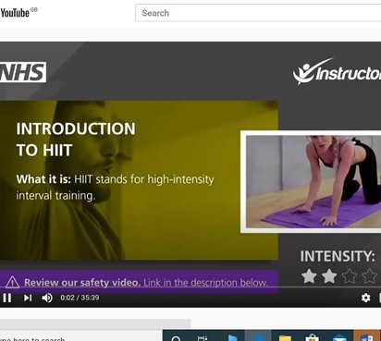
MONDAY: BE ACTIVE...

Have a go at HIIT
If you’re feeling like an active challenge but don't have long to exercise, the NHS have a series of 6 easy to follow high intensity interval training lessons on their YouTube channel that you can try from home. You can access them by following the link below:

https://www.youtube.com/watch? v=wa0Jtlh3J2s&list=PLnhASgDToTktRmHUwRwrwosx1514WR2FU&index=2 &t=0s

TUESDAY: CONNECT...

Create a Rorschach
The Rorschach test, also called Rorschach inkblot test was designed as a method of psychological testing in which a person is asked to describe what he or she sees in 10 inkblots, of which some are black or grey and others have patches of colour. The test was introduced in 1921 by Swiss psychiatrist Hermann Rorschach.

You can connect with others at home and have fun by making your own inkblots with paint or ink on a piece of paper and then compare what each other sees in them! Try folding your paper in half whilst still wet to produce lovely mirror images.

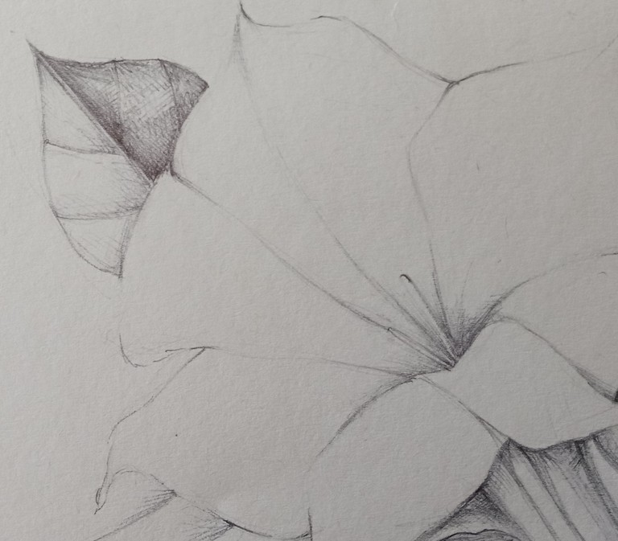
WEDNESDAY: TAKE NOTICE...

Really Look at a Flower
Georgia O'Keefe Said - When you take a flower and really look at it, it's your world for that moment. I want to give that world to someone else. Most people rush around so they don't have time to look at a flower, I want them to see it.....
Try drawing a flower in detail and give it to someone who doesn't have time to really look at a flower.

Send you photos to Elaine@startinspiringminds or
#startsketchtoconnect@startinsalfordart

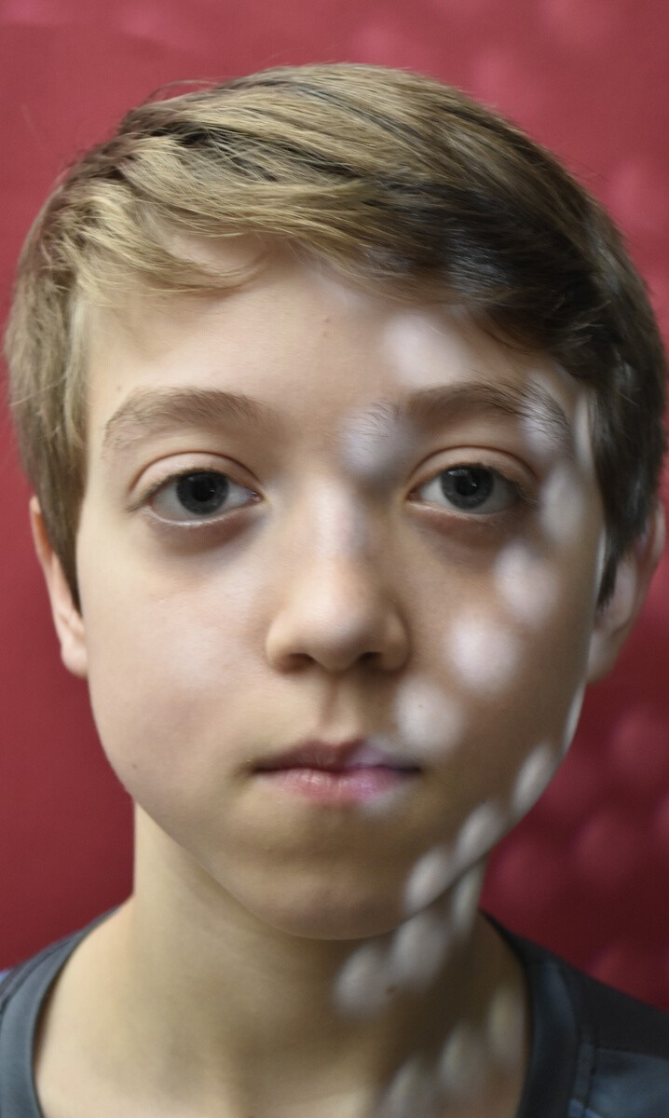
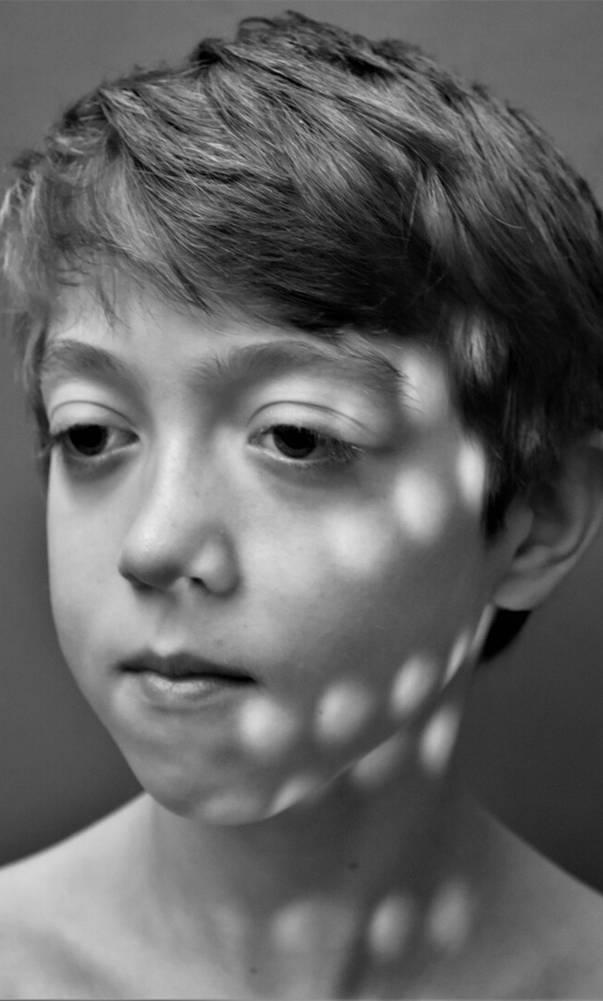
THURSDAY: KEEP LEARNING...

Create a Stylish Sieve Portrait
If you have a camera, a sieve, a lamp and are able to access YouTube, you can learn how to photograph an interesting portrait like this! And best of all, no one will guess how you managed it! Watch the tutorial by following the link below:

https://www.youtube.com/watch?v=NwYhDJ04GAk

send your sieve pics to #startphotochallenge or jeni@startinspiringminds.org.uk

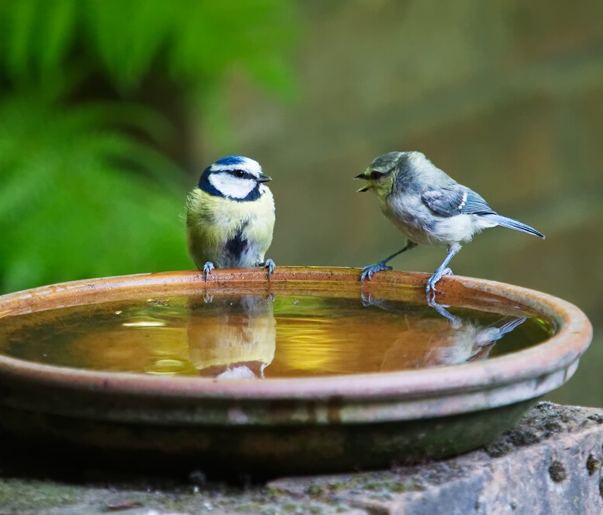
FRIDAY: GIVE...

Make a Bird Bath
Watching your birds coming for a drink or a wash can be quite a performance! So sit back and watch them having a good, splashy bath – who needs TV?
You can make your birdbath at any time of year, but summer really is a critical time when water can be scarce for birds.
You’ll often see blackbirds or starlings taking a dip, while woodpigeons may just sit in the water to cool off! Follow the link below and read the RSPB's guide to making the perfect birdbath:

https://www.rspb.org.uk/get-involved/activities/give-nature-a-home- in-your-garden/garden-activities/maketheperfectbirdbath/
ideas and inspiration welcome!

We would like you to get involved!

If you have any self care tips or creative ideas to share that may help others during this time please email sarah@startinspiringminds.org.uk and we will add them to future newsletters, and be sure to visit our YouTube channel and Instagram page for more ideas.

@startinsalfordart #startinspiringminds

