Salford CVS
Volunteers’ Expenses Fund
Guidance for Applicants
Round Three – 2021/22

Summary of the Fund Criteria

- Grants of up to £750 to cover out-of-pocket expenses of volunteers within Salford-based VCSE organisations (or with track record of delivery in Salford)
- Full Membership of Salford CVS
- Turnover limit for organisations of £100,000
- Maximum of one award per group per year
- All volunteering activity must take place in Salford
- Closing date for applications:
12:00 noon on Monday 7th February 2022
- Decisions to be made by:
w/c 14th March 2022

Salford CVS
Volunteers’ Expenses Fund
Guidance for Applicants – Round Three – December 2021

Section 1 – About the fund

What is the Volunteers’ Expenses Fund?
This fund is for small voluntary, community or social enterprise sector organisations (with less than £100,000 turnover per year) to meet the cost
of paying out expenses to support volunteers.

It is supported by NHS Salford CCG (Clinical Commissioning Group) as part of the Third Sector Fund

How much can you apply for?
Applications are invited for volunteers’ expenses up to maximum of £750.
Only one application per organisation may be submitted per round and if successful, only one award in any 12-month period will be made.

Who can apply?
Only organisations that meet the criteria below will be eligible to apply

- This fund is open to Salford-based voluntary, community or social enterprise (VCSE) sector organisations who are supporting local beneficiaries.
- All organisations must be a pre-existing member of Salford CVS. To apply for membership see the link: www.salfordcvs.co.uk/membership-0
- Applications will only be considered from Salford-based organisations or organisations with a track record of delivering activity in Salford
- All volunteering activity must take place within Salford.
- The turnover limit for organisations applying is £100,000 per year.

Eligible Costs
Only the items outlined below are eligible for funding:

1) Cost of protective clothing / specialist equipment
You can apply to the fund to cover reasonable costs of any clothing or specialist equipment required for your volunteer roles – e.g. gloves, hand sanitiser, uniforms, safety shoes, etc. A limit of £50 per volunteer can be claimed.

2) Refreshments and meals whilst volunteering
This covers reasonable refreshments such as tea, coffee and biscuits for volunteers who work less than 3.5 hours in a day. For volunteers who work more than 3.5 hours in a day meal expenses can be claimed with a limit of £5 per day on production of a receipt.

3) Care of dependants during volunteering
You can apply to the fund to cover the costs of your volunteer’s caring expenses. Please note that we can only fund expenses paid to a ‘formal’ care provider or a registered child-minder and you need to ensure you have receipts for any reimbursements. A limit of £15 per day can be claimed for each volunteer who has caring responsibilities.

4) DBS checks of your volunteers (if appropriate)
You can claim up to a maximum of £16 per volunteer DBS check. These can be obtained via Salford CVS. DBS checks have special requirements for the checks to be allowed to take place.

To check if the volunteers are eligible for a check please contact us on
0161 787 7795 or email dbs@salfordcvs.co.uk for further information.
Also see: www.salfordcvs.co.uk/dbs-checks

5) Public Transport
You can reimburse your volunteers for the cost of standard-class return bus or train tickets upon production of a valid receipt. A limit of £8 per volunteer per day can be claimed. If your volunteers have disabilities and require specific transport at an additional cost, please provide information within the application.

6) Own Transport
You can reimburse your volunteers for using their own transport to travel to and from their place of volunteering, providing they complete a Travel Expenses Claim Form. You should use current HMRC reimbursement rates when calculating how much to give to your volunteer.
For current rates see: www.hmrc.gov.uk/rates/travel

Volunteers using their own vehicle must have a full driving licence and Volunteer usage covered on their car insurance. If volunteers are also using their vehicle to transport beneficiaries, then the insurance must also cover carrying passengers.

7) Accessibility Support
Any costs associated with a volunteer’s physical or other impairment that prevents or hinders them from volunteering will be considered eligible.

What policies / other documentation is required?

All organisations will be expected to have the following policies in place at the time of application:

- Health and Safety policy
- Equality/Diversity Statement or Policy
- Volunteering Policy
- Public Liability Insurance (Cost can be included in budget)
- Risk assessments (inc Covid-19 precautions)
- Safeguarding Adults policy (if applicable to project activities)
- Safeguarding Children policy (if applicable to project activities)

Please note: If your project involves working with children or vulnerable adults you will need to include a copy of Safeguarding Policy.

What support is available to applicants?

Salford CVS can offer practical support to your organisation with developing policies, accessing volunteers, accessing wider funding, pre-application read-throughs/feedback etc.

For further information, visit our website at:
www.salfordcvs.co.uk/development-support

You can also contact our Development Team by phone 0161 787 7795 or email at: office@salfordcvs.co.uk

Also see our online Safeguarding in Salford resources: www.salfordcvs.co.uk/safeguarding-salford

If you have any questions or concerns regarding completing the application please contact the Grants Team by phone 0161 787 7795 or email at: grants@salfordcvs.co.uk

How to apply

Please read this guidance in full to ensure your application meets the criteria.

Organisations that wish to apply will need to complete the application form and submit it by email to grants@salfordcvs.co.uk in WORD or PDF format (ideally not as a scanned PDF). Alternatively, they can be posted to:

Salford CVS, The Old Town Hall, 5 Irwell Place, Eccles, M30 0FN

When is the closing date for applications?

The fund will close to applications at 12:00 noon on Monday 7th February 2022.

How will applications be assessed?

On receipt of applications Salford CVS will undertake a number of eligibility checks. All applications that are eligible will be independently scored by a panel consisting of representatives from NHS Salford CCG, a large VCSE-sector organisation and Salford CVS.

This assessment panel will then meet to agree the awards and provide feedback on unsuccessful applications.

When will we hear the outcome?

All applicants will be informed by email within 6 weeks of the closing date. Unsuccessful applicants will be provided with a summary of feedback from the assessment panel.

If successful, when will we receive the grant?

On receipt of an offer letter from Salford CVS organisations will need to complete and return an ‘Acceptance of Grant Form’ together with an invoice for the full grant amount. For organisations that have not received a grant from Salford CVS before (or changed bank account since their last award) we will also require proof of bank details. This can take the form of a scan or photo of a bank statement or paying-in slip.

On receipt of these documents Salford CVS will then issue the grant by bank transfer within 5-10 working days. The full grant amount will be paid upfront in line with the ‘Principles of Good Grant Giving’ which Salford CVS adheres to.

How long will we have to spend the grant?

All organisations receiving a grant will have up to 12-months from the date of the offer letter to spend the grant.

How will our project be evaluated by Salford CVS?

Salford CVS’ has a three-fold approach to evaluation:

- Assessing impact – the difference your project made in words, numbers, stories, quotes and photos
- Gathering learning – what you have learned as an organisation, how your organisation has developed and what you would do differently next time
- Providing assurance – demonstrating good management of public money

In practical terms this will mean providing feedback to Salford CVS in the shape of a simple report form when your project is completed. We may also select your project for a monitoring visit (in person or remotely) to help us understand how you are getting on and if you’re in need of any support.

As guardians of public money Salford CVS requires all funded organisations to keep receipts for all project spend after your project completes. Salford CVS undertakes a number of spot-audits every year and you may be asked to provide evidence of your spending.

With your help in providing simple feedback we can demonstrate how grants and investments can make a real difference to the health and wellbeing of local people. This is important in helping us report back to our funders and wider partners, and helps secure investment in our sector over the years to come.

Any further questions?

Please contact the Grants Team by phone 0161 787 7795 or email at: grants@salfordcvs.co.uk

Section 2 – Completing the Application Form

About your organisation

Question 1) – Please give the full name of your organisation.

Question 2) – Please give the name of the lead contact for this application / project. They will be the primary point of contact for all matters relating to this application and any successful project award.

Question 3) – Please give a secondary contact. They will only be contacted if we have difficulty reaching the lead contact.

Question 4) – Only pre-existing Full Members of Salford CVS are eligible to apply. Please tick this box to confirm your organisation is a Full Member. Please don’t assume that your organisation is a member of Salford CVS just because you receive regular eNewsletters from us. If in doubt, please phone us on 0161 787 7795 to check.

Question 5) – Please provide your organisation’s turnover (revenue / income) for the most recent financial year. The maximum eligible turnover for this fund is £100,000 per year.

Please note: all the information below will be shared with the Assessment Panel

Question 6) – Please restate the full name of your organisation.

Question 7) – Please tell us how your organisation is constituted. Unincorporated Organisations / Community Groups will not have an Organisation Number.

Question 8) – Please confirm that any volunteer drivers have relevant car insurance. Please check that any insurance also covers carrying passengers if applicable.

Question 9) – Please tell us if your project involves children or young people.

Question 10) – If you’re not sure if your activities require DBS checks please see:
www.salfordcvs.co.uk/dbs-checks
Question 11) – Salford CVS expects all organisations to have relevant policies in place at the time of application. Please note that that public liability insurance costs can form an element of your bid. If you need advice or support on developing policies, please see the ‘What support is available to applicants?’ section above.

Question 12) – Please give a brief description of the work of your organisation.

About your volunteers

Question 13-17) – Answer to these questions give us a better idea of how many volunteers you support and the cost per year.

Question 18) – Please tell us what the volunteers (to be supported by this application) will be doing.

Question 19) – Please tell us who benefits (beyond the volunteers themselves) from the voluntary work undertaken.

Question 20) – Please indicate the areas of Salford where the voluntary work take place. If it is across the whole of Salford, please tick ‘Salford city-wide’.
See the map below showing Salford’s new ward boundaries:

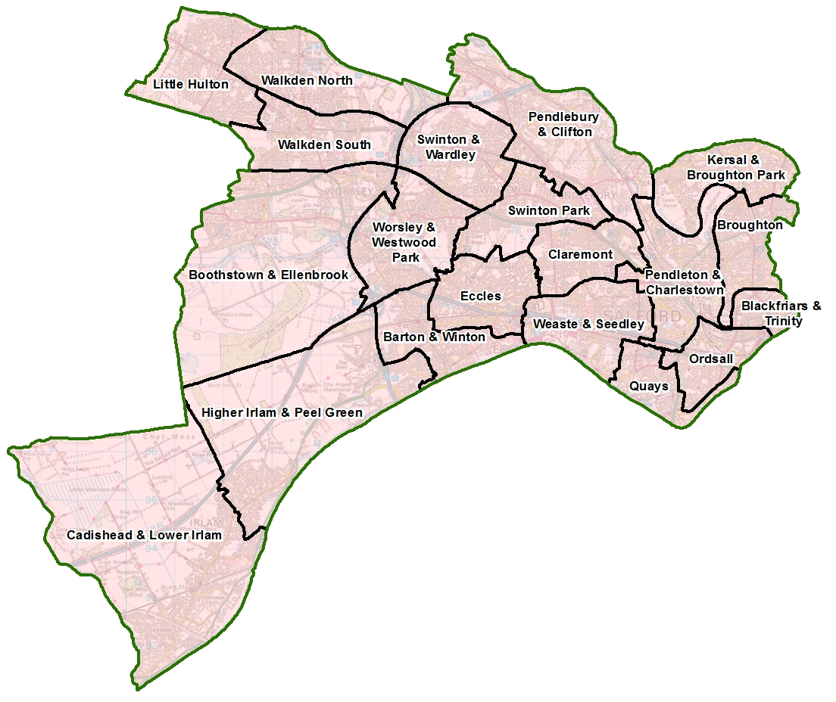
Maximising the benefits for Salford

Question 21) – Salford CVS is an accredited Living Wage Funder. This means we support all staffed organisations that pay a minimum wage of at least £9.50 per hour as set by the Living Wage Foundation. We also actively encourage organisations to become an accredited Living Wage Employer.
If you don’t employ staff, please tick the ‘not applicable’ box (N/A).

For your information, please see below for the annual Living Wage Employer accreditation fees (January 2020) for VCSE organisations (before VAT):
- 0 - 10 employees: £60
- 11 - 50 employees: £120
- 51 - 250 employees: £240
- 251+ employees: £480

This includes regular third party contractor staff.

Question 22) – As leading member of the Social Value Alliance Salford CVS wants to ensure that as much of its grant monies as possible are spent in Salford, ideally through buying goods and services from local independent businesses or fellow VCSE sector organisations. This helps to support our local economy.

The opposite of this approach is to buy directly from large chains or corporations. Amazon for example has been identified as the worst company for aggressive tax avoidance which deprives our government of much-needed funds for schools, hospitals, local services etc. If you do feel pressured to occasionally use Amazon, then buy from Amazon Marketplace which supports independent suppliers.

Question 23) – Whilst your project may be focused on particular health and wellbeing outcomes, the way you deliver it might deliver wider benefits for the people, economy and environment of Salford. For example, you might be supporting the mental health of people via a food growing or tree planting project; or you might provide training opportunities that boost people’s chance of employment.

About the money

Please note: Applications are most commonly queried or refused due to lack of detail on the budget.
Question 24) – Please provide details of what you’re wanting funding for. Please describe the items, why they’re needed and provide a breakdown of your calculations so we can see how you’ve arrived at the cost for each item. See some examples below.

Public transport example
Please provide information about where the journey is from and to, what type of transport, how much per trip or day ticket and how many trips.
Example: Two volunteers bus fares based on day ticket costing £4.10 each x one trip per week for ten weeks.
2 volunteers x £4.10 x 10 weeks = £82.00

Personal vehicle usage
Please provide information about where the journey is from and to, how many miles per trip and how many trips. The mileage rate is set at £0.45p per mile max.
Example: One volunteer makes one round trip per week of 6 miles for 10 weeks
£0.45 x 6miles x 10 weeks = £27.00.

Protective clothing/ specialist equipment:
Please provide information about how many volunteers will require the equipment, what the equipment is, and the cost per item.
Example: 5 pairs of gloves at £3.99 each + 3 x Uniforms at £25.00 each
= (5 x £3.99) = £19.95 + (3 x £25.00) = £75
Total = £94.95

Volunteer meals
Please provide how many volunteers will require lunch, how many sessions lunch is required for and the cost per person. If you have different costs per volunteers as less hours etc. please note this.
Example: 4 volunteers attending all 8 sessions lunch cost of £3.50
4 x £3.50= £14 x 8 = £112

Question 25) – Please tell us if your organisation has its own bank account.

Question 26) – If you answered No to the above question, would you need Salford CVS to hold the money in a ‘holding account’ for you?

Question 27) – Please tell us if you want to promote your volunteering opportunities on our Volunteering Portal.
Please attach
Please confirm you are attaching relevant safeguarding policies if applicable to project activities.

Declaration
Please confirm that you have read the Terms and Conditions of this grant by giving the name and role of the lead applicant.

Optional – Making a pledge to help improve Salford
If you wish to make a pledge to help make Salford 10% Better you can tell us in this final section.

You can make a pledge at the link below:
www.salfordsocialvalue.org.uk/10-better-campaign/make-a-10-better-pledge

