Salford CVS
Wellbeing Fund
Guidance for Applicants
Round Three – 2021/22

Summary of the Fund Criteria

- Grants of up to £1,000 for Salford-based VCSE organisations (or with track record of delivery in Salford) delivering health and wellbeing projects
- Full Membership of Salford CVS
- Turnover limit for organisations of £100,000
- Maximum of one award per group per year
- Funding priorities:
  - All projects must help deliver on the ‘5 ways to Wellbeing’
- Closing date for applications:
12:00 noon on Monday 7th February 2022
- Decisions to be made by:
w/c 14th March 2022

Salford CVS
Wellbeing Fund
Guidance for Applicants – Round Three – December 2021

Section 1 – About the fund

What is the Wellbeing Fund?
The Wellbeing Fund is for small voluntary, community or social enterprise sector organisations for projects which help to improve the health and wellbeing of Salford residents. It is supported by NHS Salford CCG (Clinical Commissioning Group) as part of the Third Sector Fund

Who can apply?
Only organisations that meet the criteria below will be eligible to apply

- This fund is open to voluntary, community or social enterprise (VCSE) sector organisations who are supporting beneficiaries most affected by Covid-19.
- All organisations must be a pre-existing member of Salford CVS. To apply for membership see the link: www.salfordcvs.co.uk/membership-0
- Applications will only be considered from Salford-based organisations or organisations with a track record of delivering activity in Salford.
- Of those people being supported through this fund (the beneficiaries) 100% must be Salford residents.
- The turnover limit for organisations applying is £100,000 per year.

How much can you apply for?
Applications are invited for projects up to maximum of £1,000. Only one application per organisation may be submitted per round and if successful, only one award in any 12-month period will be made.

What can you spend the money on?
The grants can be used to for staffing / volunteer costs, venue hire, project materials, promotion and publicity, refreshments, public liability insurance and any other reasonable project costs.

Note re food projects: Please note that applications seeking funding exclusively for food (e.g. from food banks and clubs or provision of food parcels) will not normally be considered. Please contact the Grants Team if you are unsure if this applies to your project proposals.
Funding priorities
We use the ‘Five Ways to Wellbeing’ to define health and wellbeing. These five ways are outlined below, with some examples of the sorts of things a project might focus on. If you’re not sure if your project is eligible for a Wellbeing Fund grant, please contact us.

Connect | Be Active | Take Notice | Keep Learning | Give
Reduced social isolation | Increased amount of physical activity | Increased confidence and self-esteem | Raised personal aspirations | Improved self-esteem from volunteering
Increased activity within communities | Improved ability to manage long term health condition(s) | Taking responsibility for activity in their local community | Ability to progress in life & achieve personal aspirations | Increased feeling of being valued by others
Increased connection between generations | Improved posture and stability in over 65s | Increased sense of belonging to your local community or feeling connected to the world around you | Increased employability | Improved happiness and feeling of wellbeing
Improved social networks & personal relationships |  |  | Improved life skills

Wellbeing Conversations
Salford CVS is encouraging all organisations supported by the Wellbeing Fund to sign-up for training in giving Wellbeing Conversations. This training will enable individuals to have a positive impact on someone's wellbeing through conversation.

If you’re interested in finding out more this training or to book a place, please see: www.salfordcvs.co.uk/event-feed

Please note that all successful applicants Wellbeing Fund recipient organisations will be asked to nominate a member to take part in upcoming Wellbeing Conversations training.

What policies / other documentation is required?
All organisations will be expected to have the following policies in place at the time of application:

- Health and Safety policy
- Equality/Diversity Statement or Policy
- Public Liability Insurance (Cost can be included in budget)
- Risk assessments (inc Covid-19 precautions)
- Safeguarding Adults policy (if applicable to project activities)
- Safeguarding Children policy (if applicable to project activities)

Please note: If your project involves working with children or vulnerable adults you will need to include a copy of the Safeguarding Policy.

What support is available to applicants?
Salford CVS can offer practical support to your organisation with developing policies, accessing volunteers, accessing wider funding, pre-application read-throughs/feedback etc.

For further information, visit our website at:
www.salfordcvs.co.uk/development-support

You can also contact our Development Team by phone 0161 787 7795 or email at: office@salfordcvs.co.uk

Also see our online Safeguarding in Salford resources: www.salfordcvs.co.uk/safeguarding-salford

If you have any questions or concerns regarding completing the application please contact the Grants Team by phone 0161 787 7795 or email at: grants@salfordcvs.co.uk
How to apply
Salford CVS is anticipating high levels of demand for the Wellbeing Fund. Therefore, please read this guidance in full to ensure your application meets the criteria.

Organisations that wish to apply will need to complete the application form and submit it by email to grants@salfordcvs.co.uk in WORD or PDF format (ideally not as a scanned PDF). Alternatively, they can be posted to:

Salford CVS, The Old Town Hall, 5 Irwell Place, Eccles, M30 0FN

When is the closing date for applications?
The fund will close to applications at 12:00 noon on Monday 7th February 2022.

How will applications be assessed?
On receipt of applications Salford CVS will undertake a number of eligibility checks. All applications that are eligible will be independently scored by a panel consisting of representatives from NHS Salford CCG, a large VCSE-sector organisation and Salford CVS.

This assessment panel will then meet to agree the awards and provide feedback on unsuccessful applications.

When will we hear the outcome?
All applicants will be informed by email within 6 weeks of the closing date. Unsuccessful applicants will be provided with a summary of feedback from the assessment panel.

If successful, when will we receive the grant?
On receipt of an offer letter from Salford CVS organisations will need to complete and return an ‘Acceptance of Grant Form’ together with an invoice for the full grant amount. For organisations that have not received a grant from Salford CVS before (or changed bank account since their last award) we will also require proof of bank details. This can take the form of a scan or photo of a bank statement or paying-in slip.

On receipt of these documents Salford CVS will then issue the grant by bank transfer within 5-10 working days. The full grant amount will be paid upfront in line with the ‘Principles of Good Grant Giving’ which Salford CVS adheres to.

How long will we have to spend the grant?
All organisations receiving a grant will have up to 12-months from the date of the offer letter to spend the grant.

How will our project be evaluated by Salford CVS?
Salford CVS’ has a three-fold approach to evaluation:

- Assessing impact – the difference your project made in words, numbers, stories, quotes and photos
- Gathering learning – what you have learned as an organisation, how your organisation has developed and what you would do differently next time
- Providing assurance – demonstrating good management of public money

In practical terms this will mean providing feedback to Salford CVS in the shape of a simple report form when your project is completed. We may also select your project for a monitoring visit (in person or remotely) to help us understand how you are getting on and if you’re in need of any support.

As guardians of public money Salford CVS requires all funded organisations to keep receipts for all project spend after your project completes. Salford CVS undertakes a number of spot-audits every year and you may be asked to provide evidence of your spending.

With your help in providing simple feedback we can demonstrate how grants and investments can make a real difference to the health and wellbeing of local people. This is important in helping us report back to our funders and wider partners, and helps secure investment in our sector over the years to come.

Any further questions?
Please contact the Grants Team by phone 0161 787 7795 or email at: grants@salfordcvs.co.uk

Section 2 – Completing the Application Form

About your organisation

Question 1) – Please give the full name of your organisation.

Question 2) – Please give the name of the lead contact for this application / project. They will be the primary point of contact for all matters relating to this application and any successful project award.

Question 3) – Please give a secondary contact. They will only be contacted if we have difficulty reaching the lead contact.

Question 4) – Only pre-existing Full Members of Salford CVS are eligible to apply. Please tick this box to confirm your organisation is a Full Member. Please don’t assume that your organisation is a member of Salford CVS just because you receive regular eNewsletters from us. If in doubt, please phone us on 0161 787 7795 to check.

Question 5) – Please provide your organisation’s turnover (revenue / income) for the most recent financial year. The maximum eligible turnover for this fund is £100,000 per year.

Please note: all the information below will be shared with the Assessment Panel

Question 6) – Please restate the full name of your organisation.

Question 7) – Please tell us how your organisation is constituted. Unincorporated Organisations / Community Groups will not have an Organisation Number.

Question 8) – Salford CVS expects all organisations to have relevant policies in place at the time of application. Please note that that public liability insurance costs can form an element of your bid. If you need advice or support on developing policies, please see the ‘What support is available to applicants?’ section above.

About your project

Question 9) – Please give your project a memorable name. This helps us identify your project should your application be successful.

Question 10) – Please give a brief description of your project that sums up what you plan to do. This may be used on our website publicise the award.

Question 11) – In this section tell what you intend to do with the grant if you’re successful. Please give details of the practicalities involved in delivering your project i.e. how you will use the money, what you plan to do, who’s doing it, the frequency of activities, how it will be promoted, on which days etc. This activity should be recognisable in your project budget.

Question 12) – Please explain how it will positively benefit the health and wellbeing of Salford residents. Have a read of the ’5 Ways to Wellbeing’ (see page 3) and think through how your project can contribute to these positive outcomes.

Questions 13) – Is the project aimed at people from a specific area? Maybe they are from a particular interest group? Please use simple language to tell us who the project is for.

Question 14) - Please only tick the equalities groups that your organisation specifically works with. If you work with ‘anybody and everybody’ please tick the ‘No specific group’ box.

Question 15) - Be realistic about how many people this project will work with. We are interested in organisations delivering good projects with a manageable number of beneficiaries.

Question 16) - If your project involves working with children or vulnerable adults you’ll need to have (or develop) appropriate safeguarding policies before activities can commence.

Question 17) - It is expected that all successful projects are fully delivered with 12-months of the award. Please note that late March 2022 is the earliest realistic start date.

Question 18) – Please indicate the areas of Salford which will receive support from your project. If it is across the whole of Salford, please tick ‘Salford city-wide’.
See the map below showing Salford’s new ward boundaries:

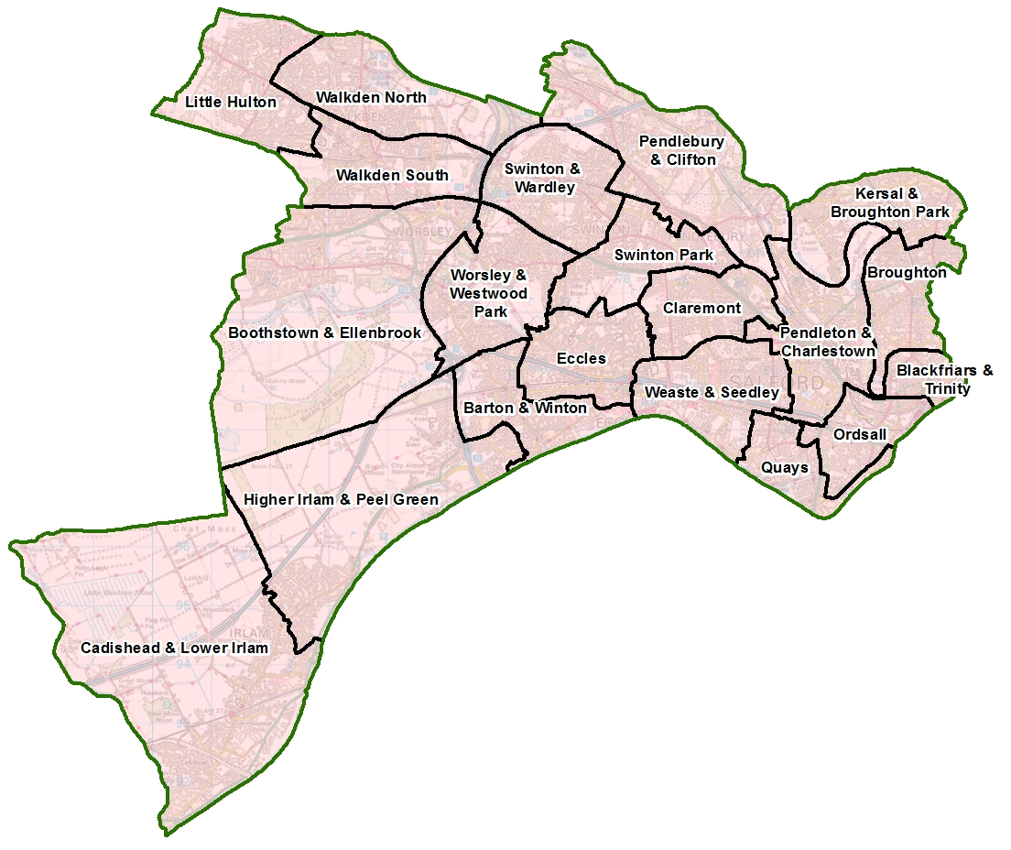

Question 19) – We want you to tell us how you can evidence progress in delivering your project. What practical things can you measure to evidence success? This might be ‘increased physical activity’ or ‘improved emotional wellbeing’ of those your project support.

How you measure these outcomes may be very simple (e.g. hours of additional exercise) or involve seeking feedback from your beneficiaries (e.g. before and after survey, quotes, photos etc.). Ultimately we want you tell us how you plan to evidence the difference your project has made to the people you support.

Maximising the benefits for Salford

Question 20) – Salford CVS is an accredited Living Wage Funder. This means we support all staffed organisations that pay a minimum wage of at least £9.90 per hour as set by the Living Wage Foundation. We also actively encourage organisations to become an accredited Living Wage Employer.
If you don’t employ staff, please tick the ‘not applicable’ box (N/A).

For your information, please see below for the annual Living Wage Employer accreditation fees (January 2020) for VCSE organisations (before VAT):
- 0 - 10 employees: £60
- 11 - 50 employees: £120
- 51 - 250 employees: £240
- 251+ employees: £480

This includes regular third party contractor staff.

Question 21) – As leading member of the Social Value Alliance Salford CVS wants to ensure that as much of its grant monies as possible are spent in Salford, ideally through buying goods and services from local independent businesses or fellow VCSE sector organisations. This helps to support our local economy.

The opposite of this approach is to buy directly from large chains or corporations. Amazon for example has been identified as the worst company for aggressive tax avoidance which deprives our government of much-needed funds for schools, hospitals, local services etc. If you do feel pressured to occasionally use Amazon, then buy from Amazon Marketplace which supports independent suppliers.

Question 22) – Whilst your project may be focused on particular health and wellbeing outcomes, the way you deliver it might deliver wider benefits for the people, economy and environment of Salford. For example, you might be supporting the mental health of people via a food growing or tree planting project; or you might provide volunteering or training opportunities that boost people’s chance of employment.

About the money

Question 23) – Please give an overview of what your project will cost by describing each item. Also break down your calculation so we can see how you’ve arrived at the cost for each item. See some examples below.

Example 1

Acceptable: Venue hire – 4hrs/wk @ £10ph x 10 weeks = £400
Not acceptable: Venue hire – £400

Example 2
Acceptable: Refreshments @ £1.50/person x 10 people x 10 events = £150
Not acceptable: Refreshments = £150

The item cost figure may be the same as the amount you’re requesting. If you have other sources of money, it may be you’re only looking for a contribution (see the example below)

Description of item | Breakdown of calculations | Item cost | Amount requested
Venue Hire | 4hrs/wk @ £10ph x 10 weeks | £400 | £200

Therefore, the total cost of the project may be more than the amount you’re requesting from the Wellbeing Fund. If this is the case, please include the other sources of funding which will support this project and whether the money has been secured or whether an application is pending. Such match funding is desirable but not essential.

Please attach
Please confirm you are attaching relevant safeguarding policies if applicable to project activities.

Declaration
Please confirm that you have read the Terms and Conditions of this grant by giving the name and role of the lead applicant.

Optional – Making a pledge to help improve Salford
If you wish to make a pledge to help make Salford 10% Better you can tell us in this final section.

You can make a pledge at the link below:
www.salfordsocialvalue.org.uk/10-better-campaign/make-a-10-better-pledge

